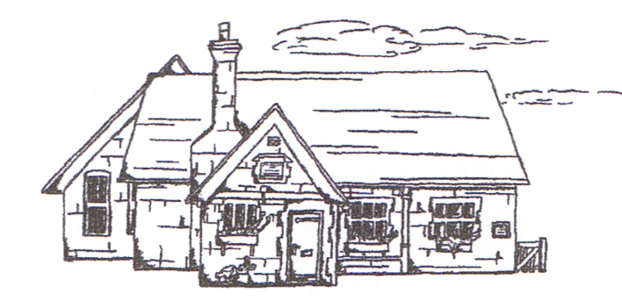
THUNDRIDGE CHURCH OF ENGLAND

PRIMARY SCHOOL NEWSLETTER

SUMMER WEEKS 7-10

FRIDAY 13TH JULY 2018

WHAT’S GOING ON NEXT WEEK
Tuesday 17th July | Library – Year 1&2
Thursday 19th July | Year 6 - Leavers Treat Day  Rounders – collect 4.15
Friday 20th July | Year 6 Leavers Assembly – am  Library - Juniors – am  Last day of term – Finish at 1.30  Friends Celebration Drinks for 2017/2018 Fundraising – The Feathers Inn – 1.30
WHAT’S ON LATER
Monday 3rd Sept | Inset Day
Tuesday 4th Sept | First Day of Autumn Term  Back To School Welcome Coffee Morning at The Feathers Inn – All welcome for complimentary coffee courtesy of The Friends & Cathy at The Feathers Inn

Birthdays….

Chloe Pearce – June 23rd
Michael Mann- July 1st
Miss Gaze – July 2nd
Mason King- July 2nd
Alex Warner – July 3rd
George Hartfield – July 6th
Mrs Welsh - July 9th
Martha Stopps – July 15th
Evie-Mae Watson - July 18th

Awards Friday 8th June 2018

Head Teacher Award
Zoe Thomas for being an exellent role model with a positive attitude towards everything.

Class Awards:
Foundation Stage – William Haworth & Hayden Mann
Year 1&2 – Billy Baker & Fearne Watson
Year 3&4 – Leo Homer & Alex Warner
Year 5&6 – Olivia MacLeod, Harrison MacLeod &
Emily Nicholson

Lunch Staff Awards:
Libby Adams, Tommy Brown, Charlotte Chamberlain & Hayden Mann

Well done all of you!

Awards Friday 15th June 2018

Head Teacher Award
Evie-Mae Watson for always being positive, even when faced with difficulties.

Class Awards:
Foundation Stage – Amy Johnson & Michael Mann
Year 1&2–Stanley Campbell & Isabelle Sampford-Poulter
Also
Harrison MacLeod, Olivia MacLeod & Emily Nicholson for helping out
Year 3&4 – Olly Judge & Martha Stopps
Year 5&6 – Jack Field & all of Year 5&6 for a great week on the Isle of Wight

Lunch Staff Awards:
Libby Adams & William Haworth

Well done all of you!

Awards Friday 22nd June 2018

Class Awards:
Foundation Stage – Out on their school trip
Year 1&2 – Henry Haworth & Jack Stone
Year 3&4 – Libby Adams, Harrison Campbell &
Oliver Chamberlain
Year 5&6-Harrison MacLeod & Mollie Sampford-Curry

Well done all of you!

Awards Friday 29th June 2018

Class Awards:
Foundation Stage – Preston Tyler & Whole Class for
their day at Paradise Wildlife Park
Year 1&2 – Whole Class for their day at RSPB
Rye Meads
Year 3&4 – Joseph Fox & Dita Purser
Year 5&6 – Maisy Robinson & Ruby Robinson

Mrs Tarbuck Award – Lewis Greatrex for completing Power of 2 Maths

Lunch Staff Awards:
Ralph Bradley-May, Michael Mann, Maisy Robinson & Preston Tyler

Well done all of you!

Awards Friday 6th July 2018

Head Teacher Award:
Joseph Fox for completing extra curricular work at home to present an excellent Powerpoint presentation which he delivered so well to the class.

And...

Kieran Francis for beautifully descriptive writing.

Class Awards:
Foundation Stage – William Haworth
Year 1&2 – Charlotte Chamberlain &
Lily-May Hewitt-Makin
Year 3&4 – Isabella Le Grys & Harry March
Year 5&6 – Jack Field

Lunch Staff Awards:
Chloe Haworth

Well done all of you!

Staff

We are very sorry to say goodbye to both Mrs Defty and Miss Gaze at the end of this term. They have both been extremely conscientious, professional and caring members of our staff and are a great loss to our team.

Mrs Defty is moving on to a Year 1 class, which has been her desire for quite some time, and Miss Gaze is seeking a full time job.

I wish them both the very best for the future.

Rose Adams

On 30th May, Rose Adams had her hair cut and has donated the 10" ponytail to the Little Princess Trust which makes real hair wigs for children who have lost their own hair due to cancer treatments and other illnesses. We are super proud of her!

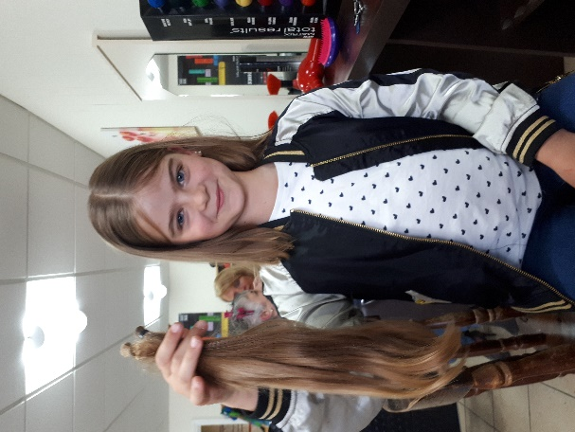

Gazebos
Thank you very much to parent, Bryan Best, for buying the school gazebos. This was very generous of Bryan and very much needed and welcomed in the heat this summer.

Year 5&6 School Journey
From the 4th to 8th June, a group of our Year 5&6 students spent a week in the Isle of Wight and kindly invited Mr Higgins and Mrs Frost to go along with them. They enjoyed a wonderful few days sightseeing and discovering the rich and varied history of the island. Highlights included visits to Queen Victoria's holiday home at Osborne House and a tour of Carisbrook Castle, home to imprisoned Royalty of the past. Further delights included dolphin watching near the Needles lighthouse in Alum Bay and fun time spent on the beach at Sandown. The children were an absolute credit to the school and their families, with various tour guides and hosts complimenting the teachers on the children's exemplary manners and behaviour.
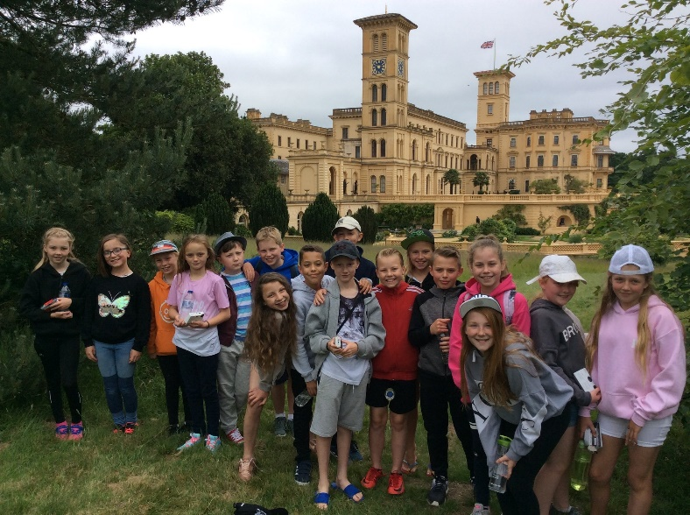

Foundation Stage Trip
On 22nd June the Foundation Stage had a fantastic trip to Paradise Wildlife Park. They were all excited to see the extraordinary animals including the grumpy camels, the cute penguins and the sleepy lions. In the ‘Amazon and Beyond’ area, the children asked some brilliant questions of the guide, Amy, and they loved seeing the two very large anacondas! They will also never forget the amazing ‘World of Dinosaurs’, it was a thrill to see all the moving dinosaurs but it was touch and go whether we would make it out!
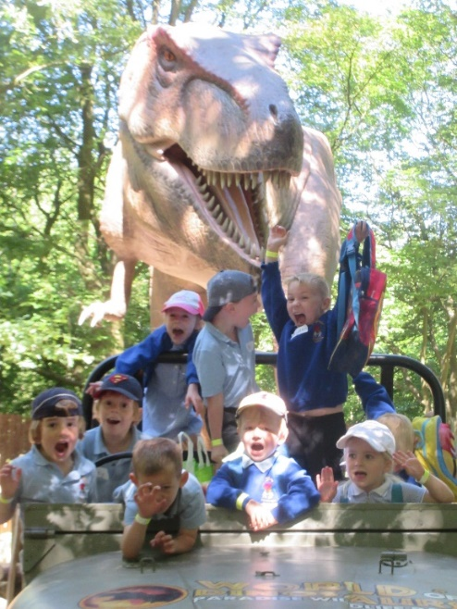

District Sports
On 25th June some children from Years 2 to 6 took part in the ‘Small Schools District Sports’ at Wodson Park.

Children were selected to take part in field events such as target throwing, javelin, standing long jump and track events of 600m, sprints and relays.

The children all behaved really well and demonstrated excellent sportsmanship.

Our Year 2 team and our Year 5&6 team both came in 3rd place. Our Year 3&4 team came in 1st place and will therefore hold the trophy for the year!

Congratulations to all children who took part and thank you to the parents who volunteered to transport them.

Well done!

1&2 Trip

All of the children in Year 1&2 had a fantastic day at Rye Meads on 27th June. They were so excited to get there by riding the first class carriage on the train!

Fun was had by all and the children who enjoyed pond dipping and learnt about the eco skeleton of invertebrates. They identified lots of underwater creatures. After a sunny lunchtime they went on a

plant hunt using a colour pallet and used their senses to identify different herbs.

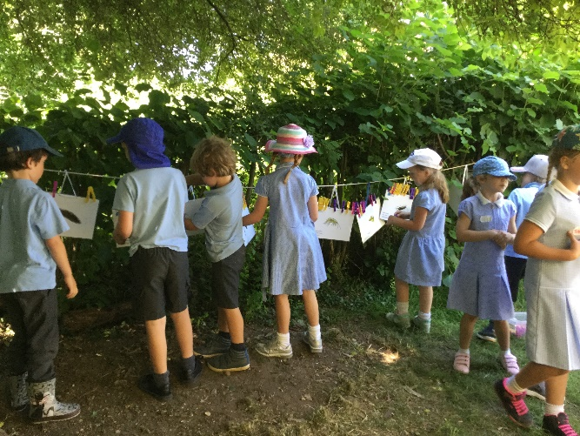

Year 5&6 Assembly
On 28th June Year 5&6 held their class assembly at the Village Hall. What a lovely show the Year 5&6 class gave during their assembly to the parents. The interactive slide-show and their funny stories about their trip to Isle of Wight was very entertaining. Many thanks to the parents for attending.

Yoga

On 11th July, we had Yoga Teacher, Claire Hutchins, visit to run a Yoga and Mindfulness Workshop for the whole school. The children really enjoyed the sessions and contributed lots of their own ideas and had the opportunity to practise during their lunch hour too. A leaflet of the yoga poses has been be handed to your children to practise at home with you.
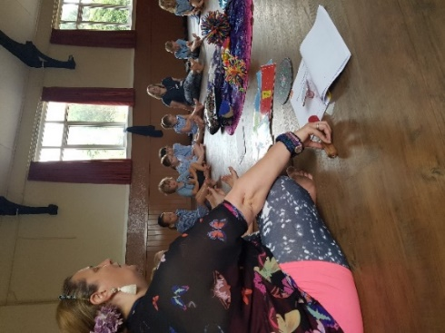
Open Evening
Also on 11th July we held our Open Evening, this was an opportunity for the children to show their parents their work and displays and for parents to meet their child’s new teacher. Thank you to those who attended.
The next day the children enjoyed ‘Moving up Day.’ Our Year 6 children visited their secondary schools and the other children school visited their new classrooms here.

Attendance
Below are the names of children who received the Hertfordshire County Council attendance awards. These were given for the year 2017/2018, where the dates given as on school reports from 5th June 2017 to 25th May 2018.

Excellent Award 100% Attendance
This was awarded to Libby Adams, Kian Bartlett, Finley Francis, Kieran Francis, Fletcher Hart, Chloe Haworth, Henry Haworth
William Haworth, Mason King, Alfie Pearce & Chloe Pearce.

Special Award
The following children received a ‘special award for having 5 absences or less (if your child has had an unauthorised absence, even if only one, unfortunately they would not receive an award).

Rose Adams, Isabella Le Grys, Phoebe Le Grys, Maisy Robinson & Zoe Thomas.

Congratulations all of you!

The Thundridge School attendance certificates that are awarded for attendance per term, will be awarded at the beginning of the autumn term.

Kind regards
Miss Greatrex

Friends of Thundridge School

Our “World Cup” Fete!: Thank you from the Committee!
Next week, further pictures of our “World Cup” fete will be published, however we just wanted to take the opportunity this time round to say a MASSIVE THANK YOU to all the parents who helped set up, take responsibility for, man stalls on Friday – and clear away afterwards! Thank you also to Luke Davy of McMullens for heavily stocking the bar and to the Teachers who helped out on stalls or running the Human Fruit Machine, and to everyone who lent us gazebos and brought in wine, Disney toys, cakes and either sold or bought Grand Draw tickets.
The day started with Adam Wright towing the continent-themed inflatables down to the field at 8.30am and from 9.00am, once Jack Satt had taken the first water butt to the field, Emma, Lindsay R and Mollie were joined by Chris Mann, Dave & Hannah Fox, Martyn Stopps and Emma Tyler to put up all the gazebos and get all the tables and equipment in place.

Chris also subsequently filled the two paddling pools with numerous fills of 35 litre water butts! Words just cannot express how grateful we were – and still are - to these wonderful parents for their time, and hugely physical labour! Thank you also to

Ian Cambell too who also came early to help in the quest & importantly set up the BBQ!
A definite lesson was learned for next time though …. We really do need more helpers (for set up and clear away)!!!

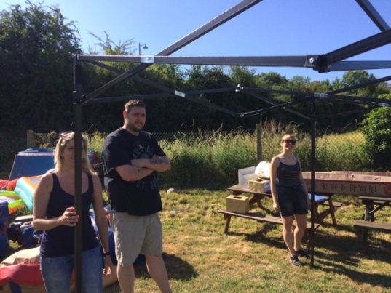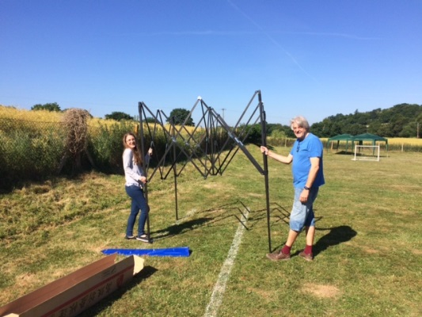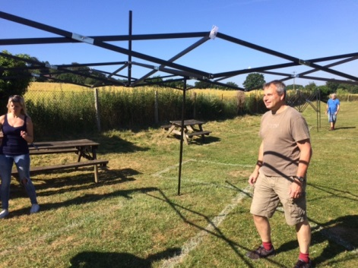
Decoration stage was next and again, a huge thanks needs to go to the following people for making their continents look SO amazing! The effort and creativity that went into decorating the continents was phenomenal – and the results outstanding! (Antarctica – Lindsay Roxburgh; S. America – Tracey Shirley; N. America – Nathalie Thomas; Australasia – Shelley Chappell & Mel Baker; Europe – Cathy Davy; Africa – Emma Le Grys, Asia – Katie Campbell).
A special thanks also goes to Christine and Ashley May for the creative artwork to make the “World Cup Passports”. We hope that the children enjoyed “Travelling the World”, visiting all 7 continents to play at the stalls, get stamps and answer continent trivia – and entering the prize draw!
Thank you for your continued support.
Friends of Thundridge School

