THUNDRIDGE CHURCH OF ENGLAND

PRIMARY SCHOOL NEWSLETTER

SUMMER WEEK 12

FRIDAY 20TH JULY 2018

WHAT’S GOING ON NEXT TERM
Friday 20th July | Last day of term – Finish at 1.30  Friends Celebration Drinks for 2017/2018 Fundraising – The Feathers Inn – 1.30pm
WHAT’S ON LATER
Monday 3rd Sept | Inset Day
Tuesday 4th Sept | First Day of Autumn Term  Back To School Welcome Coffee Morning at The Feathers Inn – All welcome for complimentary coffee courtesy of the Friends & Cathy at The Feathers Inn

Birthdays….

Evie-Mae Watson – 18th July
Ruby Robinson 25th July
Henry Howarth - 27th July
Jack Turner – 29th July
Miles Collins – 1st August
Libby Adams – 19th August
Rose Adams – 19th August
Mrs Grange – 20th August
Lily-May Hewitt-Makin – 22nd August
Lewis Greatrex – 26th August
Isla Grierson– 27th August
Mrs Gaze – 30th August
Miss Hare – 30th August
Mrs Loader – 31st August
Sydney Marshall – 3rd September
Jack Field – 7th September
Miss Harris - 7th September
Jake Ronan – 9th September

Year 6 Leavers…….

Year 6 Leavers Treat Day
Yesterday the Year 6 children had a great day at Edge Outdoor Activity Centre at Westmill Farm. The children tried their hand at archery and air rifles before careering down the hillside on mountain boards. In the afternoon, they challenged themselves on the high-ropes and whizzed down the big zip wire. They had a fantastic day supporting each other and having fun.

Year 6 Leavers Performance
This term ended with our latest group of Year 6 children treating us to their own very special assembly. It was an amazing performance show casing their many talents. It was such a treat to watch them and see how they have all grown in confidence and maturity.
I think the song and dance ‘A million dreams’ summed it up brilliantly.

A surprise visit from Laani Brown (our ex year 6 pupil who moved to Cornwall) really topped it all off!

Thank you to Michelle Harrison for creating the

Year 6 show with help from Amanda Stanley, both parents whose children are ex-Thundridge pupil. It was lovely to see their daughters Rudi and Charlotte who performed a dance routine while there was a costume change.

Michelle would like to thank Ann Powell, Lily-Mays Grandma for making the outfits for the Year 6 leavers dance and donating them to the school for pupils to use in years to come. Also thank you to the Friends Committee who donated £50.00 towards scenery, props and costumes and Liz Evans who lent many costumes.

Each child was awarded a special ‘Leavers Book’ as well as a memory stick containing photographs taken over their years at Thundridge School, including School Journeys. I am sure the children will treasure these.

We wish them all the best of luck in the future, building on their excellent achievements at Thundridge School. We will miss you all!

Trophies, Congratulations to:

Maisy Robinson who was awarded the
‘Sports’ Trophy

Mia Allgood who was awarded the
‘Outstanding Effort’ Trophy

Jemima Bright & Max Thomas who were awarded the
‘Citizenship’ Trophy

Congratulations!

It is sadly time to say goodbye to all the Year 6 children:
Mia Allgood, Jemima Bright, Joe Evans, Kieran Francis, Harrison MacLeod, Emily Nicholson, Maisy Robinson, Max Thomas, Sophie Ward and Evie Watson

We wish them every success at their new Secondary Schools. I am sure they will continue to reach their potential and am sorry to see them leave. They are a lovely group.
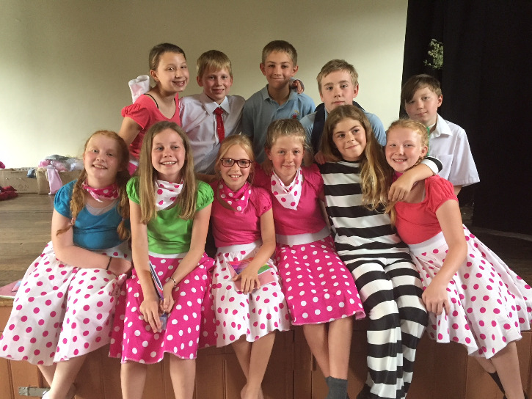

Staffing
Sadly, we are losing Mrs Rough who has been an excellent 1 to 1 Teaching Assistant. Mrs Rough is leaving to secure a more permanent position, which is not subject to external funding. Mrs Rough will be taking up a Teaching Assistant position in another school starting in September. We wish her all the best for the future.

Thank you to parents…
I would like to say big thank you to:
Chris Mann for putting together the storage box.
Parents for washing role play clothes.
Leo and Zac’s family for sweeping, cutting back, tidying the school grounds.
Kevin Chappell for fixing the wellie hogs.
Sheila White for the window box displays.
Sandra Brooks for keeping the grounds looking pretty.
Amanda Wareham for her continued support in Year 3&4 and Megan Adams & Nathalie Thomas for listening to the Year 3&4 children read every week.

Also to all the parents who transport the children to and from events all year.

Rounders

Rounders finished today with a friendly match between staff and the children who have attended rounders club this summer. It was a great match with a good staff turnout but we were outnumbered by a large number of very talented rounders players! I have to report it was competitive to say the least but in the nicest possible way and great fun!!

I cannot recall the score as there was a bit of 'cheating' on both sides so decree that the children won. Actually, I am sure they did as we cheated more than they did!

Many thanks to Tracey Shirley for running the club and to all staff who have helped support her. She is continuing in September so rounders children - keep up the good work and fun and we will try again to organise a fixture or two against another school. Great fun!

New Lining up Procedure in September
Starting in September we are going to trial a new routine for entering school. This is to encourage parents to come up to the playground and feel they are part of the school community.

The first bell will be rung at 8.50am for all the children to go through the blue gate and line up in classes on the top playground (bags can be left near the junior classes or against the wall leading to the field for the infants). Parents are welcome to go through the blue gate to talk informally to staff. More formal conversations obviously need to take place through appointments. The second bell will be rung at 8.55am when the parents are to say goodbye to their children then the children are to line up in silence in their classes.

NSPCC Assembly

On 19th June NSPCC visited the school to talk to the children about how to keep safe. They explained a variety of situations that the children should report, such as bullying inappropriate behaviour and explained who to report it to etc. All the children found this very informative.

Cluster Sports

On 21st June, after hard fought competition against Tonwell School, Puller Memorial School and the sporting super powerhouse of Stapleford School, Thundridge emerged victorious from the Cluster Sports Day held at Puller Memorial School, midsummer's day. The children faced the opposition in a variety of races from egg and spoon and obstacle races to a challenging long distance run under the blazing sun.

Thundridge School looked to have strength in depth across all age groups, finishing most races in contention for one of the top two places. Their hard work paid off as they retained the trophy for the a 2nd year. Well done everyone!

Sports Day
On Friday 29th June, in sweltering heat, the whole school took part in our annual sports day. Here the children competed in their houses of Barclay, Clarkson, Hanbury and Wodson. They took part in a variety of races against their own Year groups. At the end of a fun afternoon, and a very close competition, Barclay team yet again came first and won the trophy! Congratulations to all the teams and thank to everyone who helped make the afternoon such a success.
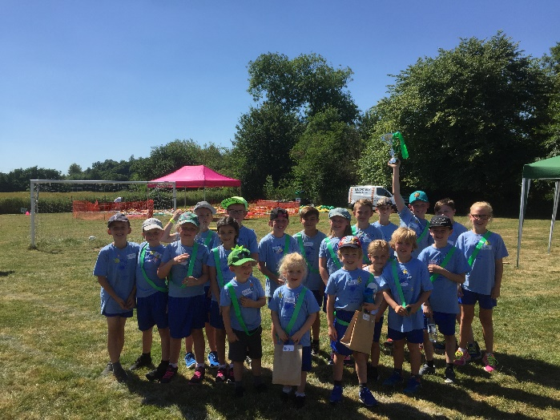

The Friends fete followed, I would like to say a huge thank you to the Friends Committee for their fantastic World Cup event. A lot of work goes into these events and a lot of preparation. They are the unsung heroes who often do an enormous amount of work behind the scenes and are all much appreciated. A heart felt thank you to you all!

Library Reading Challenge

On 10th July a representative from Ware Library visited the school to explain the ‘Reading Challenge’. The Reading Challenge theme this year is 'Mischief Makers'. The children will need to go to the library to register then from now until September read a total of six books. When they have finished each book they must take it into the library. They will be awarded with a certificate when they have completed it. This is a great opportunity for all children to visit the library and develop their love of reading.

Community Day

Chauncy School kindly invited the school to join in various activities at their school for their annual ‘Community Day’. They transported the children back and forth in their minibuses. Everyone had a great day! You will see below what each class took part in……

Foundation Stage – They had such a lovely morning with the staff and the children from Chauncy School here at Thundridge School. They were treated to a lovely story called ‘Where the Wild Things Are’ and had the opportunity to act it out with the accompaniment of instruments and props. The children loved the story and were also really engaged with the activities afterwards, making fabulous crowns, scary monster faces and brilliant boats. What a fun morning!

Year 1&2 – They spent the day making animal pots from clay, they then went to a drama workshop, where they watched the older children perform and then have a go themselves. After their lunch in the sun, they went to cooking and made jammy, sugary Victoria sponge cakes. Finally, they went to a maths workshop and learnt new maths games.
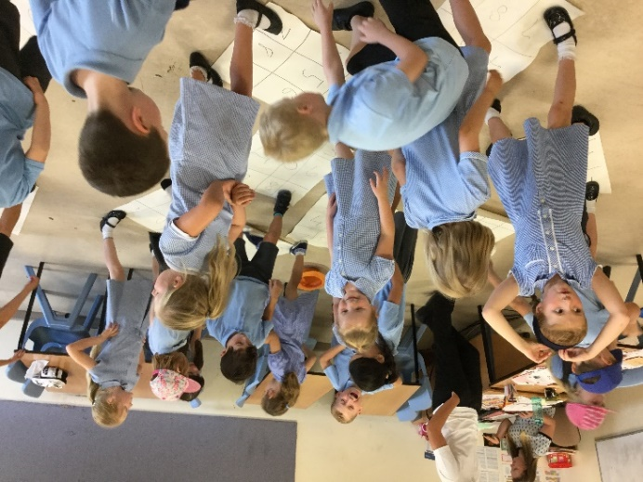

Year 3&4 – They started Community Day with a music lesson playing a number of different instruments and singing. Then they performed ‘I just can’t wait to be king’. Next they decorated a mini Victoria sponge and completed a quiz in their cookery session. The afternoon started with a drama performance by Chauncy children and the children got to have a go at acting. A very enjoyable day ended with arts and crafts.

Year 5&6 – They started with mini Olympics on the field including dodge ball and an obstacle course. Next they had a really fun session learning Japanese, learning numbers, colours and how to direct someone which included fun games. After lunch they had a numeracy class where the children solved maths problems to find clues and even played on the ‘number dance mat’ to music. To finish they learned about forensic science and how different techniques helped the police to solve crimes. All the year 5&6 were beautifully behaved and a pleasure to spend the day with Mrs Tarbuck.

Apologies, in the last newsletter ‘100% Attendance’ was missing from the ‘Excellent Award ….

Excellent Award 100% Attendance
Libby Adams, Kian Bartlett, Finley Francis, Kieran Francis, Fletcher Hart, Chloe Haworth, Henry Haworth
William Haworth, Mason King, Alfie Pearce & Chloe Pearce. Congratulations all of you!

Attendance Awards
The Thundridge School attendance certificates that are awarded for attendance per term will be awarded the first week of the autumn term due today being the last day to check the attendance. Although we do know our Year 6 leavers Kieran Francis and Maisy Robinson were awarded the ‘Gold Award for 100% attendance and Bronze award was awarded to Jemima Bright, Harrison MacLeod & Sophie Ward for the final term of the Summer 2018.

I hope you all have an enjoyable, restful, warm and sunny summer!

Kind regards

Miss Greatrex

