THUNDRIDGE CHURCH OF ENGLAND

PRIMARY SCHOOL NEWSLETTER

AUTUMN WEEKS 4-6

THURSDAY 11TH OCTOBER 2018
WHAT’S GOING ON NEXT WEEK
Monday 15th October | Netball/Football Club–Collect 4.00
Tuesday 16th October | FS Curriculum Meeting – 9.00  Library – Years 1&2  Choir – Years 3-6 – Collect 4.00
Wednesday 17th October | French – Years 1-6- Collect 4.00
Thursday 18th October | Netball & Football Matches at home against Stapleford School
Friday 19th October | Library – Juniors  Friends Monster Ball School Disco 5.00 – 7.15
WHAT’S ON LATER
Monday 22nd October | Parent Consultation Evening  3.30-6.50  No Netball/Football Club
Tuesday 23rd October | Library – Years 1&2  No Choir
Wednesday 24th October | Parent Consultation Evening  3.30-5.20
Friday 26th October | Library – Juniors
29th October–2nd November | HALF TERM
Thursday 8th November | Year 3&4 Sportshall Festival
Monday 12th November | Flu Vaccine – Whole School – 12.30  WWI Service 2.45pm – St Mary’s Church - Everyone welcome
Wednesday 14th November | Choir Rehearsal-Sacred Heart-am
Monday 26th November | Year 1&2 Dance Workshop
Friday 30th November | Occasional Day – School Closed
Sunday 2nd December | Thundridge Friends Christmas Fayre -Village Hall 10.30-1.30
Wednesday 5th December | Pantomime – Years R-Year 6 – pm  Choir Rehearsal am and Christmas Concert 7.00pm
Wednesday 12th December | Foundation Stage and KS1 Christmas Performance – 10.00am
Thursday 13th December | KS2 Christmas Performance –  2.30 & 6.30
Wednesday 19th December | School Christmas Lunch
Friday 21st December | Last day of term – Finish 1.30
Monday 7th January | Inset Day
Tuesday 8th Januray | First day of Spring Term
Birthdays….
Thomas Smyth – 13th October
Betsy Baker – 15th October
Billy Baker – 15th October
Samuel Field – 18th October
Fearne Watson – 18th October
Milan Cope – 20th October

Awards Friday 21st September 2018
Head Teacher Award
Harrison Campbell for always trying to extend and improve his learning, both at school and at home.

Class Awards:

Foundation Stage – Dana West-Harris

Year 1&2 – Miles Collins & Mortimer Davy

Year 3&4 – Charlotte Chamberlain, Isla Grierson,
Isabella Le Grys & Dita Purser

Year 5&6 – Ruby Robinson & Callum Wareham

Lunch Staff Awards:
Arley Fenton, Chloe Haworth, William Haworth & Dita Purser

Well done all of you!

Awards Friday 28th September 2018
Head Teacher Award
Preston Tyler for amazing effort in his maths work and tying so hard with his speaking.

Class Awards:

Foundation Stage – Ralph Bradley-May

Year 1&2 – Ava Field & George Harbour

Year 3&4 – Bethany Ward & Fearn Watson

Year 5&6 – George Hartfield & Leo Homer

Lunch Staff Awards:
Archie Chamberlain, Charlotte Chamberlain,
Amy Johnson & Zoe Thomas

Well done all of you!

Awards Friday 5th October 2018
Head Teacher Award
Mollie-Sampford-Curry for effort, application and enthusiasm in Spelling Punctuation and Grammar (SPAG). Rising to the challenge!

Class Awards:

Foundation Stage – Archie Chamberlain

Year 1&2 – Neve Chappell & Marina Koumi

Year 3&4 – Stanely Campbell & Joseph Fox

Year 5&6 – Kian Bartlett & Elena Smyth

Lunch Staff Awards:
Betsy Baker, Leo Homer, Michael Mann &
George Stopps

Well done all of you!

Welcome to…
Ms Wilkes who has joined Thundridge School as Teaching Assistant in Year 3&4. We hope she enjoys her time here.

WWI

We are holding a WWI 100 years commemoration service at the church on Monday 12th November at 2.45pm. All family members are welcome to join us for this.

Foundation Stage - Curriculum Meeting
A reminder the Foundation Stage meeting will take place on Tuesday 16th October at 9.00am, all Foundation Stage parents are welcome to attend.

A reminder to nursery parents/carers to collect their children at 11.50am please.

Home/School Agreement and Report Slips

We are still waiting on some signed Home/School Agreements and reports slips (duplicate copies have been sent home with your children). Please send these in by the end of the week.

Harvest Festival
On 28th September the school held their Harvest Festival at St Mary’s Church. It was a lovely service again this year, extremely well attended by families and I hope you all really enjoyed it. The children certainly enjoyed sharing their work and singing with their usual enthusiasm.

Thank you very much to Sara McCrea who led the Service, the local residents who provided cakes, tea and coffee and the staff and children themselves who were busy baking a variety of food during the week.

Year 1&s Agility Festival

On 1st October Year 1&2 class had great fun at the Agility Festival at Wodson Park. Throwing, jumping, obstacle courses, skipping and balancing were some of the skills they had the opportunity to practice. The children were able to work in teams and encouraged each other to achieve their best. The smiles on the children's faces showed how much they enjoyed the event! Thank you to the parents for transporting to the event.

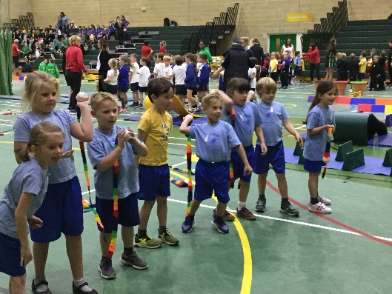

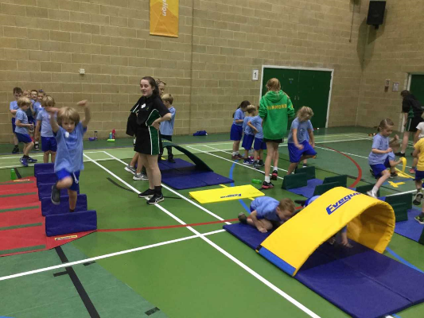

Year 3&4 PE Development Day
On 4th October Year 3&4 class attended a PE Development Day at Wodson Park. Here the children were given an opportunity to learn and try out 4 new sports. First, they learnt how to hold a bow and load an arrow, then enjoyed shooting at the targets. They then learnt how to follow an orienteering map. After this they learnt how to throw and catch an Ultimate Frisbee leading to an Ultimate Frisbee match. The last activity of the day was cheerleading. Here the children did some gym exercises to music and then worked together to build human towers and ‘fly’.

The children had an enjoyable day and learnt lots of new skills. Thank you to all the parents who helped transport the children.

Rounders Club

Rounders has now finished. Thank you to Mrs Shirley for running the club with the help of Miss Chapps. They have agreed to run it again in the Summer term next year.

Art Club
As you will have seen from the email and flyers, we are stating an art club after school on the Wednesday after half term. Please sign up on online.

Secondary Schools
A reminder applications for secondary schools is by 31st October 2018. There is still time to visit two of the Secondary Schools….

Presdales School
Thursday 18th October – 5.30-8.30
Head Teacher Talks at 6.00, 7.00 & 8.00

Richard Hale School
Monday 15th October 6.00-8.30
Head Teacher Talk at 8.00
Tuesday 16th October 4.00-6.30
Head Teacher Talk at 6.00

Volunteers Required – Don’t be shy!
The Year 3&4 class are still in need of volunteers to listen to the children read on a Wednesday and Thursday mornings from 9.10-9.40am. The Foundation Stage class require volunteer helpers in the mornings. If you can help please let Zoe know. Remember we welcome parent, grandparents, aunts, uncles who are interested in helping the children and have the time available. The next generation needs you.

Second-Hand Uniform/Lost Property:
Can we please ask you that you name every piece of school uniform and PE kit. Lots of uniform is unnamed, if you have not named your child’s PE kit can you please ask your child to bring it home to name the kit. If you find other children’s clothes at home please return them to school reception.

As a reminder, secondhand uniform can be viewed and purchased at anytime, from 50p per item. Please see Zoe to view.

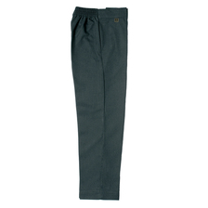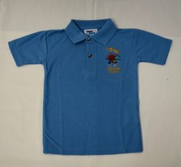

Friends of Thundridge School

What has been happening…….
We held a second-hand uniform sale a couple of weeks ago, which was really well received with lots of bargains purchased for our forever growing children.
We have finalised the 2018/19 Wish List with the Heads with the focus this year on English, Maths and French resources plus a redevelopment of the school website.

The “Thund”-Raising Thermometer competition launched!! As you will have seen from the flyers in your children’s book bags, we are hoping to raise £5,500 for the school. The thermometer competition is a fun, visual way for our children to get involved and keep track on how we are doing. All they need to do is design their own bright, colourful, fundraising thermometer poster using the Wish List items as inspiration for their drawing. Entries must be handed into Zoe ion Reception no later than Monday 15th October (on A3 paper) and the winner will be announced on Friday 26th October.

What is to come…….

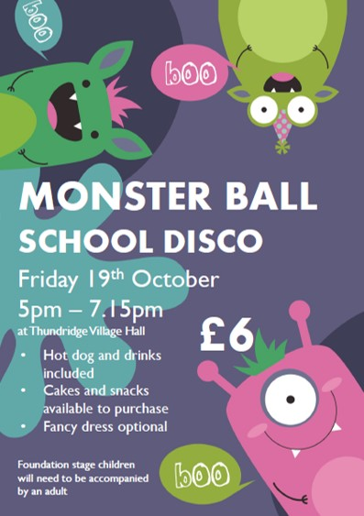 | The next School Disco will be on Friday 19th October 5.00pm-7.15pm and this time round we are having a Monster Ball! Think spooky, slimy, hairy and scary! Here is our fab flyer, which you should have received in your children’s book bags last week.
We will be starting the Christmas Card design process in the next few weeks (I know it seems a little early but we need these done in time for print turn around). These will be done in school by your children so will be a lovely surprise when you receive the proof versions later in the year. | 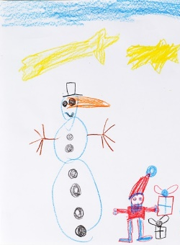
 | Tuck Shops and non-uniform days are in the making so we will let you know the dates when we have them.
We have a date for the Christmas Fayre!! It will take place on Sunday 2nd December at the Village Hall 10.30am – 1.30pm, we are still finalising the details but it looks to be a great, fun, family event.

We need you!!

Monster Ball School Disco – Any helpers on the day for setup, manning stalls during the disco and/or tidying away would be amazing. We also need the usual cake donations, either drop off with Zoe on the morning of the disco or give to Mollie/Emma/Jenny at the start of the disco.

Christmas Fayre – We need prizes sourced for our Grand Prize Draw so if you have any contacts and can get something donated that would be great. Likewise, if you are able to get any sponsorship from your company or local businesses to help us pay for the production of things like Grand Prize draw tickets, Advertising banners etc… We’re also looking for local stall holders so again, if you know anyone that would like to have a stall at our fayre then please let us know asap.

If you can help with any of the above please feel free to grab Mollie, Emma or Jenny at the school gates for a chat or drop Zoe an email and she’ll forward it on to us.

Thanks for all your help and support as always.

The Friends Committee

