THUNDRIDGE CHURCH OF ENGLAND

PRIMARY SCHOOL NEWSLETTER

AUTUMN WEEKS 7-8

FRIDAY 26 OCTOBER 2018

WHAT’S GOING ON NEXT TERM
29th October – 2nd November | HALF TERM
Monday 5th November | Netball/Football Club–Collect 4.00
Tuesday 6th November | Library – Years 1&2  Choir – Years 3-6 – Collect 4.00
Wednesday 7th November | French – Years 1-6- Collect 4.00
Thursday 8th November | Year 3&4 Sportshall Festival  Art & Craft Club – Collect 4.15
Friday 9th November | Library – Juniors
WHAT’S ON LATER
Monday 12th November | Flu Vaccine–Years R-Year 5 – 12.30  WWI Service 2.45pm – St Mary’s Church - Everyone welcome  Netball/Football Club Collect 4.00
Tuesday 13th November | Library – Years 1&2  Choir - Years 3-6 – Collect 4.00
Wednesday 14th November | Choir Rehearsal-Sacred Heart-am
Thursday 15th November | Art & Craft Club – Collect 4.15
Friday 16th November | Children in Need Day  Library – Juniors
Wednesday 21st November | School Individual & Sibling Photographs
Monday 26th November | Year 1&2 Dance Workshop
Friday 30th November | Occasional Day – School Closed
Sunday 2nd December | Thundridge Friends Christmas Fayre -Village Hall 10.30-1.30
Wednesday 5th December | Pantomime – Years R-Year 6 – pm
Thursday 6th December | Choir Rehearsal am & Christmas Concert 7.00pm-All Saints Church
Wednesday 12th December | Foundation Stage and KS1 Christmas Performance – 10.00am
Thursday 13th December | KS2 Christmas Performance –  2.30 & 6.30
Wednesday 19th December | School Christmas Lunch
Friday 21st December | Last day of term – Finish 1.30
Monday 7th January | Inset Day
Tuesday 8th January | First day of Spring Term
Birthdays…
Kian Bartlett – 21st October
Miss Greatrex – 7th November
Leo Homer – 12th November
Lily Mann – 13th November
George Harbour – 16th November
Mr Clark – 18th November
Isabelle Warner – 19th November

Awards Friday 19th October 2018

Head Teacher Award
Isabella Le Grys for always making the right choice and being an excellent role model for the class.

Class Awards:

Foundation Stage – Leona Fox

Year 1&2 - Lily-May Hewitt-Makin & Ioanna Koumi

Year 3&4 - Zac Earl & Olly Judge

Year 5&6 – Jake Sawdy, Alex Warner & Isabella Warner

Lunch Staff Awards:
Chloe Haworth, Isabella Le Grys, Freddie Shirley & Preston Tyler

Well done all of you!

Awards Friday 26th October 2018
Head Teacher Award
Maisie Wright for outstanding effort in phonics as a Reception child joinin year 1&2 class.

Mrs Tarbuck’s Awards
Lily Mann for completing Plus One Maths book
and
Libby and Rose Adams for completing the Power of 2 maths book.

Class Awards:

Year 1&2 – Bradley King & Henry Wilson

Year 3&4 – Milan Cope & Henry Haworth

Year 5&6 – Libby Adams & Olivia MacLeod

Lunch Staff Awards:
Ioanna Koumi, Marina Koumi & Jake Ronan

Well done all of you!

Junior Dragons

Max Thomas returned to Thundridge School to receive his trophy for 'the outstanding contribution' award following the Junior Dragons Competition last year when he was in Year 6. This was a great achievement as the competition involved a number of teams from a number of East Herts primary schools and therefore Max was the stand out contributor from all of the schools that took part. A further trophy was also received by Thundridge for the best poster competition.

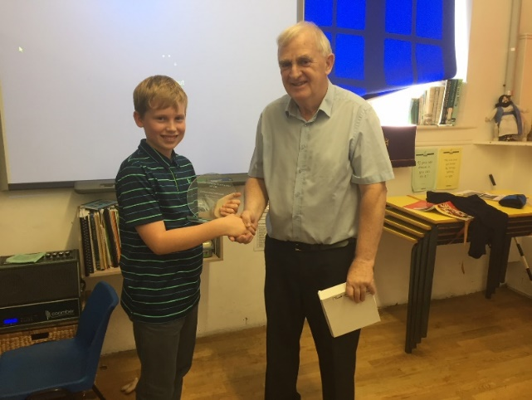

Sports Ambassadors
The new Sports Ambassadors for this year are Roxy Kripp, Chloe Pearce, Jake Ronan & Isabella Warner. They will receive their training on 7th November. They will then join our current Ambassadors, George Hartfield and Rachel Grierson in helping and leading the sporting activities throughout the school

‘RESPECT’
We needed to refresh our vision and our aims as a school. Our new Acronym to represent these was RESPECT (input from staff, children and parents).

We want our children to be and to feel:

R - Resilient
E - Enthusiastic
S - Safe
P - Positive
E - Empathetic
C - Creative
T – Thankful

After half term, these new aims will be on display in school and will go onto our website.

Art & Craft Club
Mrs Le Grys has kindly volunteered to run an Arts and Crafts Club for Year 1-6 on Thursdays after school starting after half term. The first group is full but if your child would like to join the next group after Christmas please let Zoe know.

Second-Hand Uniform/Lost Property:
If you are not sure that all uniform is named, please ask your child to bring it home to name. Please check your child’s uniform when washing to ensure you have the correct uniform as children do sometimes take home another child’s jumper, etc. home.

Secondhand uniform can be viewed and purchased at anytime, 50p per item. Please see Zoe to view.

Waste Management
On 22nd October Monika Koziara, the Education Officer from Amey Waste Management Company came to talk to the children about recycling. Following a whole school assembly, the KS2 children took part in workshops. Here they learnt which recycling container items of everyday rubbish can go in.

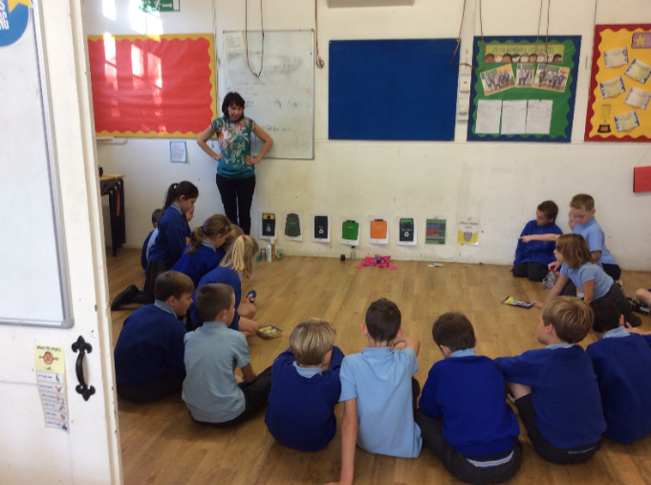

Volunteers Required – Do not be shy!
The Year 3&4 class are still in need of volunteers to listen to the children read on a Wednesday and Thursday morning from 9.10-9.30am. The Foundation Stage class require volunteer helpers in the mornings. If you can help please let Zoe know. Remember we welcome parents, grandparents, aunts, uncles who are interested in helping the children and have the time available. The next generation needs you!

Netball & Football Fixtures
The Thundridge school football team are unbeaten so far this term following their opening two fixtures.
Their first game against Hertford St Andrews School on 11th October ended in a hard-earned draw. Despite having most of the possession, the team failed to capitalise on the chances they created and went behind at the end of the first half. However, the team kept their heads up and managed to secure a late equaliser. Charlie Millhouse finished off a quick counter attack with a neat finish following a lovely through ball from Kian Bartlett who was making his debut for the school side. Other debutants for this opening game were Lewis Greatrex, Arthur Wilson. Jake Ronan and Billy Cyl who all had impressive starts.

Next up was a match against Stapleford School. The team had learnt lots from their opening fixture and moved the ball around with more purpose. Solid midfield play from Jack Field, Alfie Pearce and Alex Warner helped free up Chloe Pearce and Kian on the wings who once again provided great support to Charlie up front. Goals from Kian, Charlie and Arthur helped secure a comfortable 4-2 win for the boys (and girl) in blue.

Unfortunately, we did not have enough players for the netball match against Hertford St Andrew School.

The netball team played very well in their first match of the term. There was some great passing and excellent shooting, resulting in a 14-8 win to Thundridge School.

The last fixture this term will take place on 8th November and commence again on 7th February.

WWI
This is on show to commemorate WWI at Hertford Castle if you wish to take your children to see it. All made from knitted poppies!

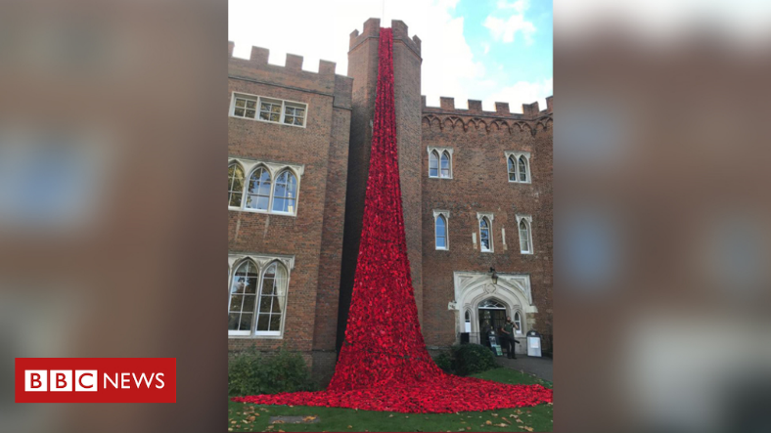

Reminders….

Lunch
There is a new lunch menu after half term, please bring your child’s lunch choice sheet in the first day of term.

Nasal Flu Immunisation
All forms to be returned from children in Reception to Year 5, even if you do not want your child to have the immunisation. To be sent in on the first day of term please. The nurses will be on Monday 12th November.

Have a good half term everyone
Miss Greatrex

Friends of Thundridge School

What’s been happening…….

With the help of our fund raising efforts the school have recently been able to purchase some fab new musical instruments and all the children are really enjoying using these in their music lessons.
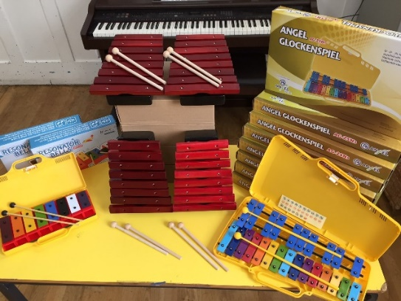
We are very pleased to announce the winners of the “Thund”-Raising Thermometer competition! Well done to all the children that took part, they all made amazing pictures and it was difficult for the judges to pick a winner. We asked the teachers to pick a winner from each class and then we had Anne, the owner of Kids Connection in Hertford, come in and pick the overall winner. Anne has also very kindly offered to sponsor the production of the thermometer billboard, so big thanks to Kids Connection for all their support. So, without further ado, winning a voucher each for ‘Jump City’, the class winners are Maisie Wright (Reception), William Haworth (Year 1), Jack Turner (Year 2), Isla Grierson (Year 3), Macy Cyl (Year 4), Elena Smyth (Year 5), Roxy Kripp (Year 6). Drum roll please…….. the overall winner, who will see their beautiful thermometer picture on the side of the school building as well as winning a cash prize is…….. ISLA GRIERSON!
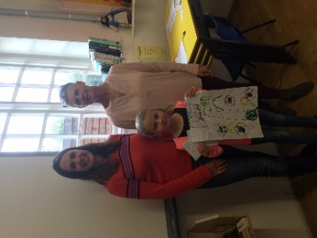

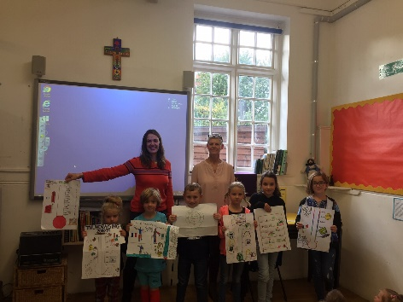

We had great fun at our Monster Ball School Disco held at The Village Hall with children and adults donning their best Monster fancy dress. We had scary monster cupcakes, gooey spooky slime making, monstrous face painting and much much more!
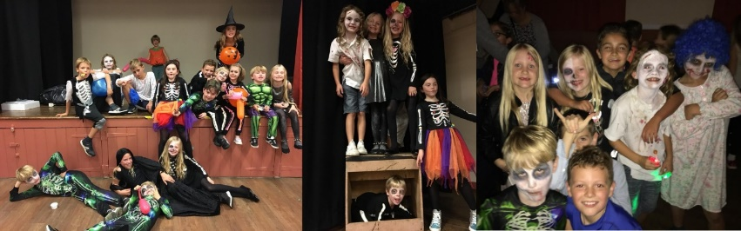
We hope you and the children all enjoyed the non-uniform day today and the tuck shop that was available after school, it’s always a nice way to finish the half term.

What’s to come…….

We’re just in the process of organising the parent’s night out for Christmas. Its lovely for us all to get together and share a glass of bubbles and a giggle, away from the school gates! We’re thinking about doing this nearer the end of November to avoid the Christmas rush so we’ll let you know the date ASAP.
Preparation for the Christmas Fayre on Sunday 2nd December is well underway, the hall is booked and all the ideas for making this a great event are coming together nicely.
We need you!!

Christmas Fayre – We still need prizes sourced for our Grand Prize Draw so if you have any contacts and can get something donated that would be great. Likewise, if you are able to get any sponsorship from your company or local businesses to help us pay for the production of things like Grand Prize draw tickets, Advertising banners etc… We’re also looking for local stall holders so again, if you know anyone that would like to have a stall at our fayre then please let us know asap.

If you can help with any of the above, please feel free to grab Mollie, Emma or Jenny at the school gates for a chat or drop Zoe an email and she will forward it on to us.
Thanks for all your help and support
The Friends of Thundridge

