THUNDRIDGE CHURCH OF ENGLAND

PRIMARY SCHOOL NEWSLETTER

AUTUMN WEEKS 9-10

TUESDAY 20TH NOVEMBER 2018

WHAT’S GOING ON THIS WEEK
Monday 19th November | No Football Club due to a match at Larkspur School  Netball Club - Collect 4.00
Tuesday 20th November | Library – Year 1&2 & Year 5&6  Choir – Years 3-6 – Collect 4.00
Wednesday 21st November | School Individual & Sibling Photographs
Thursday 22nd November | Art & Craft Club – Collect 4.15
Friday 23rd November | Library – Year 3&4
WHAT’S ON LATER
Monday 26th November | Year 1&2 Dance Workshop  NO Netball/Football Club
Tuesday 27th November | Library – Years 1&2 & Year 5&6  Choir - Years 3-6 – Collect 4.00
Thursday 29th November | Art & Craft Club – Collect 4.15
Friday 30th November | Occasional Day – School Closed
Sunday 2nd December | Thundridge Friends Christmas Fayre -Village Hall 10.30-1.30
Wednesday 5th December | Pantomime –  Years R - Year 6 – 1.30-4.00
Thursday 6th December | Choir Rehearsal am & Christmas Concert 7.00pm-All Saints Church
Wednesday 12th December | Foundation Stage and KS1 Christmas Performance – 10.00am
Thursday 13th December | KS2 Christmas Performance –  2.30 & 6.30
Wednesday 19th December | School Christmas Lunch
Friday 21st December | Christmas Carol Service – 9.15 – St Mary’s Church  Last day of term – Finish 1.30
Monday 7th January | Inset Day
Tuesday 8th January | First day of Spring Term

Birthdays…

Miss Wilkes – 16th November
Isabella Warner – 19th November
Zac Earl – 23rd November
Jude Chappell – 24th November
Archie Chamberlain – 1st December
Henry Wilson – 3rd December
Charlie Millhouse – 5th December

Awards Friday 9th November 2018

Head Teacher Award
Arley Fenton for applying his learning in phonics effectively in his independent work.

Class Awards:

Foundation Stage – Archie Chamberlain

Year 1&2 – Phoebe Le Grys & Sydney Marshall

Year 3&4 – Fletcher Hart & Olly Judge

Year 5&6 – Roxy Kripp & Zoë Thomas

Lunch Staff Awards:
Martha Stopps & Fearne Watson

Well done all of you!

Awards Friday 16th November 2018

Head Teacher Awards
Michael Mann for wanting to and having a try in writing – applying phonics sounds

&

Dita Purser for always giving 100% effort at school and extending her learning at home, which she regularly shares with the class.

Mrs Tarbuck’s Award
Mason King for a great piece of writing using nouns, verbs and adjectives.

Class Awards:

Foundation Stage – Dana Harris-West

Year 1&2 – Ava Field & Pheobe Le Grys

Year 3&4 – Harrison Campbell & Finley Francis

Year 5&6 – Ruby Stern & Martha Stopps

Lunch Staff Awards:
Ralph Bradley-May, Joseph Fox & Francesc Thomas

Well done all of you!

Remembrance Service
On Monday 12th November 2018 Thundridge School had a Remembrance Service at the church to mark 100 years of the end of the 1st World War.

Clive Brigden of the Parish Council, laid a wreath and said a few words explaining the significance of this act of commemoration. Once inside the church the children paid tribute to our fallen soldiers with handmade clay poppies from Reception and Nursery,
symbolic poems from Year 5&6, moving songs from Year 1&2 and some thoughtful prayers from Year 3&4.

Year 1&2 made a book of prayers, which is on display at the back of the church. The Thundridge Choir sang an emotional song of hope called ‘Crying Out For Love’. Donations were made from the children and congregation to the Poppy Appeal.

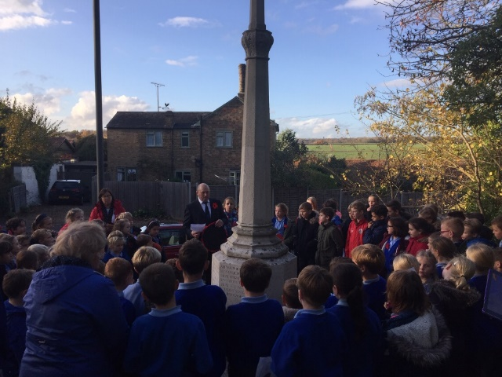

Sportshall Festival
On Thursday 8th November the Year 3&4 pupils all went to Wodson Park to develop their skills in sportshall activities. These included throwing techniques, Javelin, speed bounce, balance, high steps and sprint movements. The morning finished with a ‘Pudsey Bear’ skipping challenge between all the schools there with Milan and Oliver coming 1st and 2nd respectively. They were both awarded a Pudsey wnistband. All the children now have a personal challenge to beat their own score. The ambassadors will also be running this and other personal challenges
throughout the year for all children to take part in.

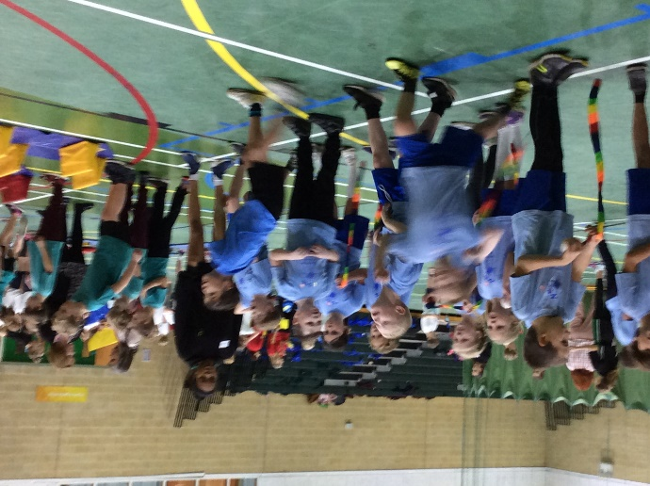

Tag Rugby Festival
On Thursday 15th November 10 children from Year 3&4 class and 10 from Year 5&6 entered the Tag Rugby Festival at Hertford Rugby Club. This was organised by Saracens Rugby Sports Foundation. Year 3&4 played Hertford St Andrews, Puller Memorial and Widford schools twice throughout the morning and performed very well winning all their matches except 1. Year 5&6 had equal success against Puller Memorial School, Stapleford School, Hertford St Andrew School and Tonwell School losing just 1 match.

Thank you very much to Mrs Judge and Mrs Wilson for their help supervising some children.

Thank you also to all parents who helped transport the children back to school. We like to offer, as many opportunities as we can for the children but without this support this would not be possible.

Year 5&6 Team
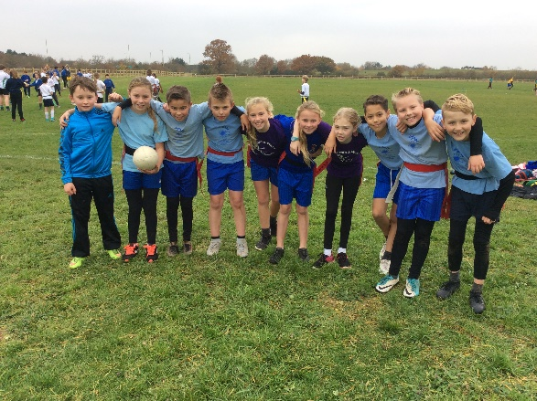

Year 3&4 Team
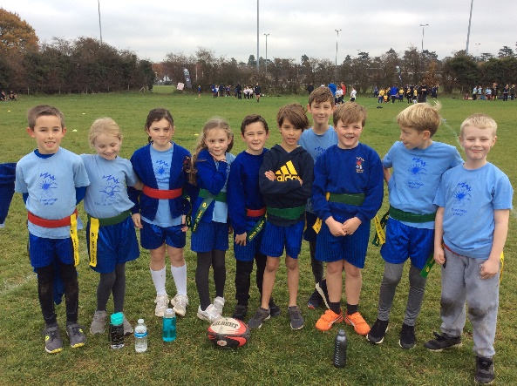

Christmas Performances
The KS2 children will be bringing home costume letters in the next few days. If any parents are available to help with costumes, scenery, props and on the day, face painting, please let Zoe or Mrs Frost know, thank you.

Children in Need
On Friday 16th November the children raised money for Children In Need by paying to come to school dressed in their pyjamas accompanied by their cuddly toy. Money was also raised through purchasing ‘Pudsey’ wristbands and badges. Staff also took part in the children in need duck race. £182.00 was raised. Thank you to everyone for your kind donations.
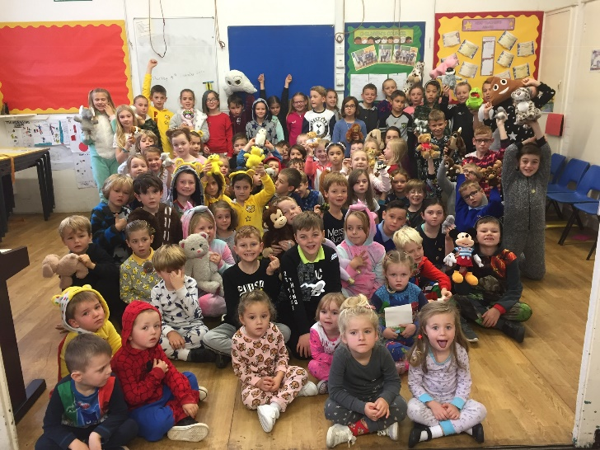

Netball & Football Fixtures
The last fixture this term took place on 8th November against Hunsdon School. This resulted in our first loss for the football team despite the outstanding team spirit and perseverance. The netball match finished on a 6-6 draw.

On Monday, the football team played a friendly match away against Larkspur School. Thundridge School won 2-1. Unfortunately, Larkspur School do not have a netball team.

Well done everyone who took part in the practices and fixtures this term.

Netball and football clubs have now finished until the new year due to the dark afternoons. Thank you to Mrs Frost and Mr Higgins for their hard work so far. Fixtures will start again on 7th February.

Kind regards
Miss Greatrex

Friends of Thundridge School
What has been happening…….
We held our AGM last week, and as most of the key decisions had already been made via smaller meetings and emails this session focused on formalising the wish list and signing members on and off the committee. We are sad to say goodbye to some of our members but we are very pleased to welcome some new faces. Thank you so much for all your efforts, old and new!

It was great to see so many order forms come in for the children’s Christmas cards, we will let you know when your orders arrive.

What’s to come…….
The parent’s night out for Christmas will be on Thursday 29th November (the night before our school inset day) We decided to go with the end of November to avoid the Christmas madness! The venue will be a bar in Ware so we’ll let you know where to meet and what time to be there. Everyone welcome, Mums, Dads, Grandparents, childminders etc.. Let’s enjoy some festive bubbles and have some time together away from the school gates!
Lots of preparation happening for the Christmas Fayre on Sunday 2nd December, we need lots of help so see more info below.

We need you!!
This year’s Christmas Fayre – on Sunday 2nd December - is fast approaching and the Friends Committee need your help!

Cakes & Mince Pies
As this year’s Fayre falls on the weekend of an Inset Day (30th November) on Sunday (2nd December), we are only able to take any shop bought donations by Thursday 29th November. For anything homemade, please bring on either Saturday night at the Village Hall (where we will be setting up) or on Sunday morning (specific times to follow).

Christmas Decorations, Fairy Lights, Boxes
We are in need of any Christmas decorations/lighting you no longer need or indeed anything you just wish to donate on the day for us to use to decorate the hall. Anything you could lend or give to us will be greatly appreciated. Please give to any committee member or Zoe asap.

Also, any empty boxes (ideally wrapped but not essential) are needed to help decorate Santa’s Grotto and the Village Hall. Please give to either Emma, Jenny or Zoe asap.

Filled Jars
This is a request to simply to fill a glass jar (of any size) with anything you like, sweets, chocolates or small toys – so that we can sell them at the Christmas Fayre. We have some spare empty jars in School Reception for you to take if you wish.

If you or your children wish to go one step further, please do feel free decorate them with anything Christmassy, you could stick, paint, draw or colour shiny snowflakes, smart Santa hats, sparkling Christmas trees, cheeky Robins - whatever you want.

Please bring to school and put it/them in the box in classrooms by Thursday 29th November.

“Re-Gift” Tombola
For one of the Friends’ stalls this year, we have decided to do a “Re-Gift” Tombola. We all have those unwanted gifts that we intended to re-gift but have never got around to doing it, or simply forgotten!!! Well, we are more than happy to take them off your hands. Please give to Zoe no later than Thursday 29th November.

Decorated Plate Competition
We will be sending home a small paper plate with the children for them to decorate. These will be used to decorate the hall with Santa judging the most Christmassy masterpiece.

And Finally … Grand Draw Tickets
As in previous years, we will be sending home 5 books of tickets per family to sell to friends, family & neighbours! Please make every effort to sell as many as you can (and if you need more, just ask Zoe). We have some fantastic prizes and made over £900.00 on this last year, so let us see if we can hit or exceed the £1000.00 mark!

We appreciate this is a busy time of the year, but any donations that can be made are greatly appreciated. As you know, all monies raised go towards funding this year’s wish list from the school to help enrich all of our children’s learning.

Thanks for all your help and support
Friends of Thundridge School

