THUNDRIDGE CHURCH OF ENGLAND

PRIMARY SCHOOL NEWSLETTER

AUTUMN WEEKS 11-13

WEDNESDAY 12TH DECEMBER 2018

WHAT’S GOING ON THIS WEEK
Thursday 13th December | KS2 Christmas Performance –  2.00 & 6.30  Art & Craft Club – Collect 4.15
Friday 15th December | Library – Year 3&4
WHAT’S ON LATER
Monday 17th December | Year 1&2 Christmas Party - pm
Tuesday 18th December | EYFS Christmas Party - am  Library – Years 1&2 & Year 5&6  NO CHOIR
Wednesday 19th December | School Christmas Lunch  Wear a Christmas Jumper  Donations to Save The Children  Children’s Council Christmas event from 2.00pm. Everyone welcome
Thursday 20th December | Juniors Christmas Party – pm  Art & Craft Club – Collect 4.15
Friday 21st December | Christmas Carol Service – 9.15 – St Mary’s Church  Last day of term – Finish 1.30
Monday 7th January | Inset Day
Tuesday 8th January | First day of Spring Term

Birthdays…
Chloe Haworth - 8th December
Jake Sawdy - 8th December

Awards Friday 23rd November 2018

Head Teacher Award

Ava Field for outstanding leadership skill by supporting and encouraging others constantly.

Class Awards:

Foundation Stage – Jude Chappell

Year 1&2 – Betsy Baker & Amy Johnson

Year 3&4 – Sam Field & LilyMann

Year 5&6 – Kian Bartlett & Chloe Pearce

Lunch Staff Awards - Phoebe Le Grys, Mollie Sampford & Preston Tyler
Well done all of you!

Awards Friday 7th December 2018

Head Teacher Awards
The amazing Thundridge Choir for their huge efforts , commitment and fantastic singing at the Hertford & Ware School Choir Concert. You were fabulous!

Class Awards:

Foundation Stage – Archie Chamberlain

Year 1&2 - Llily-May Hewitt-Makin & Haydan Mann

Year 3&4 - Oliver Chamberlain & Harry March

Year 5&6 - Jack Field & Chloe Haworth

Lunch Staff Awards: Harrison Campbell, Olly Judge & Charlie Millhouse
Well done all of you!

Welcome
Welcome to Ruby Stearn who has joined our Year 6 group. We hope she enjoys her time with us.

Goodbye to Mrs Stephens
It is with great sadness I need to inform you that Mrs Stephens will be leaving at the end of this term. Mrs Stephens has been an extremely valued, effective and caring member of our staff team and will be greatly missed. She too, is very sorry to be going and has thoroughly enjoyed being at Thundridge School but has decided to move back into a management role to utilise her previous experience.

She hopes to follow her dream of teaching in the future and we may well be seeing her again.

Welcome to Mrs Le Grys
Welcome to Mrs Le Grys who will be taking on the role of Year 1&2 Teaching Assistant from Monday 7th January 2019. Mrs Le Grys has spent considerable time working in the school already on a voluntary basis and was part of our interview process for the Year 3&4 position earlier this year. We welcome her to our team.

Dance Workshop

On Monday 26th November Year 1&2 enjoyed a dance and drama morning with Drama4ALL. Our teacher Jensen was brilliant and we had lots of fun.

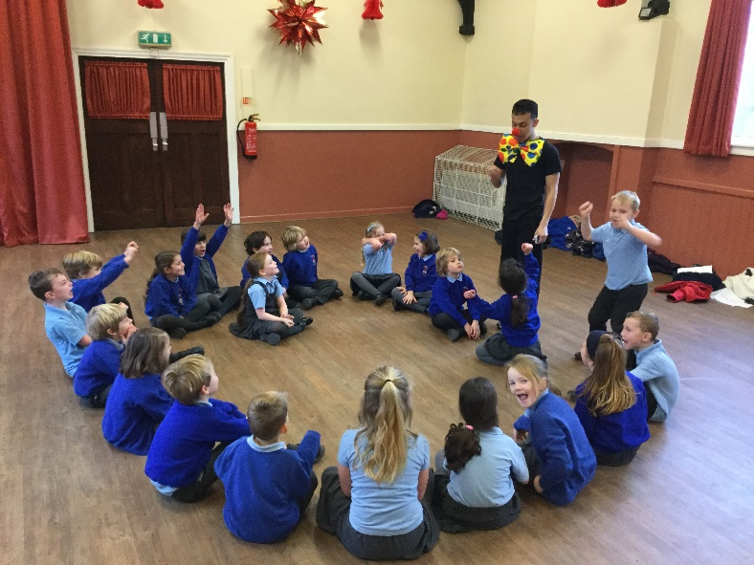

Pantomime
On Wednesday 5th December the children from Reception to Year 6 plus staff all enjoyed a lovely afternoon at Herford Theatre to see Pinochicco. Oh yes we did!!!
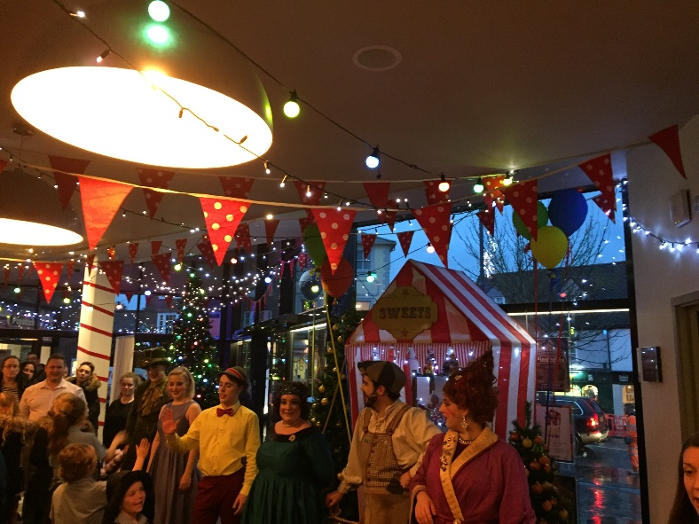

Choir
On Thursday 6th December our fabulous Choir joined the other primary school choirs from Hertford and Ware for an evening Christmas performance at All Saints Church in Hertford. The children were an absolute credit to the school. They sang beautifully and performed their own piece ‘The Star Express’ faultlessly.

They are the small choir with the big voice!
A huge thank you must also go to Mrs Gaze for the tremendous effort she puts into running and organising Choir and getting them to such a high standard.

Thank you to the parents for transporting the children to and from rehearsals. Mrs Gaze would also like to thank the parents for their support with practicing the songs.

Free!
Due to a refurbishment in two classrooms we have tables and chairs to give away. Please collect after Wednesday at 2.00pm but before Friday 21st December, first come first served basis. Please call the school if you would like to reserve any 01920 462642 by Tuesday 18th December.

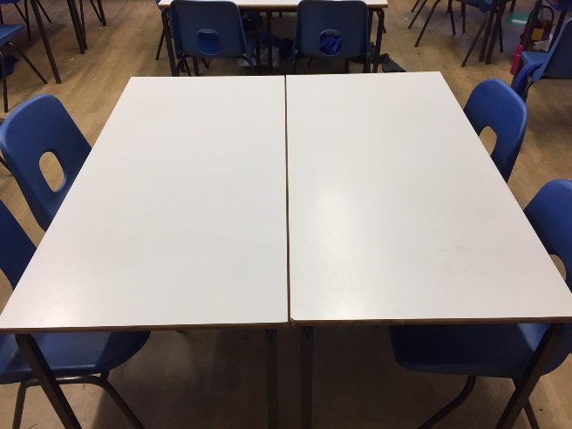

Kind regards
Miss Greatrex

Friends of Thundridge School

What’s been happening…….
We hosted a great Parents Night Out at The Mixer in Ware, there were cocktails, 80’s music and lots of laughter which was topped off by the discovery of the all night bakery down the high street!
Christmas Cards were all designed by the children in school and sold in plenty of time for writing and distribution to Friends and Families. Thank you to Shelley Chappell for taking on “Project Christmas Cards”! Not only did she do a fabulous job with project co-ordination, she also more than doubled the fundraising result this year too!
The Christmas Fayre was an amazing success! We received some wonderful comments from stallholders, local residents, and families – saying what a great Fayre it was; how happy, warm and welcoming the atmosphere was and how we were all very clearly a wonderful tight-knit community to be able to pull off the event in the way that we did! We’re still tallying up the pennies so will let you know the financial outcome soon but in the meantime, we’d just like to say another massive thank you to each and every one of you that helped in one way or another.
The amount of help given has truly been overwhelming, not just from Committee members but also from other wonderful donors and volunteers (parents, pupils, grandparents, aunties, staff and ex-pupils).

In an effort to send a thank you letter out as soon as possible after the Fayre, regrettably several people who should have been publicly thanked were missed out and Mollie sincerely apologises for this oversight and sends her utmost thanks and recognition for their contributions (for Christmas as well as other events this term) and hopes that all can be forgiven if any offence was caused.
In the hope that we have captured below everyone who has given their time, money or resources to the event, we would like to give some special thanks to the following people, without whose support, the event wouldn’t have been the fundraising success that it was:
- Everyone – for decorated jars, plates, refreshments supplies, tombola donations, decorations etc.
- Gerald Hart – for kindly and generously donating all the delicious sausages and bacon for the Christmas Fayre, and for the Monster Ball too!
- Everyone who helped transform the Village Hall into a Christmas wonderland on Saturday evening and Sunday morning
- Luke Davy – for taking responsibility for the BBQ and donating the gas, the bread rolls and the condiments, not to mention the hand-peeled onions!
- A Grandad – for providing a wonderful selection of festive cakes and mince pies for our refreshments stalls, and also for his kind donations of hot dog rolls for all the disco’s we’ve held to date too!
- Sarah Sharp – for providing delicious mince pies courtesy of Tesco in Ware.
- Santa – for coming to the Fayre in support of our fundraising year after year
- Santa’s Grotto – David and Hannah Fox who created the beautiful Santa’s Grotto!
- Christine and Ashley – for making Christmas shaped biscuits and donating all the biscuit decorating supplies
- Jo & Tony Judge – for their help with printing and Village Hall hire costs.
- Cathy Davy @ The Feathers – for donating supplies for the refreshments/Santa’s grotto
- Emma – for all her background help in making the Christmas Fayre happen, and for making and donating (again this year) the fabulous “Guess the Weight of the Cake” cake.
- Zoe – for all the time and work she put into helping the Friends both in advance and on the day.
- Caroline, Ben and Sandra Purser – for donating prizes and supplies for the Yukky Dip
- Beverley Hodgson – for kindly arranging for her work, VolkerWessels UK, to sponsor the Xmas Fayre banner publicity, thanks to Billy and Macy’s Grandma.

- Nathalie - for donating lego for the lego/duplo stall (Mollie donated the duplo)
- Mrs Tarbuck – for support of the Friends in running her fabulous 50/50 “Lucky Stocking” game!
- The Choir, Mrs Gaze, Miss Greatrex & Mrs Tarbuck – for their beautiful festive carol-singing during the Fayre.
- Ex-pupils (Harrison, Evie, Maisie)- for coming along to help run stalls and Santa’s grotto
- All non-committee parents/grandparents - for helping out set up, help on the day & help clear away.
- Mel Baker– for donating decorations sourced from America!
- £75.00 donation from Sue & David May
- And of course everyone on the Friends Committee themselves for all they did to help too.
Finally, thank you to everyone who came along on Saturday to enjoy and support the event – which, this year, was all about fundraising to buy innovative and exciting curriculum resources for the pupils, as well as enhancing the children’s (and families’) enjoyment and experience of ‘Thundridge School’. For such a small school we really are privileged to have families who, time and time again, give their support for these fund raising event.
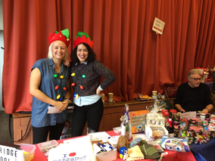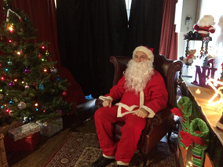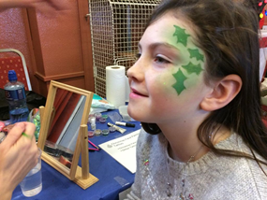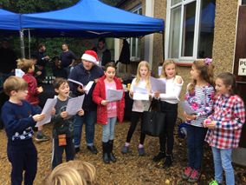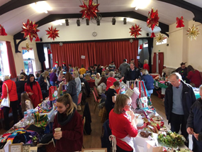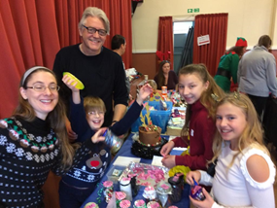

What’s been happening…..

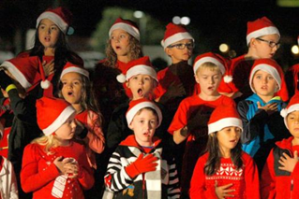 | Christmas Performances take place this Wednesday and Thursday and the Friends will be on hand selling mince pies, mulled wine and Grand Prize Draw tickets. The Grand Prize Draw will be announced at the beginning of the Juniors evening performance (6.15pm).
Thank you so much to Kirsty (Jack, Sam & Ava’s Mum) and her brother for the production of the grand prize draw tickets, there’s still tickets in the office if you need more to sell to friends and family. The draw will take place before the Juniors performance on Thursday at 6:15pm. | GRAND PRIZE DRAW

Thank you

Thank you for all your help and support all year round, we hope you all have a wonderful Christmas and a very Happy New Year.

The Friends of Thundridge

