THUNDRIDGE CHURCH OF ENGLAND

PRIMARY SCHOOL NEWSLETTER

AUTUMN WEEK 14

FRIDAY 21ST DECEMBER 2018

WHAT’S GOING ON NEXT TERM
Monday 7th January 2019 | Inset Day
Tuesday 8th January 2019 | First Day Of Spring Term
Tuesday 15th January 2019 | Children under 5  Stay and Play 9.15-10.15
WHAT’S ON LATER
Tuesday 29th January 2019 | Children Under 5  Stay and Play. 9.15-10.15
Tuesday 12th February 2019 | Children Under 5  Stay and Play. 9.15-10.15
Monday 18th –  Friday 22nd February 2019 | Half Term
Tuesday 26th February 2019 | Children Under 5  Stay and Play 9.15-10.15
Friday 5th April 2019 | End of Term - Finish 1.30
Wednesday 24th April 2019 | First Day of Summer Term  K’nex Challenge Years 3-6
Monday 6th May 2019 | Bank Holiday Monday
Friday 24th May 2019 | School Closed - Inset Day
Monday 27th May –  Friday 31st May 2019 | Half Term

Birthdays…

Ioanna Koumi - 15th December
Marinna Koumi - 15th December
Joseph Fox - 24th December
Francesc Thomas - 2nd January
Freddie Shirley - 3rd January
Zoe Thomas - 10th January

Awards Friday 14th December 2018

Head Teacher Awards
Charlotte Chamberlain for showing sensitivity, caring and exceptional maturity for her age.

Class Awards:

Foundation Stage – All the children for a fantastic Christmas performance of Born in a Barn

Year 1&2 – All the children for a fantastic Christmas performance of Born in a Barn

Year 3&4 – All the children for a fantastic Christmas performance of The Snow Queen
&
Mason King & Rylie Sampford

Year 5&6- All the children for a fantastic Christmas performance of the Snow Queen
&
All the Year 5 girls & to Olivia MacLeod

Mrs Tarbuck Award
Preston Tyler for trying so hard with his speech therapy this term.

Lunch Staff Awards:
Libby Adams, Miles Collins, Chloe Pearce
& Bethany Ward

Well done all of you!

Friends Committee
A huge thank you to the Friends Committee for all their hard work before, during and after the Christmas Fayre. It was a great day with lots to offer. The Committee will inform us of the grand total next term.

Refurbishment
I am sure you will have noticed the ever-increasing pile of furniture outside the KS2 classrooms in the bicycle area! This is because we have been given funding to completely refurbish the two KS2 classrooms. The children will have new tables and chairs, the classrooms are being painted and new carpets being laid. In addition, there will be new storage for both classrooms.

It has been a major task to clear and empty the classes and we have survived a difficult week of chaos! I must thank in particular Mr Higgins, Mrs Frost, Mrs Thomas, Miss Wilkes, Miss Hare and Mrs King who have admirably coped with both the children and the upheaval all around them.

We certainly look forward to seeing our brand new classrooms!

Performances
On Tuesday 11th December Foundation Stage and
Year 1&2 treated us all to a great performance of ‘Born in a Barn’. It was lovely to have the two classes join together as one. Everyone spoke clearly and sang beautifully. Well done to you all!
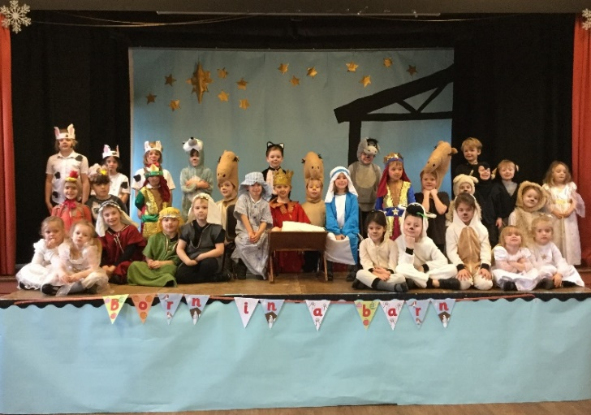

Then on Thursday 13th December we were treated to two performances of The Snow Queen. The children were excellent in both performances, singing, acting and dancing with their usual enthusiasm. There was much talent on the stage as always! Well done to all of you.

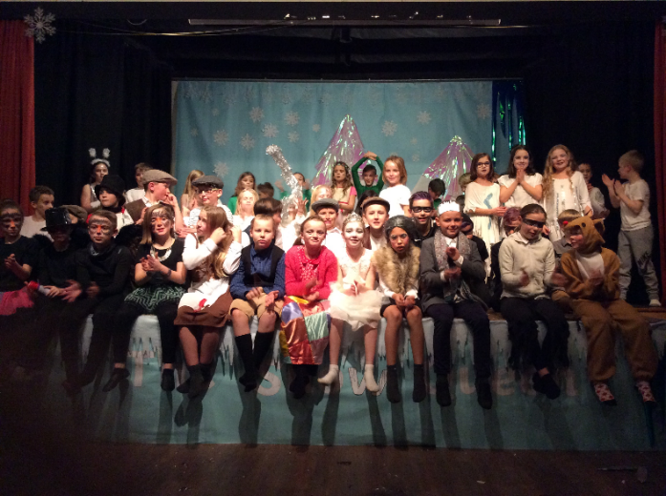

As always, the children throughout the school worked very hard for all their performances. It is also very important to recognise and appreciate the huge efforts made by all the staff in order for these productions to happen.

Christmas Lunch
On 19th December the whole school were served a delicious Christmas lunch. Thank you so much to Carol, Jo & Gemma. A special mention must also go to Mrs Welsh and Miss Whitfield who set up the hall with placemats for every child and all the adults! The children were invited to wear a Christmas jumper and donate to Save the Children, £30 was raised.
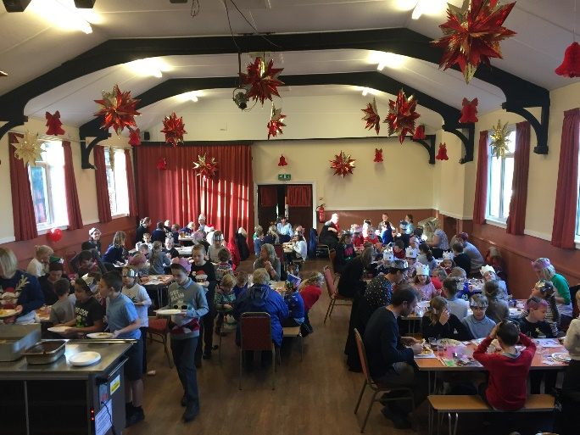

Children’s Council
The Children’s Council event was held on Wednesday 19th December. Each class made decorations or yummy treats to sell and there was also a ‘Bring And Buy Sale’. The members of the Children’s Council were extremely well organised despite the fact that two classrooms were being completely emptied of furniture!
They raised £160.00 which was a really good achievement. Well done to our Children’s Council members: Year 5&6 – Isabella, Lewis, Mollie, Rachel, Rose, Roxy and Zoe, Year 3&4 – George, Harry, Freddie, Mason and Olly and Year 1&2 – Ava, Jack and Lily-May.

Freddie Shirley won the best-decorated Christmas cracker and Joseph Fox won the best-decorated cake competition Well done!
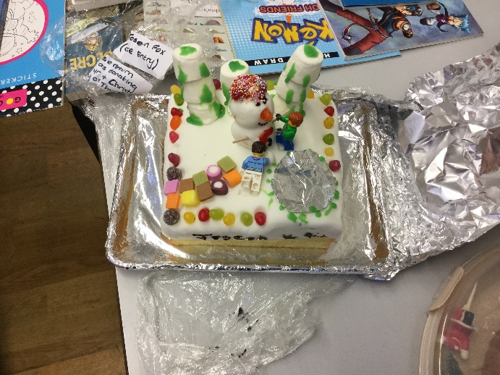

Junior Dragons
Again, Mr Gaze has arranged for the Year 6 to enter the Junior Dragons event. This year the school are raising money for ‘Community Car Scheme’. On 20th December the children washed staff cars in the morning and then served refreshments at their ‘French Café’ as part of their French curriculum during the Children’s Council Christmas event. Zoe and Freddie’s cakes/biscuits also sold out! Thank you very much to Mr Gaze for all his hard work, time and organisation, all on a voluntary basis and of course to the Year 6 children. £104,00 was raised, well done!
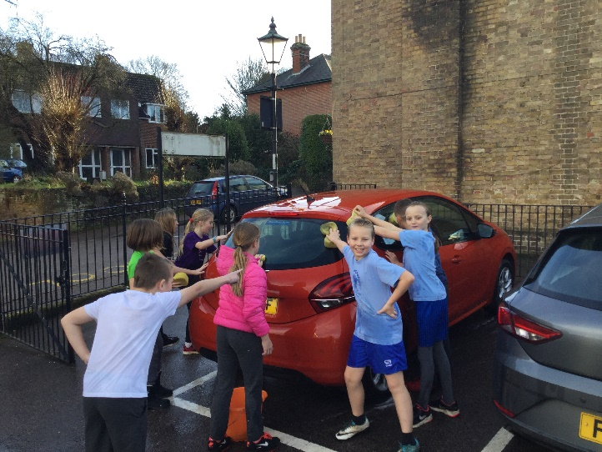

Christmas Parties
All the children had a lovely time at their parties, playing games, dancing and eating party food! Thank you to the parents for all the food donations.

Christmas Service
Today we ended the term with a carol service at St Mary’s Church, Thundridge. This was our first service with our new Reverend – Amanda Duncan and it was a lovely service. Amanda commented on the excellent quality of the service and the children’s very good behaviour throughout. Well done to everyone. The singing and readings were excellent as always.

Attendance Awards
Silver awards for 100% attendance in this Autumn term and Bronze awards for 98% or over attendance will be given in January 2019.

We hope you all have a Fabulous Christmas and
Happy New Year to you all!

Kind regards
Miss Greatrex

