`

THUNDRIDGE CHURCH OF ENGLAND

PRIMARY SCHOOL NEWSLETTER

SPRING WEEK 3-5

THURSDAY 7TH FEBRUARY 2019
WHAT’S GOING ON NEXT WEEK
Monday 11th February | Year 6 SATS Booster  Collect at 4.15
Tuesday 12th February | Children Under 5 Free  Stay and Play. 9.15-11.15  No Choir–Due to Parents Evening  Parents Evening – 3.30-5.20
Wednesday 13th February | No Year 6 SATS Booster  Parents Evening – 3.30-6.50
Thursday 14th February | Football match at home against Little Munden School (they do not have a netball team)
WHAT’S ON LATER
18th – 22nd February | Half Term
Monday 25th February | Year 6 SATS Booster  Collect at 4.15
Tuesday 26th February | Children Under 5 Free  Stay and Play. 9.15-11.15  Choir – Collect 4.15
Wednesday 27th February | Year 6 SATS Booster  Collect 4.15
Thursday 28th February | Netball match away against Northaw School (they do not have a football team)  Dance Festival – 8.00pm – Hertford Theatre – 24 Juniors
Friday 8th March | Year 1&2 Class Assembly  9.15 at the Village Hall
Friday 15th March | Year 6 - Crucial Crew Workshop
Tuesday 26th March | Choir Rehearsal - 12.00-2.00  Concert 6.45
Friday 5th April | End of Term - Finish 1.30
Wednesday 24th April | First Day of Summer Term  K’nex Challenge Years 3-6
8th April – 18th April | Easter Holidays
19th – 22nd April | Easter Weekend
Tuesday 23rd April | Inset Day
Wednesday 24th April | First day of Summer Term
Monday 6th May | Bank Holiday Monday
13th – 16th May | SATS Week for Year 6
Friday 24th May | School Closed - Inset Day
Mon 27th May – Fri 31st May | Half Term
17th - 21st June | Year 5&6 School Journey
Friday 28th June | Sports Day
Friday 5th July | Contingency Sports Day
Tuesday 23rd July | Last day of term
Monday 2nd September | Inset Day
Tuesday 3rd September | First Day of Autumn Term

Birthdays…
Phoebe Le Grys – 7th February
Harry March – 10th February
Mrs Tarbuck – 17th February

Awards Friday 19th January 2019
Head Teacher Award
Ruby Robinson for sustained high standards and effort across all subjects.

Class Awards:

Foundation Stage – Ralph Bradley-May, Michael Mann
& Harper Rose

Year 1&2 – Miles Collins & Jack Turner

Year 3&4 – Finley Francis & Fearne Watson

Year 5&6 – Jack Field & Zoe Thomas

Mrs Tarbuck Award - Amy Johnson

Lunch Staff Awards: Miles Collins, Ava Field &
Finley Francis

Well done all of you!

Awards Friday 25th January 2019
Head Teacher Award
George Harbour for always approaching his work with a positive and ‘can do’ attitude.

Class Awards:

Foundation Stage – Archie Chamberlain &
Jude Chappell

Year 1&2 – Josie Brown & Neve Chappell

Year 3&4 – Ronnie Best & Isla Grierson

Year 5&6 – Lewis Greatrex, George Hartfield &
Charlie Milhouse

Mrs Tarbuck Award - Lewis Greatrex

Lunch Staff Awards: Neve Chappell, Zac Earl, George
Hartfield & Hayden Mann

Well done all of you!

Awards Friday 1st February 2019
Head Teacher Award
Zoe Thomas for her consistently diligent and conceintious attitude, always going ‘over and above’ however heard things are.

Class Awards:

Foundation Stage – Dana Harris-West & Preston Tyler

Year 1&2 – Betsy Baker & William Haworth

Year 3&4 – Dita Purser & Macy Cyl

Year 5&6 – Ruby Stern & Francesc Thomas

Mrs Tarbuck Award - Joseph Fox

Lunch Staff Awards:
Mortimer Davy, Lewis Greatrex, Stanley Harrison & Elena Smyth

Well done all of you!

Sports Festival
On 30th January the Year 3&4 class participated in the Sportshall Festival at Wodson Park. They took part in a range of activities; - throwing the shot putt and tailball; the triple jump; high steppers and speed bounce and the obstacle, hurdle and revsa board run. The children also had the opportunity to take part in a personal challenge of speed stacking. This challenge will continue to be run within school by our Sports Ambassadors.

All the children had an enjoyable morning and learnt some new skills.

Thank you to the parents that helped transport the children and who make these opportunities possible for the children.

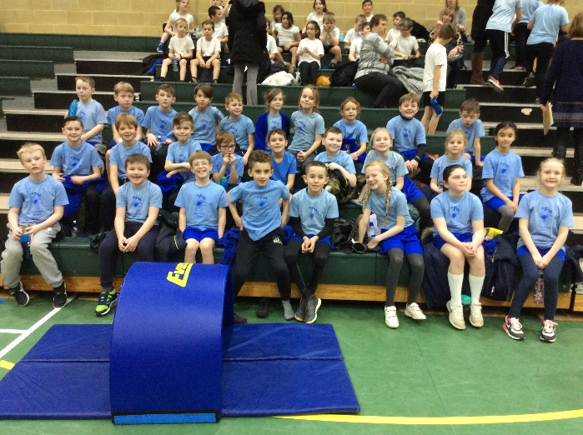

Junior Dragons

On 28th January, a team of six Year 6 students from Thundridge School did a presentation to three ‘Superdragons’ in the Boardroom of the CVS in Stanstead Abbotts. Our team, led by George, consisted of Alfie, Billy, Isabella, Rachel and Roxy. They made a confident presentation using Powerpoint slides created by Kian, Jack and Mollie. They also showed their outstanding poster describing their Dragons project, which had been produced by Olivia, Ruby R and Ruby S, so it really was a whole team effort from all of Year 6. We do not have the results yet but the judges were certainly impressed and the Thundridge School team did themselves and the school proud. They were all great Ambassadors for Thundridge School. We will be presenting a cheque soon for £105.00 to the Community Car Scheme charity. Well done everybody!

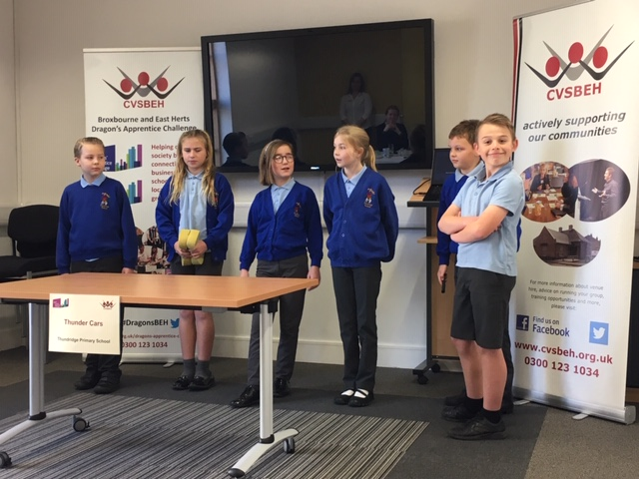

Enjoying The Snow!

It's 'Snow' fun at Thundridge School!

I know some children may well have sighed on Friday 1st February when they woke up to not quite enough snow to enjoy tobogganing at home but they made up for it in school!

Awake and active was a half hour fun session of giant snowball making and snowball throwing using the staff for target practise!

The children had break and lunch play on the field where they continued to have fun and enjoy 'the white stuff' while it lasted!

Reminders…

Free! – Under 5’ Stay & Play Sessions
From 9.15am to 11.15am
Come and join our Foundation Stage class for a morning of fun with arts and crafts etc. Please spread the word, tell your friends and family to come and join us. The next sessions will be held on:

Tuesday 12th February
Tuesday 26th February

Just turn up or book a place on 01920 462642 or email admin@thundridge.herts.sch.uk

Netball & Football
The football team had their first football match against Puller Memorial School as part of the Hope Cup tournament on 24th January which they won 8-2. Well played everyone. Football and netball matches resume today, 7th February. Unfortunately, Ponsbourne’s school pitch is not match-worthy so we are playing Larkspur School instead. We will let you know in the next newsletter how they get on.

Friends of Thundridge School

Launch of 2018/2019 “Thundraising” Thermometer

On a cold and frosty afternoon in January, the Friends of Thundridge were finally able to unveil this years winning design of the “Thundraising” Thermometer Competition.

This years’ winner was Isla Grierson of Year 3).

Anne of Kids Connection, Hertford and Olly Judge (Year 4) representing his dad Tony Judge of Direct Bathrooms and Tiles - our two amazing sponsors of this year's Thermometer were both able to be present for this exciting event!

Mollie (Chair of the Friends Committee) made a wonderful speech reminding all the children what the thermometer is for, and how much all the money raised over the coming year helps everyone who attends Thundridge School.

Isla cut the ribbon to cheers and everyone had a good dance to Yazz – ‘The Only Way is Up’, as we are already exceeding our expectations of funds raised, and cannot thank everyone enough for all of their help and support.

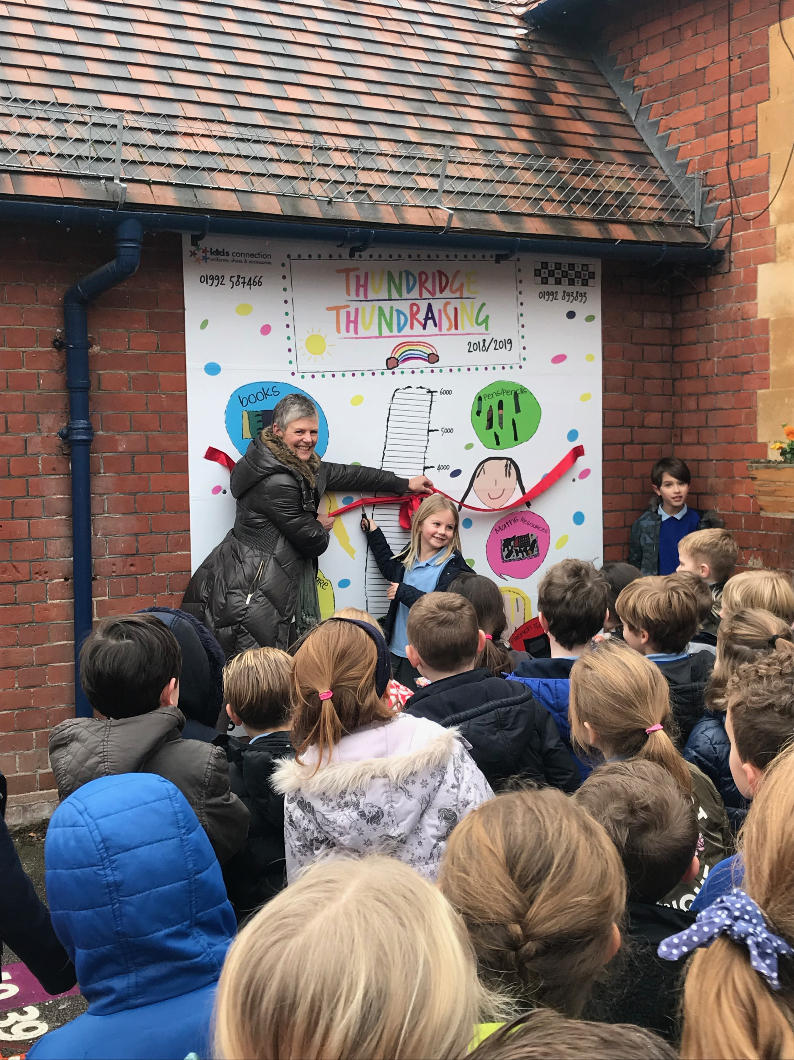
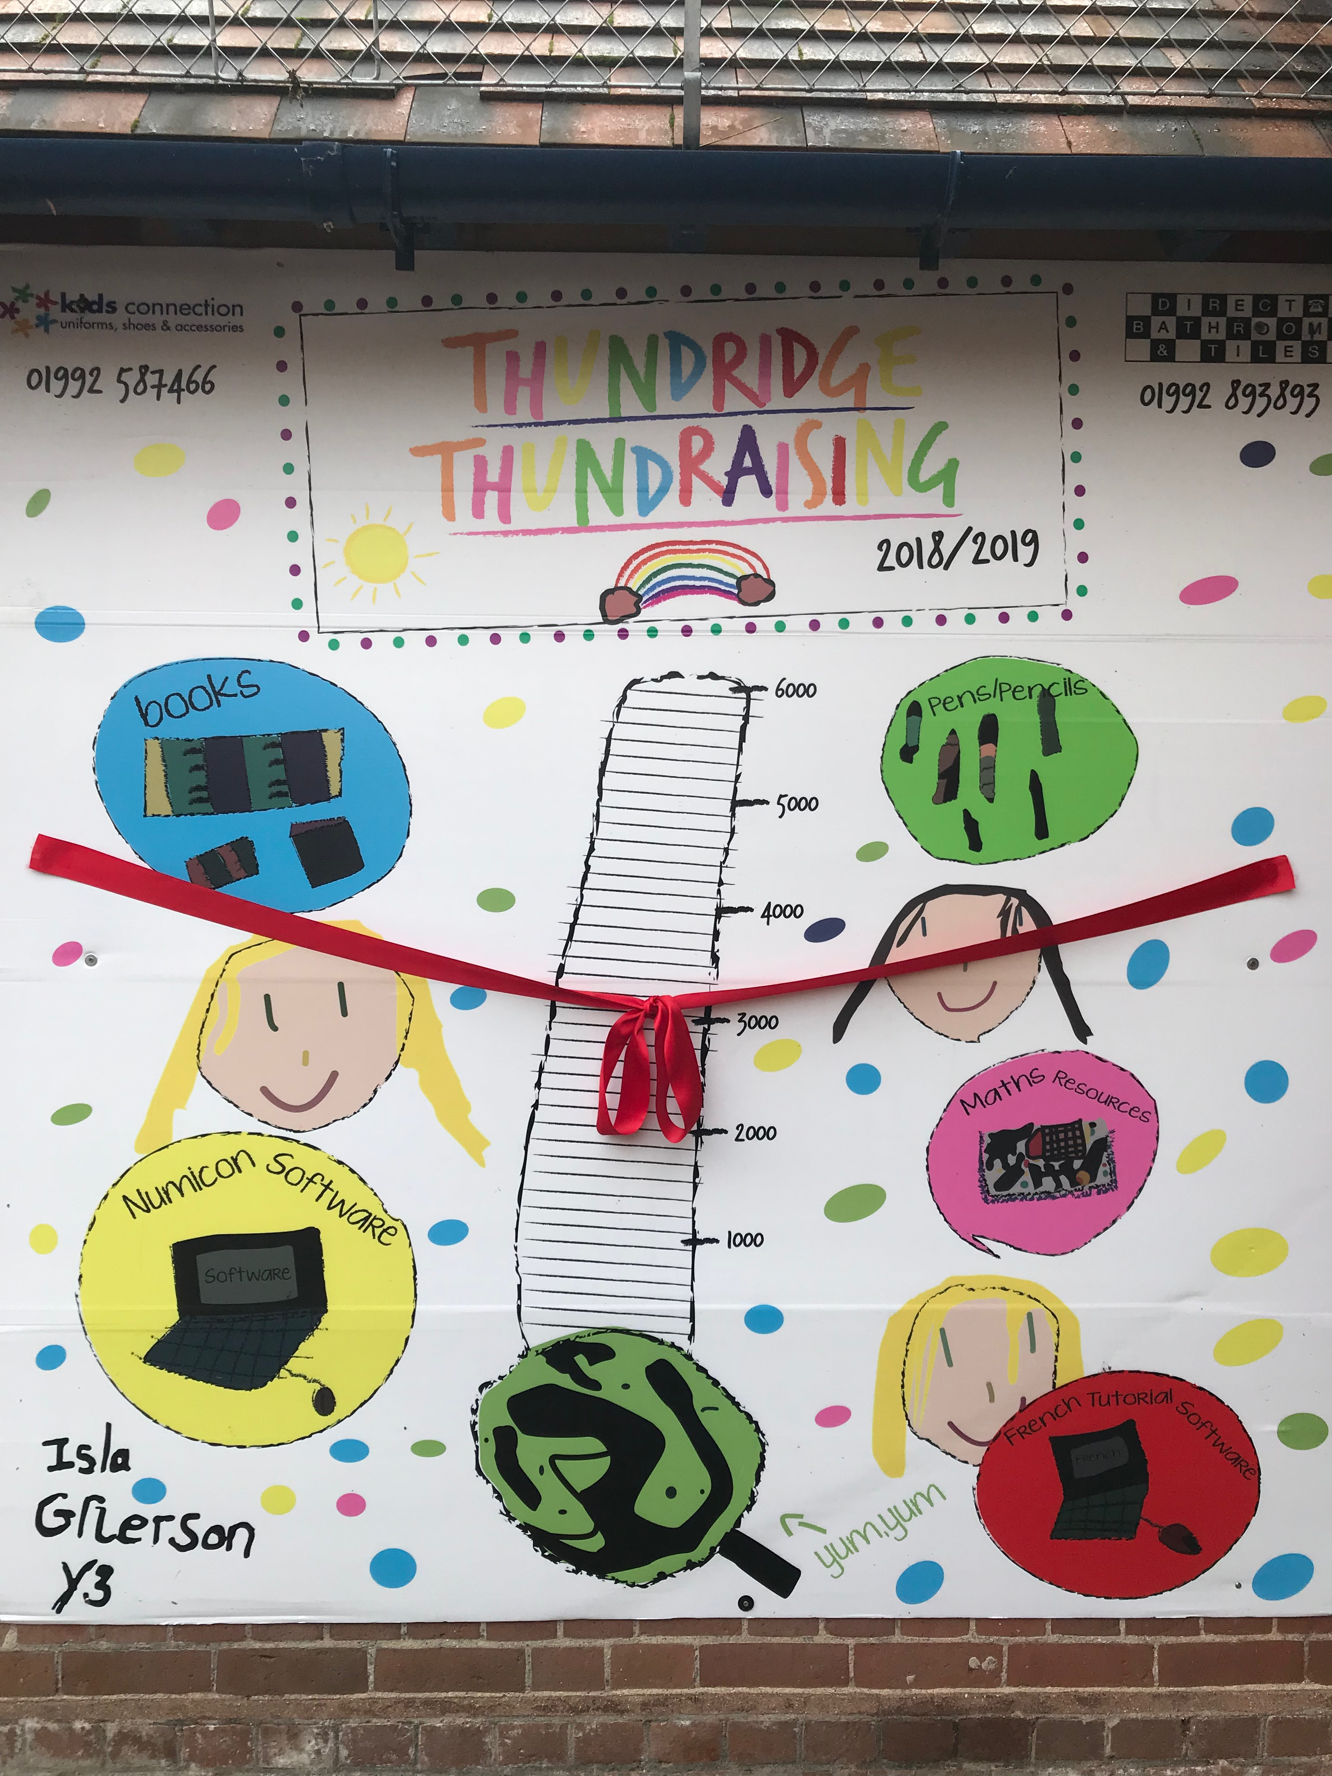

Foundation Stage Class New Equipment
At the beginning of every school year, the School gives a wish list of things they would like the Friends of Thundridge to buy. The Nursery Class bought:-

Two new Tables
A tuff spot
Bamboo guttering of different sizes along with bamboo guttering holders of varying sizes

They are already being used and enjoyed by the children……..

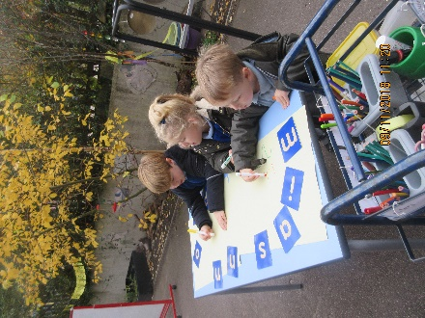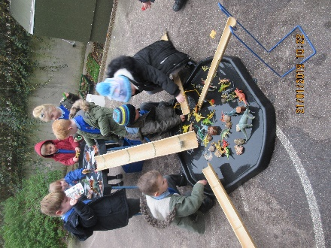
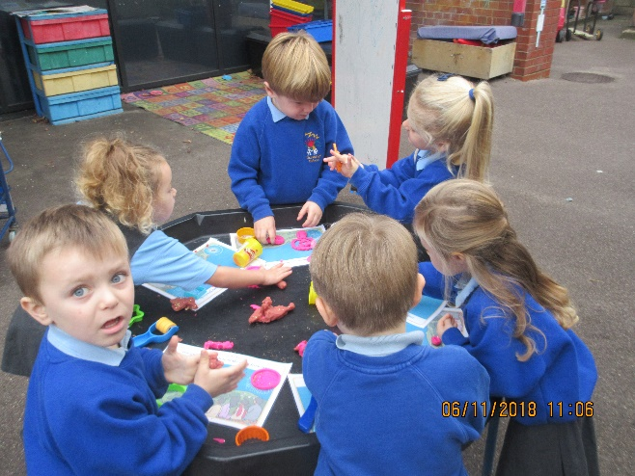

Dates for the Diary

Valentine Day - Non-Uniform Day/Tuck Shop

Date: 15th February
£1.00 per pupil
Wear anything red/pink or white

School Disco

Please give your money (exact please in a named envelope or cheque made payable to ‘Friends of Thundridge School’) to Zoe as soon as possible so we can arrange catering.

With Valentine’s Day just around the corner, some of you might be thinking of making a few extra purchases online. Please could we ask you to try and remember to use Easy Fund Raising, as its simply easy money to add to the pot for school essentials, the app can easily be downloaded onto any device. £325.00 has been raised so far!!

Just go straight to this link and search for your favourite retailers, you will be surprised who’s on there…..

https://www.easyfundraising.org.uk
If you have not set it up before, please go onto the link above to get started, so that the retailers can donate a proportion of your online spending to the school (at no extra cost to yourselves).

This month’s star retailers are (along with over 3000 more) are:-

