THUNDRIDGE CHURCH OF ENGLAND

PRIMARY SCHOOL NEWSLETTER

SPRING WEEK 7-9

THURSDAY 21ST MARCH 2019
WHAT’S GOING ON NEXT WEEK
Monday 25th March | Year 6 SATS Booster Collect 4.15
Tuesday 26th March | Children Under 5 Free  Stay and Play. 9.30-11.30  Choir Rehearsal - 9.00-1.30  Concert 6.45  Library – Year 1&2 & 5&6
Wednesday 27th March | Year 6 SATS Booster Collect 4.15
Thursday 28th March | Magical Math’s Collect 4.20
Friday 29th March | Library – Year 3&4  Friends Committee  Selling of Mother’ Day Gifts
WHAT’S ON LATER
Monday 1st April | Year 6 SATS Booster Collect 4.15
Tuesday 2nd April | Children Under 5 Free  Stay and Play. 9.30-11.30  Library – Year 1&2 & 5&6
Wednesday 3rd April | Year 6 SATS Booster Collect 4.15
Thursday 4th April | Magical Math’s Collect 4.20
Friday 5th April | Library – Year 3&4  End of Term - Finish 1.30
8th April – 18th April | Easter Holidays
19th – 22nd April | Easter Weekend
Tuesday 23rd April | Inset Day
Wednesday 24th April | First day of Summer Term
Friday 26th April | Friends Committee  St Georges Day Non Uniform Day
Thursday 2nd May | Class Photographs
Monday 6th May | Bank Holiday Monday
Sunday 12th May | Friends Committee - Sponsored Walk around Youngsbury - Morning
13th – 16th May | SATS Week for Year 6
Wed 22nd may | 3&4 Egyptian Day In School
Friday 24th May | School Closed - Inset Day
Mon 27th May – Fri 31st May | Half Term
17th - 21st June | Year 5&6 School Journey
Friday 28th June | Sports Day followed by Friends Committee Event
Friday 5th July | Contingency Sports Day
Friday 12th July | Friends Committee School Disco
Tuesday 23rd July | Last day of term
Monday 2nd September | Inset Day
Tuesday 3rd September | First Day of Autumn Term

Birthdays…
Mrs Frost – 10th March
Ronnie Best – 17th March
George Stopps - 18th March
Jack Stone – 20th March
Callum Wareham – 21st March
Bethany Ward – 26th March
Ava Field – 28th March

Awards Friday 1st March 2019

Head Teacher Award
The fantastic Thundridge School Dance Troupe for their commitment, perserverance and enthusiasm resulting in a great performance

Class Awards:

Foundation Stage – Leona Fox & Preston Tyler

Year 1&2 – Thomas Smyth & Henry Wilson

Year 3&4 – Fletcher Hart & Aden Kilighan

Year 5&6 – Kylie Kilighan & Jack Field

Lunch Staff Awards: Macy Cyl, George Harbour,
Mason King & Jake Sawdy

Well done all of you!

Awards Friday 8th March 2019

Head Teacher Award
Ronnie Best for huge progress in all aeas. Well done.

Class Awards:

Foundation Stage – Brodie Fenton & Dana Harris-West

Year 1&2 – Arley Fenton & Jack Turner

Year 3&4 – Joseph Fox & Henry Haworth

Year 5&6 – Rose Adams & Kian Bartlett

Lunch Staff Awards – Miles Collins, Chloe Pearce,
Jack Turner & Francesc Thomas

Well done all of you!

Awards Friday 15th March 2019

Head Teacher Award
Rose Adams for amazing skill and perserverance

Class Awards:

Foundation Stage – Archie Chamberlain &
Maisie Wright

Year 1&2 – Mortimer Davy & Amy Johnson

Year 3&4 – Milan Cope & Isabella Le Grys

Year 5&6 – Lewis Greatrex & Zoe Thomas

Mrs Tarbuck Award – Zoe Thomas

Lunch Staff Awards – Josie Brown, Stanley Campbell,
George Harbour & Jack Stone

Well done all of you!

Welcome
Welcome to Aden & Kylie Kilighan who have joined Thundridge School in Years 4 & 6. We hope they enjoy their time at Thundridge School.

As you will read and see below we have had a very busy term so far!……

Dance Festival
On 28th February 24 children from the Juniors took part in the Hertford and Ware Schools Dance Festival at Hertford Theatre. The theme was Fairy Tales & Fables. They performed Pinocchio to the music ‘Come Alive’. The day started with a dress rehearsal. Here the children were able to perform their routine in front of the other schools taking part. They were dressed as Pinochios, Geppettos, Jiminy Crickets and Dolls and looked amazing in their costumes with their faces painted. The evening performance saw many children waiting in their back stage dressing rooms. They performed their dance extremely well and were all a credit to the school. Thank you to Mrs Le Grys for her help with costumes and face paints and to the parents for transporting the children.

Mrs Frost wrote this so I would like to add a huge thank you for all her time and effort taken to produce the dance.

Official Dance Festival Photograph to follow soon, meanwhile, waiting to go on! ….

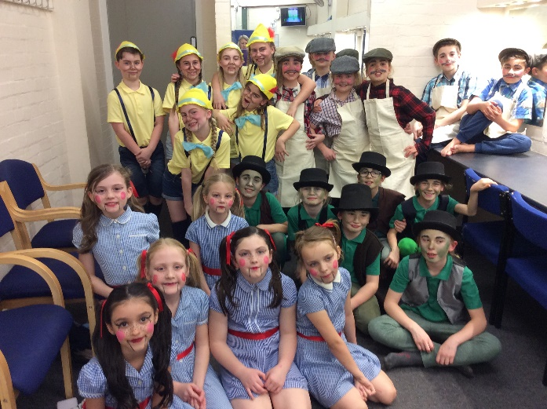

Crucial Crew

On 4th March Year 6 children went along to Morgans School to take part in this year’s Crucial Crew. This is an extremely informative school trip. A number of companies, charities and the emergency services all took part. They created real life scenarios for the children to experience and think about, such as fire hazards, using the recovery position, cyber bullying and railway safety. In each scenario the children were taught how to keep themselves safe. As always our children were extremely well behaved and contributed to the afternoon with enthusiasm. Thank you to parents and staff for transporting the children.

Sports Hall Competition

On 6th of March Year 5&6 took part in the Hertford and Ware Schools Sports Partnership 'Sportshall Athletics Competition' at Wodson Park. The children tested their skills in a number of indoor track and field events ranging from obstacle races and relay sprints to an assortment of throwing and jumping disciplines. Each child took part in at least 2 activities and the points they earned helped Thundridge School to finish in a very credible third place behind two substantially bigger schools and ahead of a number of others.

Well done to the children for their Olympic spirit and thank you to the parents who volunteered to drive the children to Wodson Park during the middle of the day.

World Book Day
On 7th March we celebrated World Book Day by inviting the children to dress up as ‘Word’ or a book character and bringing in a favourite book. The day was spent engaging the children in various activities linked to books and was enjoyed by all.

Thank you to Mrs White & Mrs Hammond for organising a quiz and poetry trail.

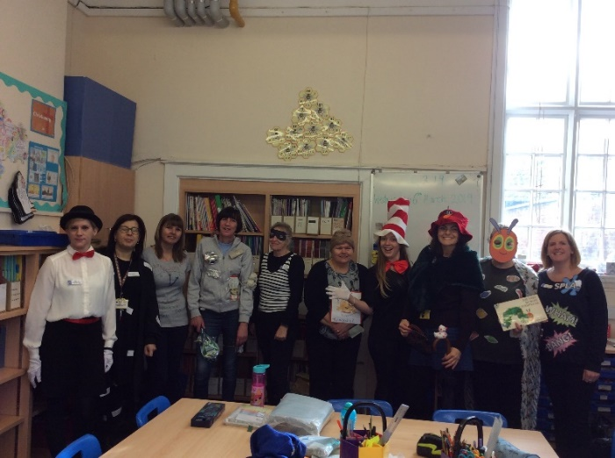

Football

Since the last update, the football team competed in the Hope Cup competition against league favourites Hunsdon School. After a tough first half with the wind and referee (Mr Higgins!) against them, Thundridge School found themselves 4-0 down. A spirited second half performance saw them compete fantastically and they were lucky not get more than one goal. That strike came from an acute angle from Charlie Millhouse who minutes later hit the cross bar.

Unfortunately on 14th March there was a misunderstanding with Bayford School, they thought we were going to their school so unfortunately the football match could not go ahead.

Year 1&2 Assembly

On 8th March parents, children and staff were all treated to a brilliant assembly by our Year 1&2 class.

They all spoke with great confidence, clarity and obvious enthusiasm about what they had been learning including arrays to help with understanding multiplication in maths, computer programming, drama work on Little Red Riding Hood, topic work on Florence Nightingale and several other aspects of the curriculum they have been covering including a very catchy multiplication song which the found hard to stop! A huge well done to all the children and staff involved with the preparation of this thoroughly enjoyable and informative assembly. Well done all!

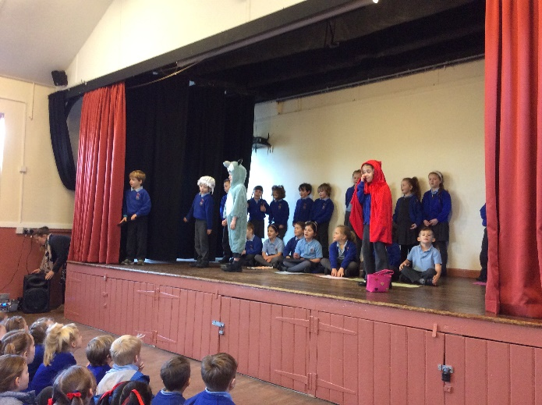

GlaxoSmithKline Science Day

Thanks are again due to the parents who braved the torrential rain to get the Year 5&6 class to Allenbury's Sports Club on 12th March for the GSK's annual science extravaganza. During the 'Gas, Liquids and Solids' workshop, the children saw how chemical elements and compounds change state depending on their temperature. The scientists from GSK then showed how knowledge of the properties of different elements allow them to be combined in interesting ways... cue lots of lasers and explosions! Throughout the fun and excitement, the children were very well behaved and it is just probable that they might even have learnt something too!

Red Nose Day
On 21st March the children and staff raised money for Comic Relief by dressing up in red and buying ‘Red Nose’ merchandise, £157.00 was donated, thank you for donating.

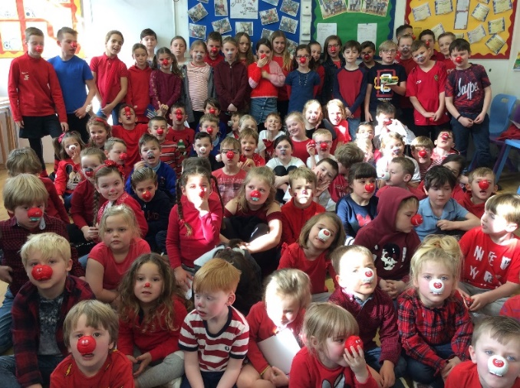

House Points
Results:

Week 4 Winning House – Barclay
Week 5 Winning House – Clarkson
Week 6 Winning House - Barclay

Pencil Cases

Individual pencil cases are becoming an issue in school, and a distraction to some children. Whilst we appreciate it is a step towards independence and individualism, we cannot have it disrupting the classroom by constantly playing with items within them. Although this may seem an insignificant point, we are having to stop teaching at least 3 or 4 times a day in order to deal with the distractions these cause!

Please be aware that the children are provided with all the writing equipment that they need for their

classwork- colouring pens, handwriting pens, pencils, rulers, rubbers, pencil sharpeners, etc. Furthermore, children are not allowed to trade items whilst in school time. Please discuss this with your children and we will continue to monitor how this develops regarding disruptions and inform you of any next steps we are intending to take.

Reminders…

Free! – Under 5’ Stay & Play Sessions
From 9.30am to 11.30am
Come and join our Early Years Foundation Stage class for a morning of fun with arts and crafts etc. Please spread the word, tell your friends and family to come and join us. The last session this term will be held on:
Tuesday 26th March
Just turn up or book a place on 01920 462642 or email admin@thundridge.herts.sch.uk
Kind regards
Miss Greatrex

Friends of Thundridge

Another successful school disco was held earlier this month at the Village Hall. From the pictures it looked like everyone had a great time with lots of children enjoying the music, homemade cakes and 50p stalls. As always, these things are only successful because of the continued support from parents and all the hard work that goes on behind the scenes.

The Friends will once again be selling Mother's Day gifts for your children to purchase for you. This year, it has been a group effort which all of the children in the school have contributed to the design of this special gift! If you would like your child/children to make a purchase, the gift will be on sale for £4.00 on Friday 29th March in school. Please send your child in with the correct money in a named purse or envelope. If you have more than one child at the school, other gifts will be on sale for £2.00 (and members of the Friends Committee will be on hand to ensure there is no duplication!).

In addition to this, the Friends Committee will be selling tea towels featuring all of the children in the school, as well as the school's logo. This would make a fantastic gift for the other Mother's in your life, so please let Zoe know if you would like to purchase one.

Spring seems to have sprung along with British Summertime starting at the end of the month, if you haven’t already booked any summer breaks/holidays please could we ask you to try and remember to use Easy Fund Raising, as its simply easy money to add to the pot for school essentials, the app can easily be download onto any device.

Just go straight to this link and search for your favourite retailers, you will be surprised whose on there…..

https://www.easyfundraising.org.uk

If you have not set it up before, please go onto the following link to get started, so that the retailers can donate a proportion of your online spending to the school (at No extra cost to yourselves).

This months star retailers are (along with over 3000 more) are:-

Dates of the Diary:

Sale of Mother’s Day Gifts - Friday 29th March

