THUNDRIDGE CHURCH OF ENGLAND

PRIMARY SCHOOL NEWSLETTER

SUMMER WEEKS 1-3

WHAT’S GOING ON NEXT WEEK
Monday 13th May | Year 6 SATS Week
Tuesday 14th May | EYFS Stay & Play Session 9.15-11.00
Thursday 16th May | Rounders – Years 3-6 – Collect 4.15
Friday 17th May | Library – Year 3&4
WHAT’S ON LATER
Monday 20th May | Walk to School Week  School Journey Meeting for Parents – Puller Memorial School -7.00
Tuesday 21st May | Children Under 5 Free  Stay and Play. 9.15-11.15  Library – Year 1&2 & 5&6
Wednesday 22nd May | Year 3&4 - Egyptian Day In School
Thursday 23rd May | Polling Day – Everyone to have home or school packed lunch  Rounders – Years 3-6 – Collect 4.15
Friday 24th May | School Closed - Inset Day
27th May– 31st May | Half Term
Monday 3rd June | Class Photographs
Tuesday 4th June | EYFS Stay & Play Session 9.15-11.00
Friday 7th June | Year 5&6 Swimming 9.15 at Fanshaw Pool for 6 weeks
Tuesday 18th June | EYFS Stay & Play Session 9.15-11.00
17th - 21st June | Year 5&6 School Journey – Kingswood
Monday 24th June | Library Reading Challenge Assembly
Tuesday 25th June | EYFS New Parent Visits
Wednesday 26th June | Athletics Years 2-6 Wodson Park Time TBC
Friday 28th June | Sports Day followed by Friends Committee Event
Tuesday 2nd July | EYFS New Parent Visits
Friday 5th July | Contingency Sports Day
Wednesday 10th July | Open Evening – 5.00-7.00
Thursday 11th July | EYFS New Children Visit  ‘Moving up Day’ – Whole school  Year 6 visit their Secondary School
Friday 12th July | Chauncy Community Day  Whole School involved  Friends Committee School Disco
Thursday 18th July | Year 6 Leavers Day Treat
Tuesday 23rd July | Leavers Assembly – Village Hall – 9.15  Last day of term
Monday 2nd September | Inset Day
Tuesday 3rd September | First Day of Autumn Term

Birthdays…

Izzy Basham – 5th May
Amy Johnson – 14th May
Stanley Campbell – 19th May
Mortimer Davy – 20th May

Awards Friday 26th April 2019

Head Teacher Award
Leo Homer for fantasic progress and attainment in reading.

No Class Awards as only a short week

House Points Winner – Week 8 - Hanbury

Well done all of you!

Awards Friday 3rd May 2019

Head Teacher Award
Roxy Kripp for fantastic growth mind set in preparation for SATS.

Class Awards:

Foundation Stage – Izzy Basham & Harper Rose

Year 1&2 – Bradley King & Hayden Mann

Year 3&4 – Harrison Campbell & Charlotte Chamberlain

Year 5&6 – Jake Sawdy & Ruby Stern

Lunch Staff Awards – Lily Mann & Jack Turner

House Points Winner – Week 9 - Clarkson

Well done all of you!

Awards Friday 10th May 2019

Head Teacher Award
Lily-May Hewitt-Makin for consistent positive behavior and attitude which in turn has had an impact to produce excellent work.

Class Awards:

Foundation Stage – Ralph Bradley-May &
Dana Harris-West

Year 1&2 – Neve Chappell & Pheobe Le Grys

Year 3&4 – Zac Earl & George Stopps

Year 5&6 – Rachel Grierson & Charlie Millhouse

Mrs Tarbuck Award – Henry Wilson

Lunch Staff Awards – Archie Chamberlain &
Betsy Baker

House Points Winner – Week 10 - Wodson

Well done all of you!

We hope you all had a good Easter break.

Welcome
Welcome to Izzy Basham who has started in our Reception class of Early Years Foundation Stage. We hope she enjoys her time at Thundridge School.

Easter Service
On the last day of term we held our Easter Service at St Mary’s Church, Thundridge. Each class contributed to the service. Thank you to Reverend Amanda for conducting the Easter Service and to all the parents who attended.

Year 5 Junior Dragons
On 3rd April the Year 5 Junior Dragons team enjoyed a fantastically successful event supporting CATS Whisker Rescue, a local Hertford based charity. The amazing total of £302.00 raised was achieved by organising a sponsored fun run, refreshments, an Easter egg hunt, a raffle and visit from the ‘Easter Moggie’. Everyone played their part in the team captained by Charlie Millhouse. The money raised will be used to look after cats who are homeless. Well done everyone!

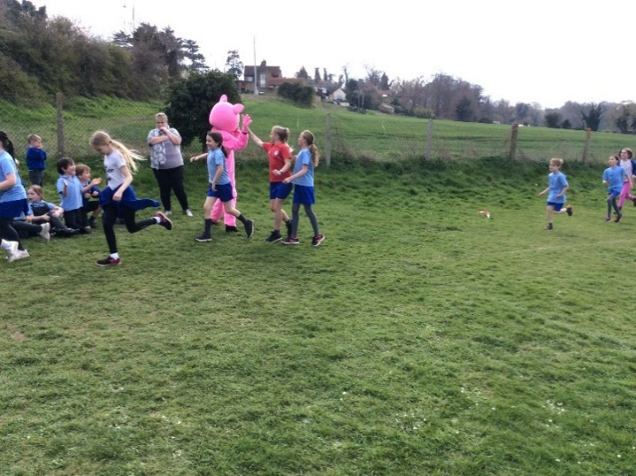

K’Nex Challenge
On 24th April, Rathy Kantharoopan, a Scientist from GSK in Ware, came into school for the K’Nex Challenge. This is an annual competition between schools, to see who can build the best model. This year’s theme was a ‘Flying Machine of The Future’, as it was sponsored by Luton Airport. The children in Years 3&4 and Years 5&6 both had 2 hours to design and build their machine.

Congratulations to our winners: Zac Earl & Joseph Fox for Year 3&4, and Elena Smyth & Alex Warner for Year 5&6. There were some fantastic entries, with some really innovative designs, well done everyone.

Year 3&4 K’Nex Winners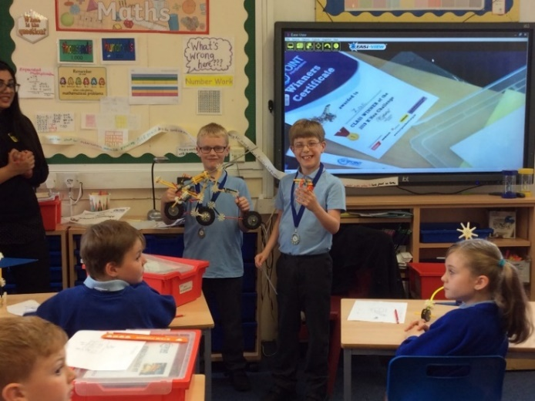

Year 5&6 K’Nex Winners
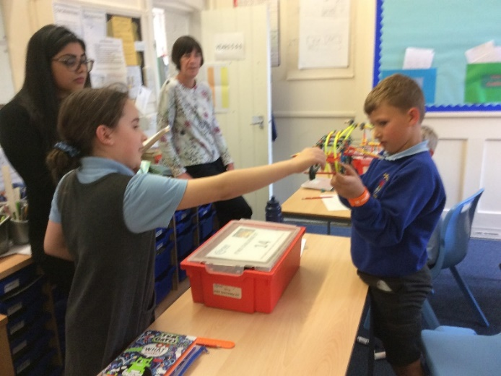

Attendance Awards

Gold certificates were awarded to those children who had 100% attendance in the Autumn & Spring terms: - Harrison Campbell, Stanley Campbell, Jude Chappell, Neve Chappell, Arley Fenton, Jack Field,

Lewis Greatrex, Isla Grierson, Chloe Haworth,

Lily-May Hewitt-Makin, Mason King, Ioanna Koumi, Marina Koumi, Alfie Pearce, Jake Ronan &

Thomas Smyth.

Silver certificates were awarded to those children who had 100% attendance in the Spring Term:-

Betsy Baker, Billy Baker, Josie Brown, Tommy Brown, Archie Chamberlain, Charlotte Chamberlain,

Oliver Chamberlain, Mortimer Davy, Brodie Fenton, Leona Fox, Finley Francis, Henry Haworth,

Bradley King, Roxy Kripp, Isabella Le Grys,

Chloe Pearce, Mollie Sampford-Curry & Zoe Thomas.

Bronze certificates were awarded to those children who had 98.3% or more attendance in the Spring Term-
Libby Adams, Kian Bartlett, Ralph Bradley-May,
Billy Cyl, Macy Cyl, Ava Field, Samuel Field,
Joseph Fox, Fletcher Hart, Amy Johnson,
Phoebe Le Grys, Ruby Robinson, Elena Smyth, Alexander Warner & Isabella Warner.

Well done everyone!

Dates
Please make a note of the new dates listed on the front page. Paper copies of the newsletter are available on the carousel in School Reception.

Wanted…..Shoes boxes for EYFS class for Monday if anyone has any please.
Kind regards
Miss Greatrex

Friends of Thundridge School

St George’s Day Celebrations
To celebrate St George’s Day this year, the whole school was invited to come in wearing red and white to celebrate the Patron Saint, with a donation of £1.00, all of which goes into the Friends Funds to assist the school with extra equipment. Lots of smiles all round.

Summer Event/Summer Grand Draw
Plans are already underway in organising this years summer event. As always, all ideas/help/suggestions are welcome.

We are currently still looking for:

- A live band to come and play (3.00pm-6.00pm);
- Prizes for the draw; and
- Food supplies/donations for the BBQ/Bar

We have a meeting scheduled for this coming Monday in the Feathers from 7.30pm in the back room. If you can help in any way, please do feel free to come along, new faces/ideas are always welcome.

SPONSORED WALK (Sunday 12th May) -CANCELLED

The sponsored walk scheduled for this Sunday has been cancelled for reasons out of our control.

Have you seen that John Lewis, M&S and Argos have all signed up to Easy Fund Raising! If you have not already, please sign up and help us to get that “easy” extra money for our school.

Just go straight to this link and search for your favourite retailers, you will be surprised whose on there.

https://www.easyfundraising.org.uk

At the moment, we have 58 supporters with £364.95 raised so far for just ordering through this site, it would be great to get a few more people signed up.

Friends and family members can also sign up for free and have their donations come to Thundridge School.

Thank you for your continued support

Friends of Thundridge School Committee

