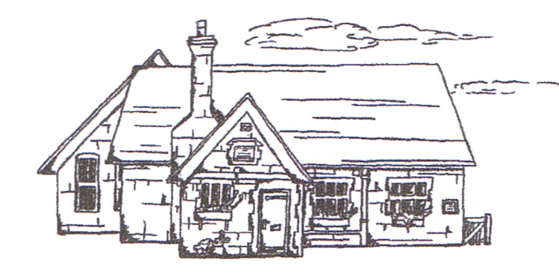
THUNDRIDGE CHURCH OF ENGLAND

PRIMARY SCHOOL NEWSLETTER

SUMMER WEEKS 4-7

20TH JUNE 2019

WHAT’S GOING ON NEXT WEEK
Monday 24th June | Library Reading Challenge Assembly
Tuesday 25th June | EYFS New Parent Visits 9.00am  Dance & Drama Lunch Club
Wednesday 26th June | Athletics Some Years 2-6 Wodson Park – Afternoon Collect at 5.00
Friday 28th June | Year 5&6 Swimming 9.15 at Fanshaw Pool  Sports Day – start 1.30 followed by Friends Committee Event
WHAT’S ON LATER
Tuesday 2nd July | EYFS New Parent Visits  Dance & Drama Lunch Club
Thursday 4th July | Year 5&6 Class Assembly 9.15am – Village Hall
Friday 5th July | Contingency Sports Day
Wednesday 10th July | Cluster Sports – Years 3-6 – Stapleford School  Open Evening – 5.00-7.00
Thursday 11th July | EYFS New Children Visit  ‘Moving up Day’ – Whole school  Year 6 visit their Secondary School
Friday 12th July | Chauncy Community Day  Whole School involved  Friends Committee School Disco
Thursday 18th July | Year 6 Leavers Day Treat
Tuesday 23rd July | Leavers Assembly – Village Hall – 9.15  Last day of term
Monday 2nd September | Inset Day
Tuesday 3rd September | First Day of Autumn Term
Birthdays…
Rachel Grierson -1st June
Isabella Le Grys - 1st June
Fletcher Hart - 5th June
Mrs King - 7th June
Elena Smyth - 10th June
Billy Cyl – 11th June
Chloe Pearce – 23rd June
Michael Mann – 1st July
Miss Gaze – 2nd July
Mason King – 2nd July
Alex Warner – 3rd July
Ralph Bradley-May – 6th July
George Hartfield – 6th July
Mrs Welsh – 9th July

Awards Friday 17th May 2019

Head Teacher Award-
Year 6 for a huge effort, concentration and a positive attitude during all the SATS.

Class Awards:

Foundation Stage – Brodie Fenton, Aoife Obrien &
Preston Tyler

Year 1&2 – Betsy Baker & Josie Brown

Year 3&4 – Oliver Chamberlain & I sabella Le Gry

Year 5&6 - Lewis Greatrex & Martha Stopps

Mrs Tarbuck Award –

Lunch Staff Awards – Izzy Basham, George Hartfield
& All of Foundation Stage

House Points Winner – Clarkson

Well done all of you!

Awards Friday 7th June 2019

Head Teacher Award-
Dana Harris-West for amazing use of phonics in her independant writing.

Class Awards:

Foundation Stage – Jude Chappell & Michael Mann

Year 1&2 – Lily-May Hewitt-Makin & Amy Johnson

Year 3&4 – Tommy Brown & Lily Mann

Year 5&6 – Billy Cyl & Elena Smyth

Mrs Tarbuck Award – Joseph Fox

Lunch Staff Awards – Ralph Bradley-May

House Points Winner – Hanbury

Well done all of you!

Awards Friday 14th June 2019

Head Teacher Award-
Joseph Fox for a positive attitude towards all his learning and sharing his extra knowledge enthusiastically with the rest of the class.

Class Awards:

Foundation Stage – Izzy Basham, Ralph Bradley-May,
Micheal Mann & Preston Tyler

Year 1&2 – Sydney Marshall & Thomas Smyth

Year 3&4 – Zac Earl & Harry March

Year 5&6 – Libby Adams, Rachel Grierson, Jake Sawdy
Elena Smyth & Martha Stopps

Mrs Tarbuck Award – Zoe Thomas

Lunch Staff Awards – George Hartfield, Jack Turner
& Preston Tyler

House Points Winner – Barclay

Well done all of you!

Year 1&2 Teachers
It is with regret I need to inform you Mrs Grange, our part time Year 1&2 Teacher will be leaving at the end of the term to start a full time Teacher position at a special school, nearer home as she now lives a long way away. We wish her all the best in her new position.

However, we are pleased to inform you that Mrs Loader is remaining in Year 1&2 in a full time capacity.

Year 3&4 Assembly

On 14th June the Year 3&4 class presented their assembly to the whole school and family at the Village Hall. We were all treated to a brilliant assembly all about the Ancient Egyptians. It truly was amazing with a real 'dead body' included! The children had covered so many aspects of this topic including art, design and technology, maths, English, music and of course, history. This was all presented in a dramatised way and the children looked stunning in their costumes.

Very well done to all the children and to Mrs Frost!

Year 3&4 Ancient Egyptian Day
Here are extracts from the children’s writing, the next day.

Introduction
It was probably the best day ever (Fletcher). Our class had an Egyptian Day and a man called Mark came in for the day. We had to dress up as an Egyptian, a Mummy or an Egyptologist (Isla). Mark came to our school to tell us about Egypt as it is our topic (Ronnie).

History
Mark showed us a map of Egypt (George). He told us who ruled Upper and Lower Egypt (Aden). They were both ruled by Kings that did not like each other (Henry). Lots of tribes tried to steal Egypt’s gold and silver (Izzy). Cleopatra put on her best dress and make up, got a basket and pulled out a poisonous snake. It bit her! (Charlotte).

Games
There were 8 quiz boards. We had to answer them (Mason). I got nearly all of them right (Milan). We played ‘Hounds and Jackals’, which was a board game (Jack). It is a bit like Snakes and Ladders (Rylie). Outside, we used foam javelins for spears and hunted animals (Jack). We pretended to hunt for our food (Fearne). You had to try not to hit the Hippo (Macy).

Mummification
Some of us acted out parts, like Priestesses and Pharaohs (Izzy). Stanley was the Pharaoh and Milan was his Queen (Lily). I had to march as a man (Stanley). The Pharaoh was poisoned by food he ate (Beth). The Pharaoh died, so we had to mummify the body (Harry). Dead people have their organs taken out (Joseph). We wrapped him in bandages, like a mummy, and put him in a sarcophagus (Olly).

Artefacts
Later he showed us artefacts (Finley). I loved seeing the artefacts and the different patterns (Fearne). He showed us a 3500 year old piece of mummy bandage from a tomb and a beer jug with a little naked creature on it, called Bez, who always protected the owner’s family (Oliver).

And Finally
At the end we were told Cinderella in the Egyptian form (Dita). Overall, I thought the day was a brilliant day of learning about Ancient Egypt (Harrison).

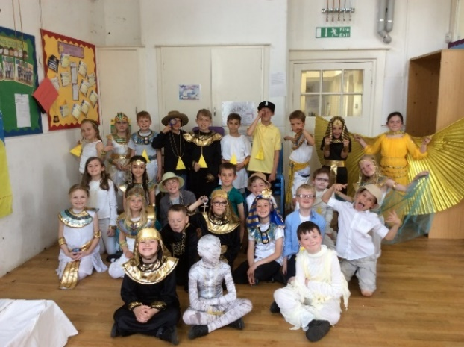

Every One In
On 6th June, nine children from Year 5&6 spent the afternoon trying out some amazing new sports and games at Wodson Park. The event was organised for small schools in the area and was a Festival rather than a competition, so everybody got to try everything for about 25 minutes, from Dodgeball, Archery, Boccia and other games not normally played. Everybody had a great time learning new skills and working hard while having fun.

Year 3&4 Assembly

On 14th June the Year 3&4 class presented their assembly to the whole school and family at the Village Hall. We were all treated to a brilliant assembly all about the Ancient Egyptians. It truly was amazing with a real 'dead body' included! The children had covered so many aspects of this topic including art, design and technology, maths, English, music and of course, history. This was all presented in a dramatised way and the children looked stunning in their costumes.

Very well done to all the children and to Mrs Frost!

Stay & Play Sessions
Thank you to everyone who supported our Stay and Play sessions, we hope they all enjoyed them. They will commence again in the next academic year.

Message from the School Nurse…
Please remember you can have your children’s eyes tested for free at the Opticians.

Please contact your GP if you are concerned about your children’s hearing and they will arrange a hearing test with the school nurse. If you need to contact the school nurse they can be contacted on www.hct.nhs.uk.

Charlotte Chamberlain
‘I decided to donate my hair (15 inches) to the Little Princess Trust because I wanted to help the children that had lost their hair due to illness. I raised £320.00 and I am really happy with that amount, as my target was £250.00!!

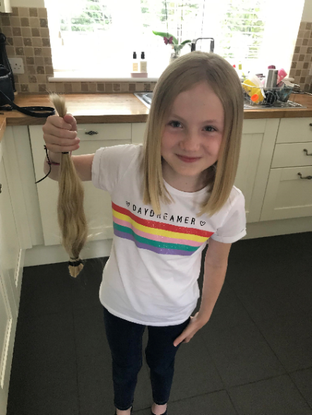
Amazing Charlotte, well done!

Reminders……

Sports Day
Sports Day will start prompt 1.30 followed the Friends Committee Event. We look forward to see you there.

Kind regards
Miss Greatrex

Thundridge School Committee

The Friends of Thundridge School were delighted to be able to give the school £3,346.00 to purchase some wonderful new school equipment which is already being used by the children in their day-to-day learning.

The products purchased by the school were:-

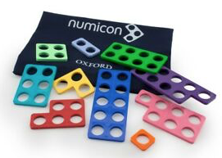
Numicon, this is the UK’s leading maths resource that is used in many schools to support maths teaching, particularly in the Early Years and Key Stage 1.

Phonics Play is an online resource tool to assist the
children with their phonics learning and encourage vital reading skills and hopefully give them a real love of reading;

and lastly.,
Language Angels is a product available to help primary schools progression with foreign languages, as part of the National Curriculum.

Friends of Thundridge School

