
THUNDRIDGE CHURCH OF ENGLAND

PRIMARY SCHOOL NEWSLETTER

SPRING WEEK 7-8

FRIDAY 2ND MARCH 2018

WHAT’S ON NEXT WEEK
Monday 5th March | Netball & Football Club–Collect 4.20
Tuesday 6th March | Library - Year 1&2  Year 6 English Booster–Collect 4.20  Choir – Lunchtime
Wednesday 7th March | French Club Years 1-6 Collect 3.45
Thursday 8th March | Netball & Football Matches at home against Bayford School
Friday 9th March | Friends Selling of Mother’s Day Gifts  Year 6 Maths Booster – Starts 8.00  Library - Juniors – am
WHAT’S ON LATER
Monday 12th March | Netball & Football Club–Collect 4.20
Tuesday 13th March | BMX Bike Day – Years 1-6  Library - Year 1&2  Year 6 English Booster–Collect 4.20  Choir – Lunchtime
Wednesday 14th March | Science Day
Thursday 15th March | Netball or Football Matches away against Tower School
Friday 16th March | Year 6 Maths Booster – Starts 8.00  Library - Juniors – am
Tuesday 20th March | Choir Rehearsal 9.15-12.00 – Ware Drill Hall & Performance Evening
Thursday 22nd March | Year 1&2 Assembly – Village Hall
Sunday 25th March | Postponed - Friends Sponsored Walk & Lunch
Thursday 29th March | Easter Church Service – Everyone welcome - am  End of Spring Term – Finish 1.30
30th March – 13th April | Easter Holidays
Monday 16th April | First day of Summer Term
Monday 7th May | Bank Holiday Monday
Monday 14th – 17th May | Year 6 SATS week
Friday 25th May | Inset Day – School Closed
28th May - 1st June | Half Term
4th-8th June | Year 5&6 - School Journey Week
Friday 29th June | Sports Day followed by Friends Fun Day
Friday 6th July | Contingency Sports Day followed by Friends Fun Day
Friday 20th July | Last day of term
Monday 3rd September | Inset Day
Tuesday 4th September | First Day of Autumn Term

Birthdays

Hayden Mann - 4th March
Miss Reed - 6th March
Roxy Kripp – 6th March
Finlay Francis – 7th March
Mrs Frost – 10th March
Max Thomas – 15th March

Awards Friday 23rd Febraury 2018
Head Teacher Award:
Mia Allgood for a really positive attitude towards everything resulting in good progress.

Class Awards:
Foundation Stage – Ralph Bradley-May &
Phoebe Le Grys
Year 1&2 – Neve Chappell & Fearne Watson
Year 3&4 – Finley Francis
Year 5&6 – Jack Field & Sophie Ward
Dance Festival Children – Well done to all the children who took part in the Dance Festival on 22nd
February

Lunch Staff Awards:
Oliver Chamberlain, Jack Field, Hayden Mann &
Jake Sawdy.

Well done all of you!

Awards Friday 2nd March 2018
Head Teacher Award:
Dita Purser for always being on task and making 100% effort with her work both in and out of school.

Class Awards:
Foundation Stage – Miles Collins & Michael Mann
Year 1&2 – Stanley Campbell & Lily Mann
Year 3&4 – Harry March & Callum Wareham
Year 5&6 – Joe Evans & Isabella Warner

Lunch Staff Awards:
Libby Adams, Billy Baker, Joe Evans, Maisy Robinson

Well done all of you!

Choir
Four children in the choir auditioned for either a singing solo or a narration. We were thrilled to hear this week that they have all been successful and will be performing at the March Hertford & Ware concert. They all put in the practice to make their audition the best it could be so huge congratulations go to Evie, Maisy, Max and Roxy.

Dance Festival
On 22nd February 27 boys and girls from Years 2-6 took part in the Hertford & Ware Dance Festival at Hertford Theatre. Following a successful rehearsal in the morning, the children eagerly returned to the theatre for their evening performance. They all waited excitedly in the dressing room for their turn. Everyone performed their routine to ‘The Nicest Kids in Town’ from Hairspray brilliantly.

Their enthusiasm, costumes, smiling faces and behaviour were fantastic – a real credit to Thundridge School. Well done to you all.

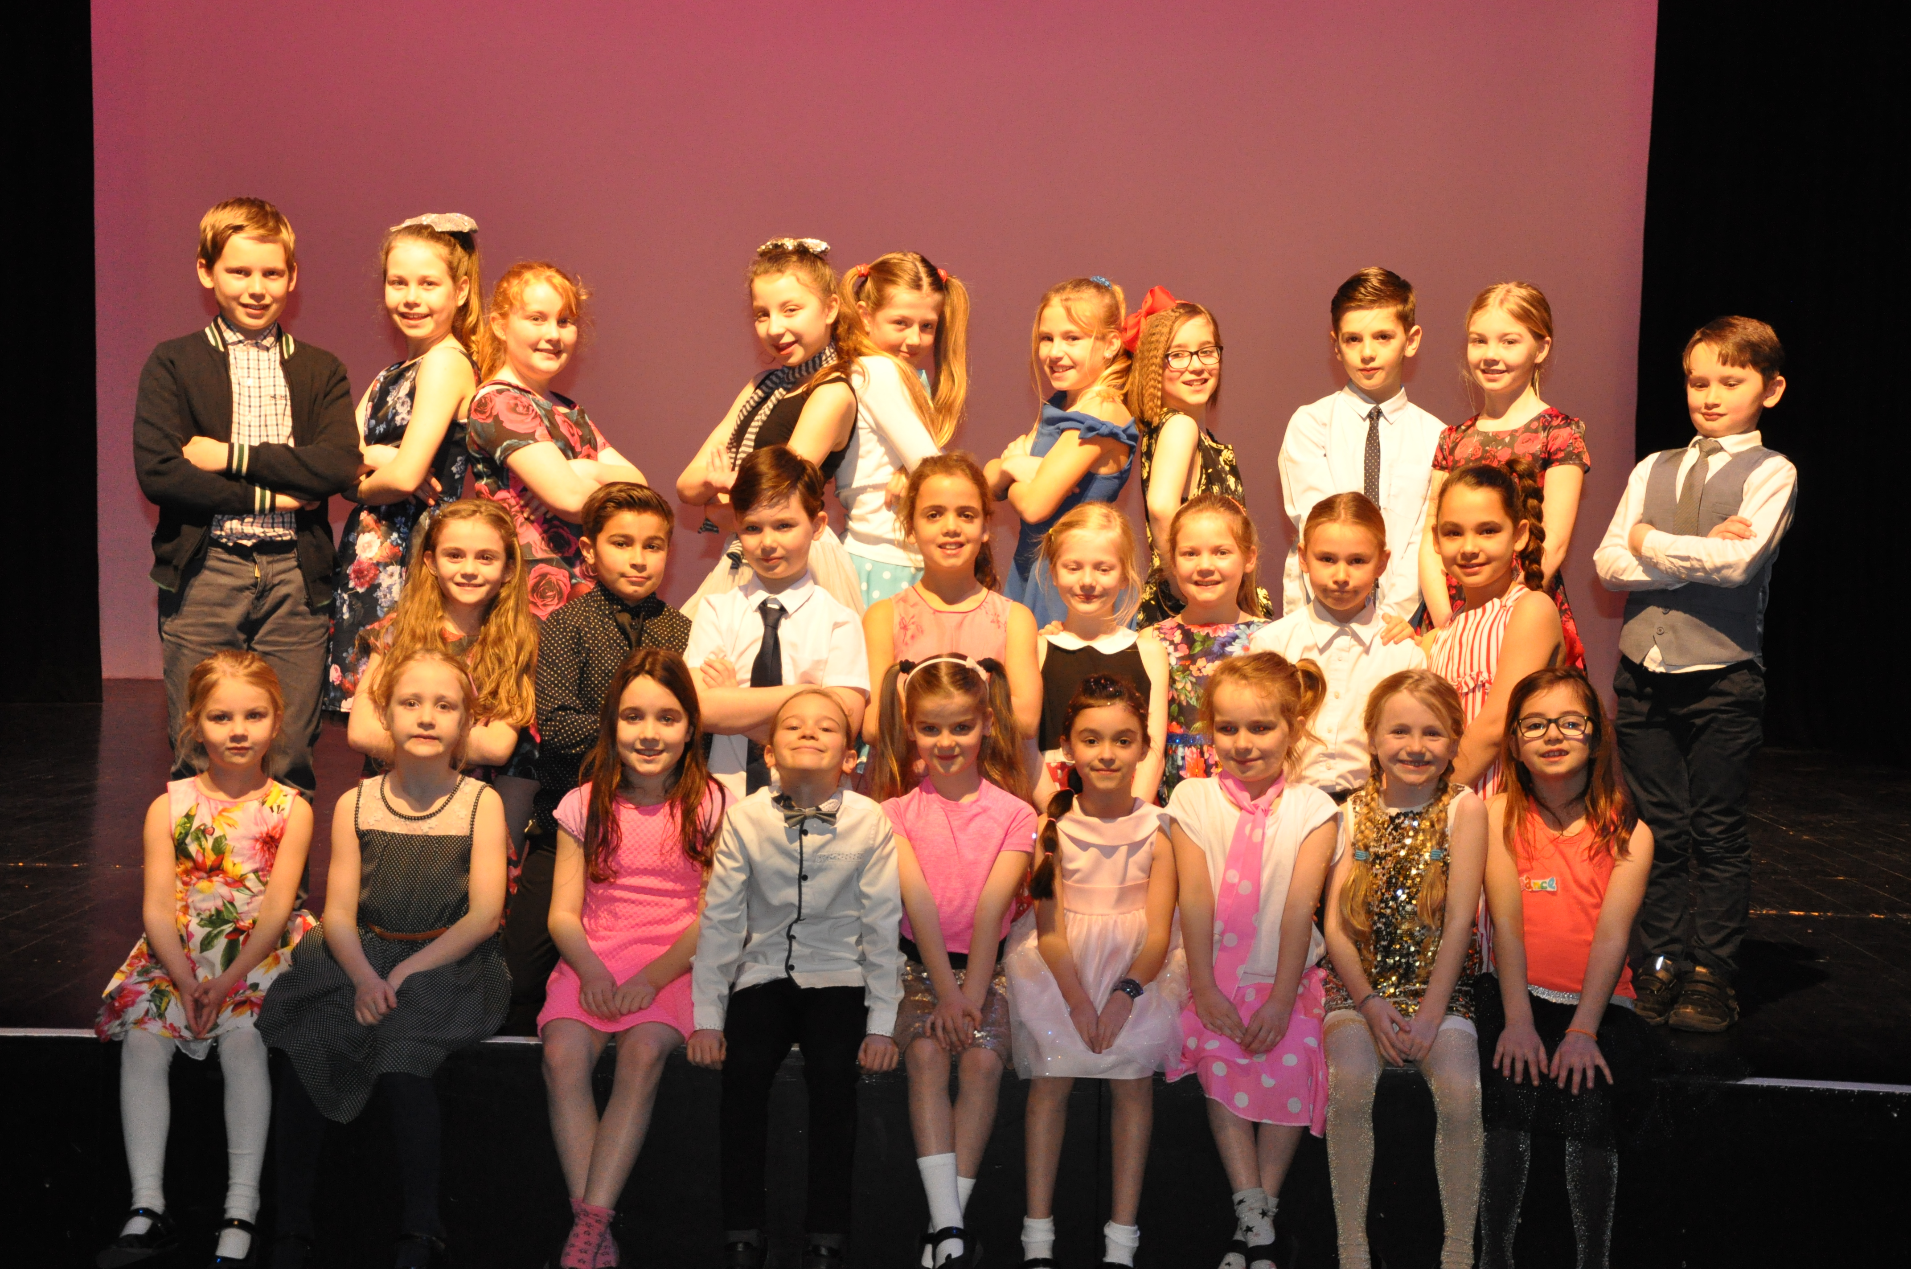
A big thank you also to the parents for transporting the children to rehearsals.

Wow Maths Day
On 26th March the whole school took part in ‘Wow Maths Day’. Details on how each class got involved are as follows:

Early Years Foundation Stage

EYFS thoroughly enjoyed their ‘Wow Maths Day.’ The Nursery children explored positional language by making lines and different paths and following them. They told each other what they saw along the way.
Reception children found out how much liquid different containers held and were surprised to see the tallest container actually held the least!
The afternoon activity was all about turning flat shapes into fat shapes. The children explored various 3D shapes and began to describe them!
Year 1&2

Year 1 and Year 2 had a fabulous time on the ‘Wow Maths Day’. From money work, symmetry drawing and doubling games on the whiteboard to a Smartie Challenge where they counted, tallied and made bar graphs, our morning was full to bursting.

In the afternoon they went to the Village Hall and used PE equipment to work out some addition and subtraction word problems. They then went on to make arrays to work out multiplication and division word problems. There are some photos to view on our class page.

Year 3&4
The Year 3&4 morning Maths was based around the Winter Olympics. They started by having one hour to solve Maths clues to find out who had stolen the missing curling stones. Just within the time we had solved all the clues and identified the culprit. Later we worked out sums to break the number code to find the names of different sports held at the event.

Our science lesson was spent measuring the length of the skeletons bones, weighing out healthy portions of food and measuring quantities of ‘blood’ (red coloured water!)

Then our Wow Maths met RE. Here the children were matching numbers to people and stories from the Bible. Here are some: 3=Wise Men 24=Days of Advent 40=Days of Lent. The children enjoyed their learning – all based around Maths.

Year 5&6

They had a cool time investigating the freezing temperatures this week; carrying out a controlled experiment recording the changing temperature of liquids in different locations. The children then displayed their data in a variety of ways and were able to interpret their findings and draw conclusions from them.

All classes enjoyed their ‘WOW Maths Day’.

Crucial Crew

On 27th February the Year 6 pupils attended an extremely informative Crucial Crew morning at Morgan’s School, Hertford. A number of companies, charities and the emergency services all took part. They created real life scenarios for the children to experience and think about, such as fire hazards, using the recovery position and railway safety. In each scenario the children were taught how to keep themselves safe. Although this was an extremely serious morning, the organisers did their best to make it fun and the children enjoyed it. As always our children were praised for their excellent behaviour and contribution to discussions

Thank you to Mrs Thomas for transporting and chaperoning the children to the event and also to Mrs Nicholson for transporting the children.

World Book Day
On 1st March the children took part in World Book Day by dressing up as book characters and/or bringing in an artefact from a favourite book. Individual classes took part in various book related tasks in the morning.

During the afternoon children from different classes joined together in small groups to share books. The Junior classes got to ‘Hot Seat’ me to find out which character I was portraying. In some cases it took several guesses!

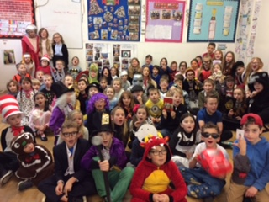

Thank you to Mrs White for arranging a quiz for the children and also to the parents who came in to share their favourite children’s book with classes towards the end of the day.

Every child was given a £1.00 World Book Day voucher (10 books to choose from most book retailers) to purchase a £1.00 World Book Day book or put towards another book.

Another one of the challenges of the day was to ‘Guess the Staff Member.’ You will find out the winners in the next newsletter.
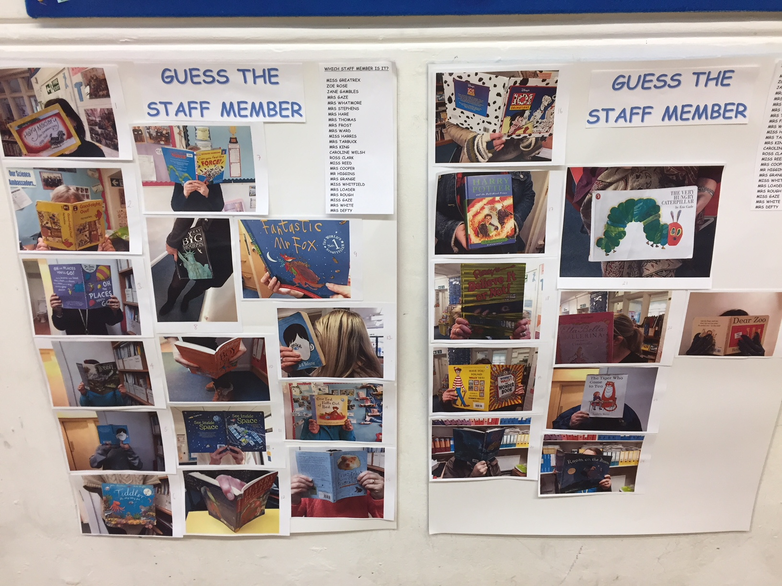

Year 1&2 Open Assembly
Everyone invited to attend the Year 1&2 assembly on Thursday 22nd March at approximately 9.15am at the Village Hall. No booking required.

Village Life Magazine
We now sell the Village Life Magazine, which is full of lots of colourful information about the local parishes. This could be an opportunity to advertise your business or find a trader. Only 60p a copy.

Video Clips on our Website
We plan to place a video clip of the children taking part in recent events. A letter will be sent out to parents in due course for you to indicate if you do/no not wish your child to appear in the clips. To view a short trial clip from World Book Day, visit the website and click on the ‘Newsletter’ pencil tab on the home page. Kind regards
Miss Greatrex

Friends of Thundridge School
As you can see from the photograph of our Thund-raising Thermometer, we have now successfully raised almost £3,800 (thanks also to the £1,000 from HSBC pound-matching!). This is fantastic news and thank you again for all your support! We are looking into the purchase of the promised 10 laptops as we ‘speak’!
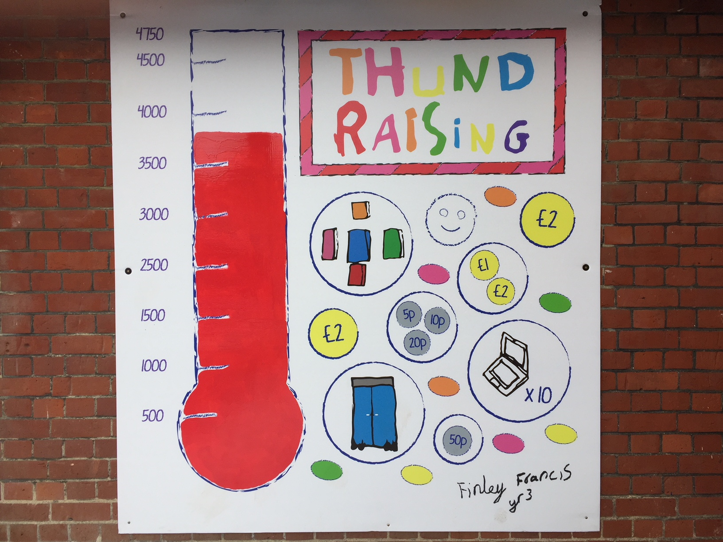

Mother’s Day Gifts
The Friends Committee have been busy helping the children make individualised gifts this week and the lovely – and lovingly - hand-made gifts will be on sale next Friday, so please be sure to send your children in with £2.50 each in a named purse or envelope.

Sponsored Walk
The Friends Committee have taken the decision to postpone this event to later on in the Spring so watch this space for details, dates etc… Apologies for any inconvenience.

Friends Summer Event
This year’s Summer event will follow Sports Day on Friday 29th June so please put it in the diary. If anyone has any ideas regarding themes for the event, or would like to help out, please could you speak to one of the Committee, or let Zoe know.
Thank you for your continued support.
The Friends Committee

