THUNDRIDGE CHURCH OF ENGLAND

PRIMARY SCHOOL NEWSLETTER

SUMMER WEEKS 4-6

6TH JUNE 2018

WHAT’S GOING ON THIS WEEK
4th-8th June | Year 5&6 - School Journey Week
Tuesday 5th June | Library – Year 1&2
Wednesday 6th June | Years 5&6 – No Swimming
Thursday 10th June | Rounders – collect 4.15
Friday 11th June | Library - Juniors – am
WHAT’S ON LATER
Tuesday 12th June | Library – Year 1&2
Wednesday 13th June | Swimming Year 5&6 – am
Thursday 14th June | Rounders – Collect 4.15
Friday 15th June | Library - Juniors – am  Friends Committee – Selling of Father’s Day Gifts
Monday 18th June | Year 5&6 – Worldwide Games – Wodson Park – am
Tuesday 19th June | Whole School NSPCC Assembly & Workshops
Thursday 21st June | All of Years 3-6 – Cluster Sports – am at Puller Memorial School
Friday 22nd June | EYFS School Trip to Paradise Wildlife Park
Monday 25th June | Some children from Years 2-6 – District Athletics at Wodson Park - pm
Wednesday 27th June | Years 1&2 School Trip
Thursday 28th June | Years 5&6 Open Assembly – Everyone welcome - Village Hall  Special World Cup Lunch – Everyone welcome to join - flyer to follow - £2.40
Friday 29th June | Sports Day followed by Friends Fun Day
Friday 6th July | Contingency Sports Day/Friends Fun Day
Wednesday 11th July | Open Evening 5.00-7.00
Thursday 12th July | Moving up Day – All children visit their new classes – am
Friday 20th July | Year 6 Leavers Assembly - am  Last day of term – Finish at 1.30
Monday 3rd Sept | Inset Day
Tuesday 4th Sept | First Day of Autumn Term

Birthdays

1ST June – Rachel Grierson
1st June - Isabella Le Grys
7th June - Mrs K ing
10th June - Elena Smyth

Awards Friday 11th May 2018

Head Teacher Award
Joe Evans for increased motivation, engagement and positivity.

Class Awards:
Foundation Stage – Arley Fenton & Bradley King
Year 1&2 – Sam Field & Jack Turner
Year 3&4 – Rose Adams & Rylie Sampford
Year 5&6 – Alfie Pearce

Lunch Staff Awards:
Kian Bartlett, Neve Chappell & Hayden Mann

Well done all of you!

Awards Friday 18th May 2018

Head Teacher Award
All of Year 6 for their fantastic efforts and positivity throughout SATS week.

Class Awards:
Foundation Stage – Josie Brown & Amy Johnson
Year 1&2 – Tommy Brown & Sydney Marshall
Year 3&4 – Chloe Haworth & Freddie Shirley
Year 5&6 – All of Year 5 for their dedication to learning karate and performing in front of the whole school.

Lunch Staff Awards:
Ava Field & Lily-May Hewlitt-Makin

Well done all of you!

Awards Thursday 24th May 2018

Head Teacher Award:
Ronnie Best for having a growth mindset resulting in a great improvement in learning.

Class Awards:
Foundation Stage – Hayden Mann
Year 1&2 – Ronnie Best
Year 3&4 – Finley Francis & Mason King
Year 5&6 – Joe Evans & Ruby Robinson

Lunch Staff Awards:
Ronnie Best, Roxy Kripp & Chloe Pearce

Well done all of you!

Year 3&4 Farm Trip

On 15th May Years 3&4 spent a very exciting morning at Spackman's Farm in Standon Green End. They were welcomed by Tony, Martin and Chris and of course Bob the dog. They then treated them to a tour of the farm where they learnt lots of interesting facts about the farm's animals, the wildlife and the plants. This all linked with the children's learning on teeth, food and digestion and exploring the local area. At the end of the tour, the children were able to see and hold some animals' skulls and teeth found on the farm. Thank you very much to the Spackman Family for a very educational and thoroughly enjoyable morning.
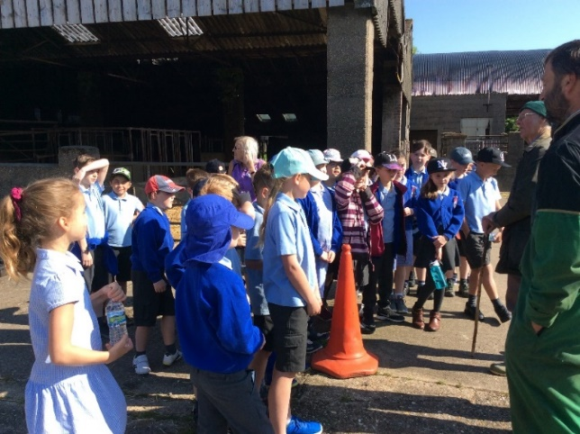

Year 5 Karate
Whilst the Year 6 children were involved in SATS Mrs Gambles, our Administration Assistant, kindly took the rest of the class, our Year 5’s, for daily sessions of Shotokan karate. These sessions lasted one hour and fifteen minutes and were an introduction with a focus on discipline, respect and this art form. The children thoroughly enjoyed the course and at the end of the week demonstrated their skills to the whole school.
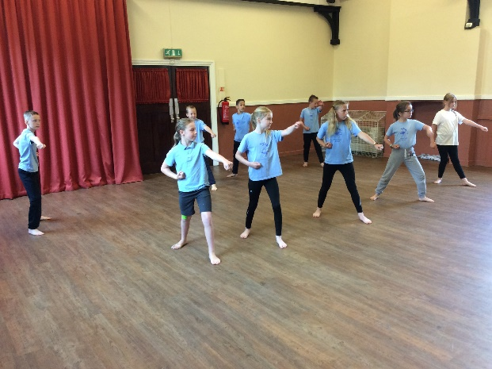

Year 5&6 School Journey
The Year 5&6 children are on their School Journey to Isle of Wight for 5 days from 4th to 8th June. Unfortunately, we were not able to join with Puller Memorial School this year, due to non-availability, but they will be back together for Kingswood Activity Centre in Norfolk for their School Journey next summer. We will inform you in the next newsletter about all their adventures they had in the Isle of Wight. We hope the weather stays good and wish them all a great time.

Years 1&2 Agility Festival at Wodson Park

On Friday 18th May, Years 1&2 took part in the Multi- Skills Festival at Wodson Park. The children had a fantastic morning taking park in lots of fun agility activities. They were jumping, skipping, running, throwing to a target and especially enjoyed the tennis skills. Thank you to all the parents who helped get everybody back to school again afterwards!
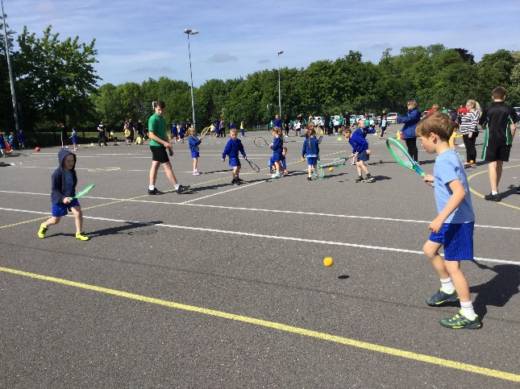

Year 6 Leaver Hoodies
The year 6 parents arranged and paid to have personalised hoodies made for their children. The Friends Committee kindly donated £100.00 towards the cost, I am sure you will agree they look great!.

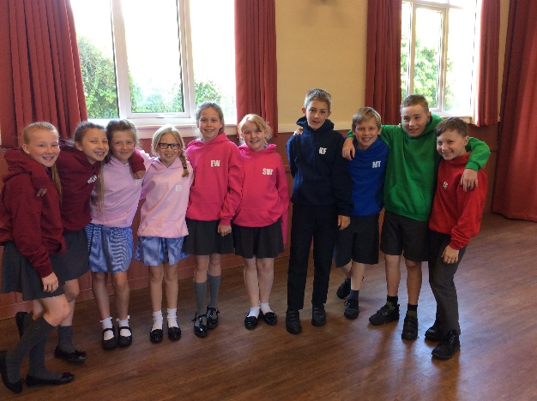

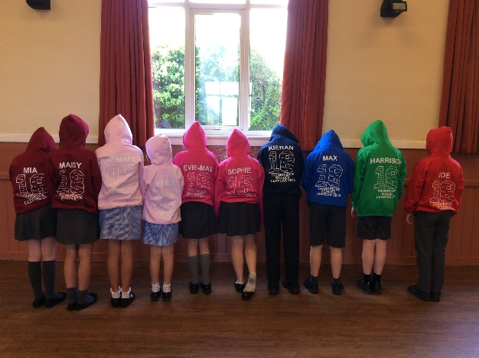

Walk to School Week – 21st- 25th May 2018
Well done to all those who walked to school last week. It would be great to see more of you walking on a regular basis now the summer weather is here and to avoid congestion in Ermine Street.

Year 5&6 School Journey
The Year 5&6 children are on their School Journey to Isle of Wight for 5 days from 4th to 8th June. Unfortunately, we were not able to join with Puller Memorial School this year, due to non-availability, but they will be back together for Kingswood Activity Centre in Norfolk for their School Journey next summer.

We will inform you in the next newsletter about all their adventures they had in the Isle of Wight. We hope the weather stays good and wish them all a great time.

A message from Thundridge Beavers And Cubs….

We have vacancies in our Beaver Colony and Cub Pack. If you have a son or daughter aged 6-10 years old who would like to join us, please come along on Tuesday 5th June. Beavers 4.45pm-5.45pm and Cubs

6.00pm-7.15 pm.

For further details contact Jenny Matthews on

01920 461582.

Reminders….

EYFS Parents

Can we please ask EYFS parents to come to the teachers to collect your children rather than waiting at the end of the playground. Also, please may we remind parents to be punctual when collecting their children at both midday and end of school collections.

Library Books
Can you please ensure your children bring their library books back to school. They will not be able to take others out until previous books on loan are returned.

Consent Forms for photographs and video
Please return this form asap, one for each child please.

In school on a Daily Basis….
Please ensure your children have a NAMED PE kit, water bottle, sun hat and rain coat in school every day.
On hotter days please apply sun cream before school.

Dates
New dates have been added to the calendar list

No dogs are allowed on the school premises unless guide dogs please.

Kind regards
Miss Greatrex

Friends of Thundridge School

Royal Wedding Karaoke Disco
To celebrate both the end of SATS week and the Royal Wedding, the Friends organised a Karaoke Disco for all the children. It was a great event, everyone dressed up or accessorised in red, white or blue, and even the face-painting and fairy cakes followed the same theme!

Many thanks to all those who made cakes and to all the extra helpers on the night too -without everyone pulling together as they did, these fun events would just not be possible! THANK YOU!!

Here are a few pictures from the evening – and thank you also to the “Duke & Duchess of Sussex” (aka Nathalie and her Dad!) for coming along to welcome the children into the hall!
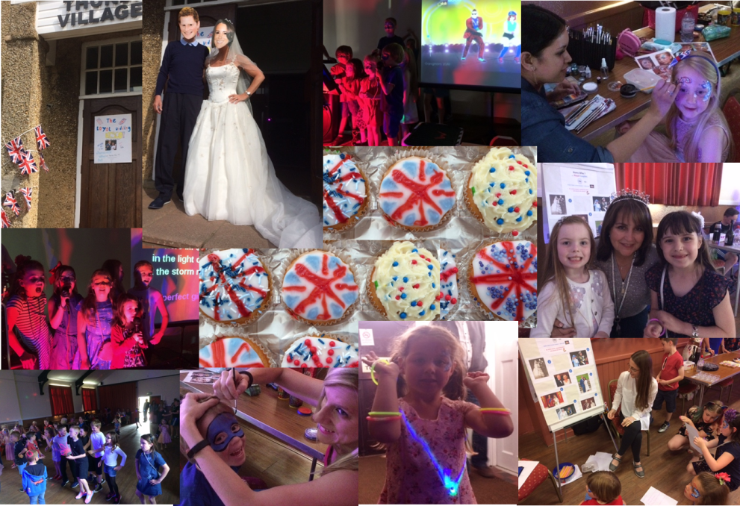

Friends World Cup Summer Event – FRIDAY 29th JUNE 3-6.30pm ish (AFTER SPORTS DAY)
Please put the date in your diaries for our Summer Event.
Wristbands will go on sale soon for the children to play on the fun inflatables, and Summer Grand Draw tickets will soon be available too!

