`

THUNDRIDGE CHURCH OF ENGLAND

PRIMARY SCHOOL NEWSLETTER

SPRING WEEK 6

FRIDAY 15TH FEBRUARY 2019
WHAT’S GOING ON NEXT WEEK
18th – 22nd February | Half Term
Monday 25th February | Year 6 SATS Booster Collect 4.15
Tuesday 26th February | Children Under 5 Free  Stay and Play. 9.30-11.30  Choir – Collect 4.15
Wednesday 27th February | Year 6 SATS Booster Collect 4.15
Thursday 28th February | Dance Festival – 8.00pm
Friday 1st March | Friends Committee  St David’s Day School Disco
WHAT’S ON LATER
Monday 4th March | Year 6 SATS Booster Collect 4.15
Tuesday 5th March | Choir – Collect 4.15
Wednesday 6th March | Year 6 SATS Booster Collect 4.15
Thursday 7th March | World Book Day Details to follow
Friday 8th March | Year 1&2 Class Assembly  9.15 at the Village Hall
Tuesday 12th March | Children Under 5 Free  Stay and Play. 9.30-11.30
Thursday 14th March | Whole School Science Day
Friday 15th March | Year 6 - Crucial Crew Workshop
W/C 25th March | Friends Committee  Selling of Mother’ Day Gifts
Tuesday 26th March | Children Under 5 Free  Stay and Play. 9.30-11.30  Choir Rehearsal - 9.00-12.45  Concert 6.45
Friday 5th April | End of Term - Finish 1.30
8th April – 18th April | Easter Holidays
19th – 22nd April | Easter Weekend
Tuesday 23rd April | Inset Day
Wednesday 24th April | First day of Summer Term
Friday 26th April | Friends Committee  St Georges Day Non Uniform Day
Thursday 2nd May | Class Photographs
Monday 6th May | Bank Holiday Monday
Sunday 12th May | Friends Committee - Sponsored Walk around Youngsbury - Morning
13th – 16th May | SATS Week for Year 6
Friday 24th May | School Closed - Inset Day
Mon 27th May – Fri 31st May | Half Term
17th - 21st June | Year 5&6 School Journey
Friday 28th June | Sports Day followed by Friends Committee Event
Friday 5th July | Contingency Sports Day
Tuesday 23rd July | Last day of term
Monday 2nd September | Inset Day
Tuesday 3rd September | First Day of Autumn Term

Birthdays…

Macy Cyl – 20th February
Lydie Fagan – 26th February
Dana Harris-West – 27th February
Charlotte Chamberlain – 28th February
Mrs Harrison – 28th February
Mrs Le Grys – 3rd March
Hayden Mann – 4th March
Roxy Kripp – 6th March
Miss Reed – 6th March
Finley Francis – 7th March

Awards Friday 8th February 2019
Head Teacher Award
Aoife Obrien for showing a really good ‘can do’ attitude in all her work.

Class Awards:

Foundation Stage – Leona Fox & Michael Mann

Year 1&2 – Billy Baker & Amy Johnson

Year 3&4 – Mason King & Rylie Sampford

Year 5&6 – Ruby Stern & Alex Warner

Lunch Staff Awards: Oliver Chamberlain, Lily May
Hewitt-Makin & Ruby Robinson
Well done all of you!

Awards Friday 15th February 2019
Head Teacher Award
Isla Grierson for always being a positive and conscientious student and stretching expectations.

Class Awards:

Foundation Stage – Whole class for their effort and
preparation for their ‘Tea Party’

Year 1&2 – Ava Field & Phoebe Le Grys

Year 3&4 – Sam Field & Freddie Shirley

Year 5&6 – Chloe Haworth, Roxy Kripp &
Martha Stopps

Lunch Staff Awards: - Mortimer Davy, Dita Purser,
Thomas Smyth & Zoe Thomas
Well done all of you!

House Points
We are now using our Sports Day Houses for more “competitive” and team building ways throughout the school. Each class has reward systems in place where children can earn house points in a range of different ways. The children can also earn points for their house for each lap of the field they complete in Awake and Active. This is another lovely way to see the children across the school working together.

Week 1 Winning House – Tied - Clarkson and Wodson
Week 2 Winning House – Barclay
Week 3 Winning House - Clarkson

Junior Dragons

We have just heard the ‘Superdragons’ who judged the teams awarded Thundridge School two trophies which will be presented in assembly in the near future. They were for ‘Best Poster’ and for ‘Team Unity’, which means that the judges felt that the whole year group contributed and showed outstanding team work. Well done Thundridge School - a magnificent result!

Foundation Stage Class Assembly
Parents and the rest of the school were treated to a wonderful insight into the work our Reception and Nursery children have been learning. They confidently sang together and spoke clearly in front of so many people and showed the dinosaurs they had been making. Well done to all of them. It was lovely to see how much they enjoyed sharing their work.
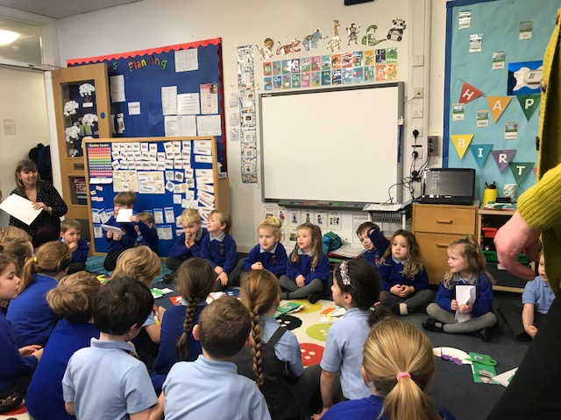

Netball & Football
On 7th February the football team played a match away against Larkspur School, the score was 2-0 win to Larkspur School. Unfortunately, they do not have a netball team to play against.

Early Years Foundation Stage Tea Party!

Today EYFS had their tea party linked to the story "The Tiger who came to tea." The children led the learning throughout the week, making lists of what was needed for the tea party and learning to make real tea. They explored the story in depth discussing what they would do if a tiger came to tea at their house and who they would like to visit for tea themselves. The party was a great success and a wonderful opportunity for the parents to share in their children's learning.

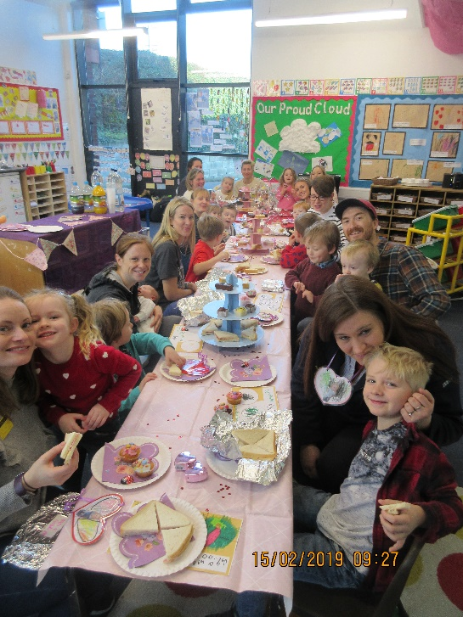

Reminders…

Free! – Under 5’ Stay & Play Sessions
From 9.30am to 11.30am
Come and join our Early Years Foundation Stage class for a morning of fun with arts and crafts etc. Please spread the word, tell your friends and family to come and join us. The next sessions will be held on:

Tuesday 26th February
Tuesday 12th March
Tuesday 26th March

Just turn up or book a place on 01920 462642 or email admin@thundridge.herts.sch.uk

Friends Committee

Love was in the air today at school for end of term Valentines non-uniform day, children were encouraged to wear anything pink, white, red or blue. By the looks on their faces, today was going to be a fun day full of love and happiness.

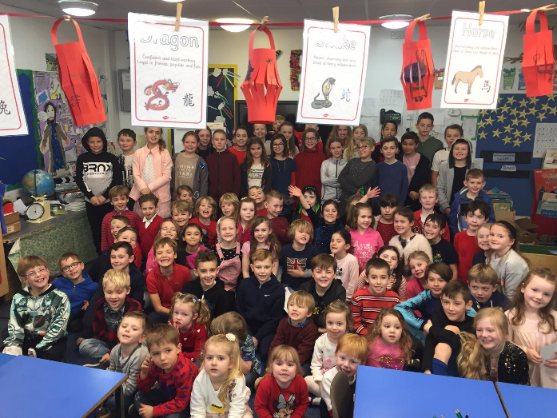

Dates for the Diary….

March

St David’s Day School Disco – Friday 1st March

Mother’s Day gifts on sale – w/c 25th March

April

St George’s Day Non Uniform – Friday 26th April

May

Sponsored Walk around Youngsbury – Sunday May 12th (morning)

June

Friends Summer Event - Friday 28th June

(Please let Mollie know if anyone knows of and bands who might play at this event).

Thank you for your continued support
Friends of Thundridge School

