THUNDRIDGE CHURCH OF ENGLAND

PRIMARY SCHOOL NEWSLETTER

SPRING WEEK 10

FRIDAY 5TH APRIL 2019

WHAT’S GOING ON NEXT TERM
Monday 22nd April | Easter Monday
Tuesday 23rd April | Inset Day
Wednesday 24th April | First Day of Summer Term  Year 3&4 and Year 5&6 -  K’nex Challenge  Year 6 SATS Booster Collect 4.15
Thursday 25th April | Magical Math’s Collect 4.20
Friday 26th April | Library – Year 3&4  Friends Committee  St Georges Day Non Uniform Day
WHAT’S ON LATER
Monday 29th April | Year 6 SATS Booster Collect 4.15
Tuesday 30th April | Children Under 5 Free  Stay and Play. 9.15-11.15  Library – Year 1&2 & 5&6
Wednesday 1st May | Year 6 SATS Booster Collect 4.15
Thursday 2nd May | Polling Day – Everyone to have home or school packed lunch  Magical Math’s Collect 4.20
Friday 3rd May | Library – Year 3&4
Monday 6th May | Bank Holiday Monday
Sunday 12th May | Friends Committee - Sponsored Walk around Youngsbury - Morning
13th – 16th May | SATS Week for Year 6
20th -24th May | Walk to School Week
Wed 22nd May | Year 3&4 - Egyptian Day In School
Friday 24th May | School Closed - Inset Day
27th May– 31st May | Half Term
Monday 3rd June | Class Photographs
17th - 21st June | Year 5&6 School Journey
Monday 24th June | Library Reading Challenge Assembly
Friday 28th June | Sports Day followed by Friends Committee Event
Friday 5th July | Contingency Sports Day
Friday 12th July | Friends Committee School Disco
Tuesday 23rd July | Last day of term
Monday 2nd September | Inset Day
Tuesday 3rd September | First Day of Autumn Term

Birthdays…

Henry Wilson – 4th April
Dita Purser – 5th April
Mrs Thomas - 5th April
Preston Tyler – 9th April
William Haworth – 11th April
Olivia MacLeod - 12th April
Maisie Wright – 14th April
Ollie Brewer – 15th April
Mrs Welland-Price – 21st April
Arthur Wilson - 21st April
Miss Whitfield – 24th April
Brodie Fenton – 26th April
Rylie Sampford - 8th May
Amy Johnson – 14th May

Awards Friday 22nd March 2019

Head Teacher Award
Billy Cyl for a mature attitude and great effort towards all aspects of learning.

Class Awards:

Foundation Stage – Harper Rose, Leona Fox &
Jude Chappel

Year 1&2 – All children for superb behaviour and
learning at the Gunpowder Mills

Year 3&4 – Lily Mann & Jack Stone

Year 5&6 – Roxy Kripp & Charlie Millhouse

Mrs Tarbuck Award – Bethany Ward

Lunch Staff Awards: Charlotte Chamberlain,
Isla Grierson, Macy Cyl & Freddie Shirley

House Points Winner – Week 5 - Barclay

Well done all of you!

Awards Friday 29th March 2019

Head Teacher Award

The amazing Thundridge Choir for their huge effort, commitment and enthusiasm resulting in a fantastic performance.

Class Awards:

Foundation Stage – Ralph Bradley-May &
Dana Harris-West

Year 1&2 – Billy Baker & Lily-May Hewitt-Makin

Year 3&4 – Stanley Campbell & Olly Judge

Year 5&6 – Roxy Kripp & Charlie Millhouse

Mrs Tarbuck Awards – Preston Tyler

Lunch Staff Awards - Alfie Pearce

House Points Winner – Week 6 Barclay
Week 7 Wodson

Well done all of you!

World Book Day
On 7th March we also celebrated World Book Day with a quiz and poetry trail arranged by Mrs White. The winners in Year 3 were Charlotte Chamberlain and Isla Grierson and in Year 4 Aden Kilinghan, Oliver Chamberlain, Izzy Le Grys and Dita Pursar. These children were able to name all the missing characters from the front covers and titles of books that Mrs White had copied from our school library. Well done to these children whose efforts were rewarded with a £2.00 Book Token.

Early Years Foundation Stage Trip

On 13th March EYFS visited Foxholes Farm in Hertford. They had a wonderful morning where they fed pigmy goats, sat in a tractor and got to taste some of the yummy food. All the children enjoyed themselves... they even named a 2 week old calf - Jet!

The children could not quite believe how big the tractor wheels were and enjoyed sitting in it and see its features. After lunch the children were given a tour of the shop and learned about all the different produce.

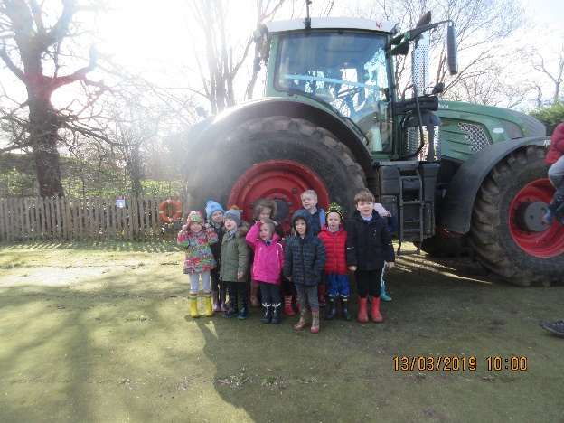

Science Day

On 14th March, we celebrated British Science Week with our own Science Day. The whole school spent the day working scientifically, asking questions, investigating and testing predictions.

Well done to all the children who took part in the home science project and shared them in our science assembly. They were all fantastic and are on display in the library area!

Author visit
On 19th March the children were very lucky to meet Author, ‘Billy Bob Buttons’, Edward Trayer. Billy Bob Buttons had a one hour session with each class.

In EYFS the children had a real treat when they were visited by Billy Bob Buttons. He shared his books with them and even read one of his stories ‘The Hungry Grasshopper’. The children really enjoyed this experience.

In Year 1&2 they learnt how to make our writing "sparkle" by using interesting words. He explained that this keeps our reader wanting to know what's going to happen next and stops them being bored. The children had a little competition. They listened to ‘Billy Bob Buttons’ read an explanation of one his monsters and they had to draw it from our imagination. The winner got one of ‘Billy Bob Button's’ signed books. The winner was Thomas Smyth.

In the Year 3&4 class the children were reminded that in all the best stories, the characters need to appear real to the reader. To do this they were encouraged to come up with similes to describe characters that compared with things that other children in the class could picture. The children joined in enthusiastically. Ending the session, Billy Bob Buttons read to the children from one of his own favourite stories.

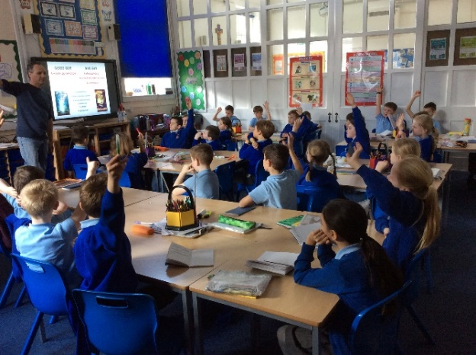

In Year 5&6, the children learnt from ‘Billy Bob Button’s how to structure a story. They talked about the importance of getting the characters plot and setting right and how crucial it is to make the first few sentences of your story exciting to entice the reader to read on.

Year 1&2 Trip to Gunpowder Mills
On 21st March Year 1&2 went to the Gunpowder Mills to enjoy a Victorian Day. They had a great time. Ladies always went first in the Victorian times, so our gentlemen had to wait for us to sit, open doors for us and let us walk in front. They experienced a Victorian Workhouse and a Victorian School. They learnt about Victorian holidays and played with Victorian toys. They had a marvellous time!

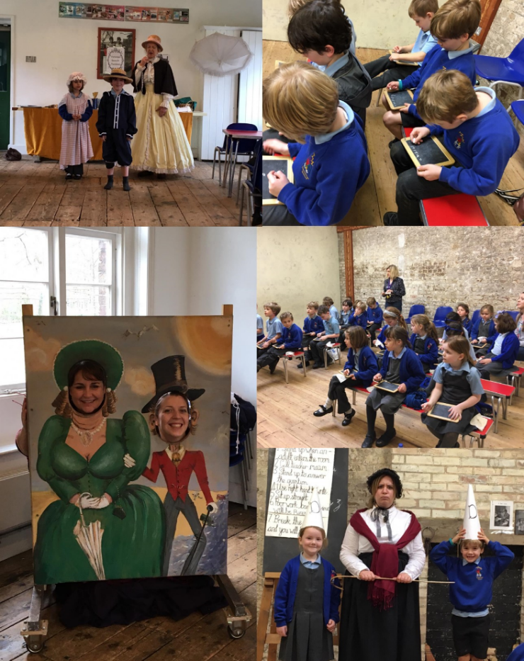

Football Tournament
On 25th March 9 members of the football team represented Thundridge School in the Hertford & Ware Small Schools Football Tournament at Wodson Park. After a slow start to the competition by Thundridge School the team went from strength to strength with impressive wins over Hertford St Andrew (twice) and Bayford School. The overall tournament winner was Hunsdon School with Thundridge School a close second, and the team improved tremendously during the competition with particularly good performances from Kian Bartlett, Charlie Millhouse and Chloe Pearce, though all the team played well. 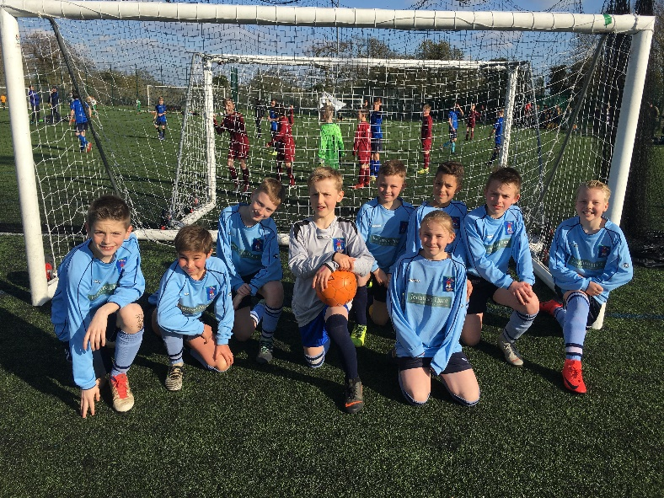

Choir
On 26th March our Choir took part in the Hertford & Ware Music Concert. The children sang beautifully and did us proud. A special well done to our readers Rachel & Isabella and the soloists Lewis & Roxy. Thank you to the parents for transporting the children to rehearsals. Thank you to Mrs Gaze for all her hard work, commitment and enthusiasm in running our fabulous choir.

Message from Mrs Gaze – I could not have been more pleased. It was an exciting, and a little nerve-racking,to sing in front of such a large audience. Well done our super choir!
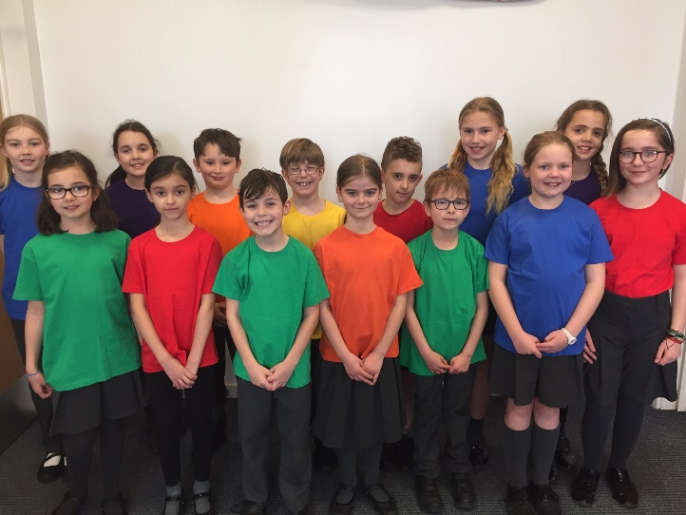

Message from Hertfordshire County Council …

The Hertfordshire Road Safety Partnership and Active and Safer Travel Team are running a campaign about the importance of wearing your seatbelt.

Most people do wear their seatbelts but still nearly ten per cent choose not to – help them make the right decision for themselves and others. If you have friends or family, who still do not realise how important it is to belt up, have that conversation and make sure they know how much you value their safety, and everyone else’s in the vehicle. Please make sure children are secured in the most appropriate car seat for their age and height. For more on seatbelts and car seats go to www.hertfordshire.gov.uk/seatbelts

The Hertfordshire Road Safety Partnership is supporting the seatbelt campaign run by Roads Policing, raising awareness about the importance of wearing your seatbelt. You can receive a fine of up to £500 if you are caught not wearing your seatbelt.

* Air Ambulance Stamp Appeal*
Our ongoing Stamp Appeal supports the UK's Air Ambulance Services, we are now working in conjunction Xchange Master Ltd, so we have changed our postal address and can now provide Freepost envelopes.
The UK’s Air Ambulance Services are charities which receive no government funding and reply entirely on charitable donations to continue flying and responding to life threatening medical emergency. We can recycle your used postage stamps in to funds to help these vital services.
All kinds of stamps are welcome, on or off paper. You just need to leave no more than a 5mm single thickness border around them, and the perforations should not be damaged.
Anyone can help; individuals, businesses and schoolchildren can all collect stamps to support the UK''s Air Ambulance Services.
So remember to keep all the stamps you receive as every stamps really does help!!! Please give your used stamps to Zoe.

Have a great Easter
Everyone

Kind regards
Miss Greatrex

