THUNDRIDGE CHURCH OF ENGLAND

PRIMARY SCHOOL NEWSLETTER

SUMMER WEEKS 4-7

19th JULY 2019

WHAT’S GOING ON NEXT WEEK
Tuesday 23rd July | Leavers Assembly – Village Hall – 9.15  Last day of term finish at 1.30
WHAT’S ON LATER
Monday 2nd September | Inset Day
Tuesday 3rd September | First Day of Autumn Term

Birthdays…

15th July - Martha Stopps
18th July - Aoife O’Brien
25th July - Ruby Robinson
27th July - Henry Haworth
29th July - Jack Turner
1st August - Miles Collins
19th August - Libby Adams
19th August - Rose Adams
19TH August - Ruby Stern
20th August - Mrs Grange
20th August - Harper Rose
22nd August - Lily-May Hewitt-Makin
26th August - Lewis Greatrex
27th August - Isla Grierson
30th August - Mrs Gaze
30th August - Mrs Hare
31st August - Mrs Loader
3rd September - Sydney Marshall

Awards Friday 28th June 2019

Head Teacher Award-
Freddie Shirley for a very positive attitude towards his learning and never giving up.

Class Awards:

Foundation Stage – Archie Chamberlain &
Brodie Fenton

Year 1&2 – Ioanna Koumi, Marina Koumi & Jack Turner

Year 3&4 – Milan Cope & Fearne Watson

Year 5&6 – George Hartfield, Chloe Haworth,
Jake Satt & Alex Warner

Lunch Staff Awards – Izzy Basham & Maisie Wright

Well done all of you!

Awards Friday 5th July 2019

Head Teacher Award-
Fearne Watson for being a supportive friend to somebody experiencing a difficult situation and standing up for what is right.

Class Awards:

Foundation Stage – Brodie Fenton & Preston Tyler

Year 1&2 – Josie Brown & George Harbour

Year 3&4 – Charlotte Chamberlain, Isla Grierson
Isabella Le Grys & Dita Purser

Year 5&6 – Ruby Robinson & Callum Wareham

Mrs Tarbuck Award – George Harbour

Lunch Staff Awards – Milan Cope, Macy Cyl &
Freddie Shirley

House Points Winner – Hanbury & Wodson

Well done all of you!

No Awards week commencing 12th July 2019

Awards Friday 19th July 2019

Head Teacher Award-
Kian Bartlett for an excellent attitude towards all aspects of learning and a fantastic work ethic.

Class Awards:

Foundation Stage – Ralph Bradley-May & Maisie Wright

Year 1&2 – Betsy Baker & William Haworth

Year 3&4 – All the children in Year 4 for being such a
lovely group to work with, good luck in
Year 5.

Year 5&6 – Olivia MacLeod & Francesc Thomas

Lunch Staff Awards – Maisie Wright

House Points Winner – Hanbury

Well done all of you!

Year 5 Junior Dragons - Congratulations to the Year 5 Junior Dragons team who not only raised an amazing £340. for the local charity Cats Whiskers Rescue, but also won the trophy for the Overall Winner from the six teams taking part. They organised a sponsored run, an Easter raffle and a visit from the Easter Moggy to raise the money. The team also won two other trophies for Best Co-operation with the charity and with their Dragon. Team members: Charlie, Chloe H, Elena, Leo, Lewis, Libby & Zoe. Well done!

Snowdrop Care Home Art Competition

Schools from Ware and the surrounding villages were invited to take part in this competition. The theme was Alice in Wonderland. The artwork entered was displayed around the home and residents and their visitors then voted on their favourites. We are delighted to announce that all 3 winners came from Thundridge School, Year 3&4 class. 2 representatives from Snowdrop Care Home came and joined our Collective Worship assembly on 10th July to talk about their role and present prizes to our winners:- Congratulations to 1st place Macy, 2nd place Isla and 3rd place Joseph who received goodie bags.
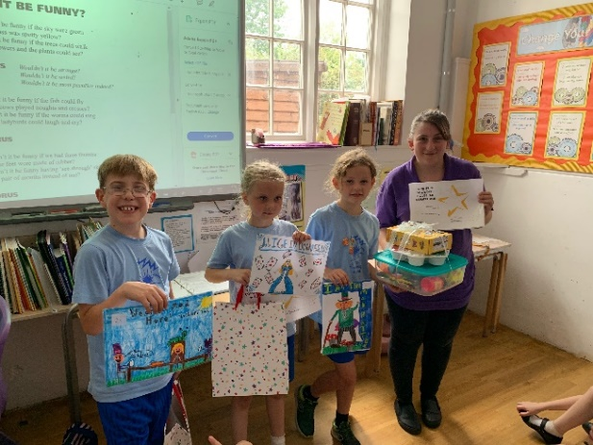

School Games Mark

This is a national award that every school has the opportunity to apply for between May and July. We are required to present evidence collected throughout the year on the school’s involvement in a range of physical activities. This includes encouraging all children to take up personal challenges, provide competitive challenges for those who already have a love of sport and developing young sporting ambassadors and leaders, within the school. We are proud to announce that we heard last week that we have been awarded the Gold Mark! A great achievement!

School Journey

On Monday 17th of June, with great excitement, Years 5&6 set off to Kingswood Activity Centre in West Runton on the Norfolk coast for a 5 day residential trip with their counterparts from Puller Memorial School. The action packed itinerary included such adrenaline fuelled activities as abseiling, rock climbing, caving, the leap of faith, dune buggying and zip-wiring. All children took a step out of their comfort zones and many conquered fears. The children worked amazingly together in the problem solving activities and team building exercises and even managed to make their beds and keep their rooms tidy! There was also time for some fun on the beach, rock pooling and paddling in the sea. The children were impeccably behaved at all times and were a real credit to the school and their families. We cannot wait for the Isle of Wight next year!

Thundridge School Choir

The Thundridge School choir members sang during the early evening outdoor service at the Old Church, Thundridge on Saturday 22nd June. Local people gathered to mark the importance of the Church within the village and Thundridge. It was a privilege to be asked and the children were excellent ambassadors for our local school and the community.

Small School Athletics

On 26th June, some children from Years 2 to 6 took part in the Athletics competition at Wodson Park competing against 7 other schools. The children took part in sprinting, longer distance and relay races. The field events consisted of standing long jump, javelin, throwing and the shot putt. The final results in the different competitions were:-

Year 2 – 4th

Year 3&4 – 1st and awarded a trophy.

Year 5&6 3rd

When all the points across the competitions were added together Thundridge School were the overall winners and were awarded a further trophy. Congratulations to you all on a fantastic achievement.

Thank you to parents who transported the children.

Sports Day

On 28th June Sports Day was enjoyed by all with great team spirit and participation by all. Everyone did their best and it was a closely won contest with Hanbury pipping Barclay to the post by one point! Well done to everyone and thank you to Mrs Frost for her meticulous organisation of this event. Thank you to all the parents too who came and supported their children.

Friends Committee

A MASSIVE heartfelt thankyou to those unsung heroes - The Friends of Thundridge Schol. You would not believe what they do behind the scenes and the work they do. The recent fete was testimony to this. On behalf of the staff I would like to express my gratitude as, at a time of huge cuts in education and budget shortfalls the money they raise is essential for our school to keep going and get those extras we so desperately need. Thank you too to Zoe who goes above and beyond her office duties to support on the administrative side of these events.

Year 5&6 Assembly

On 4th July the Year 5&6 assembly certainly told us all the true story of Kingswood! We were humorously informed of massive spiders and bugs in bedrooms, horrible food, terrifying experiences, horrible food, dodgy evening entertainment and horrible food!! Seriously now, the assembly was a treat and the children all obviously enjoyed the experience and the content of the assembly was testimony to this despite the horrible food!

Well done to the children for a great, fun assembly and a HUGE thank you to Mr Higgins and Mrs Thomas who worked so hard to make the trip such a success despite the horrible food!!

EYFS Strawberry Picking Trip

On 5th July, the children in Foundation Stage and their parents joined Miss Hare at Pearces Farm to do some strawberry picking. They had great fun seeing who could find the largest strawberry and then enjoying slices of rainbow cake! A big thank you to all the parents who transported the children and shared the sunny afternoon with us.

Cluster Sports

All the juniors took part in Cluster Sports on the morning of 10th July. This year it was held at Stapleford School with Tonwell and Puller Memorial schools making up the 4 schools competing. The morning consisted of many traditional sports day races along with some novelty team events, ending with a shortened “cross country” event. In this our “Awake and Active” mornings clearly are having a good effect with Thundridge School winning all the long distance races. The overall winners this year, were Stapleford

School with Thundridge School coming a very good second. Well done to all the children.

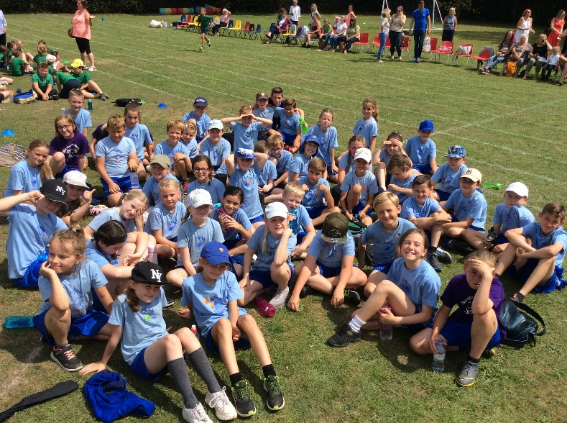

Open Evening

Open Evening on 10th July was again well attended this year and it was so good to see parents looking at their new classes where applicable and spending time enjoying the work of their children. I think next year we need to offer food and wine!

Moving UP Day

On 11th July was our ‘Moving Up Day’ when our lovely Year 6 pupils visited their new secondary schools. This gave everybody else an opportunity to move up to their new classes within our school. The new children joining our school in Nursery had a lovely morning exploring the Early Years classroom. The morning, gave everyone a chance to meet their new teachers, to ask questions and begin to feel familiar with their new surroundings. For the children staying in that class, it gave them the opportunity to explain routines and rekindle old friendships. For the teachers, this time together, was helpful to begin to lay the foundations for expectations in learning and behaviour. We all had a great time and everyone is looking forward to the new year....but not before a well earned rest!

Chauncy Community Day

This popular annual event took place on Friday 12th July. A fleet of minibuses arrived at Thundridge to transport our children to Chauncy to take part in a variety of activities. Thank you to Chauncy.

Year 1&2
Year 1&2 had a great morning learning to make music on the computer, some lovely (and loud) songs were created!
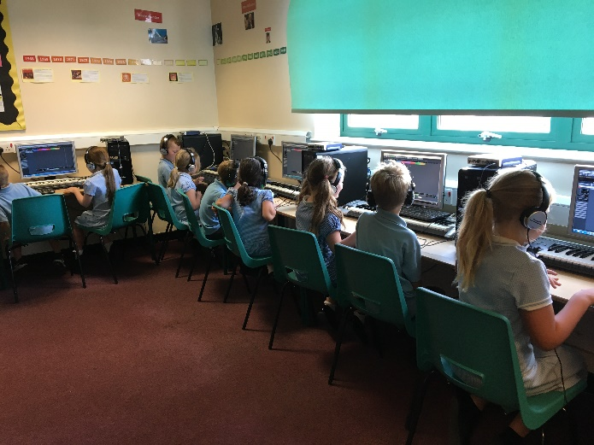

Year 3&4

Year 3&4 started with an Art and Craft session with the aim of turning a brown paper bag into a ‘Minion’. They then went outside for ‘Mini Olympics’. The children practiced their football and tennis skills and played unihoc and table tennis. After lunch they went to a Clay Workshop. They were expecting to make our Canopic Jars, but due to time restrictions, the children made an Egyptian Cat pot-without the lid instead. Finally in the Forensic Science Lab, the children had to do a range of experiments to see who had stolen and eaten the Headmaster’s chocolate cake.

Year 5&6

Community Day at Chauncy school was another fun day for Years 5&6 where they got a taster of some secondary school lessons. They enjoyed cricket and rounders for PE, put together a song in a music workshop and really excelled in the bridge building challenge in Design Technology. Just look at this amazing construction!

It was a fantastic day.

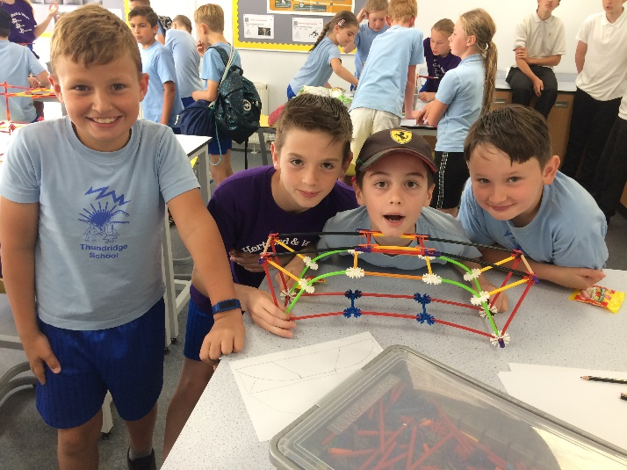

Library Assembly

The library service came into school to tell them about the Hertfordshire Library Service Reading Challenge, the details for the library are below.

Space Chase – Summer Reading Challenge in Libraries
Space Chase is an out-of-this-world adventure inspired by the 50th anniversary of the first moon landing. This summer children will help our super space family track down books nabbed by mischievous aliens! As they read library books, they will solve clues and collect special stickers to complete their mission folder.

Research shows that children's reading can 'dip' during the long holidays and this can cause children to lose confidence when they return back to school. The Summer Reading Challenge encourages children to get into libraries and helps them keep up their reading skills. It is the UK’s biggest promotion of reading for children – last year over 20,600 Hertfordshire children took part, that’s our second highest number of participants ever – and it’s free.

Children are challenged to read six library books or eBooks of their choice during the holidays. For every two books they read, they are rewarded with two stickers. When they have completed the challenge, they will receive a bookmark and some colour-in glasses and are invited to a presentation ceremony where they will be given their certificate and medal. In addition, participants will have the opportunity to win tickets to an exclusive author event with Steve Cole. The Summer Reading Challenge materials are suitable for visually impaired children.

Space Chase packs will be available in all Hertfordshire public libraries from Saturday 13th July while stocks last, finishing on Saturday 7th September.

Link to the library: www.hertfordshire.gov.uk/libraries

Kind regards
Miss Greatrex

