

**THUNDRIDGE CHURCH OF ENGLAND**

**PRIMARY SCHOOL NEWSLETTER**

**SUMMER WEEK 10**

**23rd JULY 2019**

|  |  |
| --- | --- |
| **WHAT’S ON NEXT TERM** | |
| Monday 2nd September | Inset Day |
| Tuesday 3rd September | First Day of Autumn Term  Back To School Welcome Coffee Morning at The Feathers Inn – All welcome for complimentary coffee courtesy of the Friends & Cathy at The Feathers Inn |

# **Year 6 Leavers…….**

**Year 6 Leavers Treat Day**

# This year's Leavers Treat turned out differently than anticipated but a fun time was had by all nonetheless. After a wet and disappointing  start to the day, the children kept their spirits up with a march to Woody's Play Barn where they spent a couple of fun-filled hours running riot!  They were only tempted out of the soft play by a whizz around the Sky-Ride which was an exhilarating zip-line through the trees. This was followed by a craft workshop in the Art Shed where the children spent a quiet hour painting and chatting. After lunch they all enjoyed round of crazy golf before a lovely walk back to school with ice-lollies supplied by Mrs Thomas.

It is sadly time to say goodbye to all the Year 6 children: Alfie, Billy, George, Jack, Kian, Kylie, Issie, Mollie, Olivia, Rachel, Roxy, Ruby R, & Ruby S.

**Year 6 Leavers Performance**

This term ended with our latest group of Year 6 children treating us to their own very special assembly. It was an amazing performance show casing their many talents. The staff sketch was so funny and apt! It was such a treat to watch them and see how they have all grown in confidence and maturity. Their teamwork shone through, particularly in the cup song – perfect unison!

They have been a great group to work with and we will all miss them very much.

Each child was awarded a special ‘Leavers Book’ as well as a memory stick containing photographs taken over their years at Thundridge School, including School Journeys. I am sure the children will treasure these.

We wish them all the best of luck in the future, building on their excellent achievements at Thundridge School.

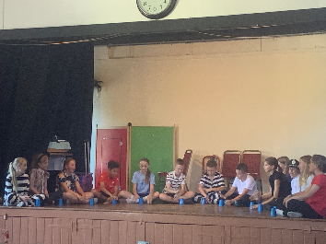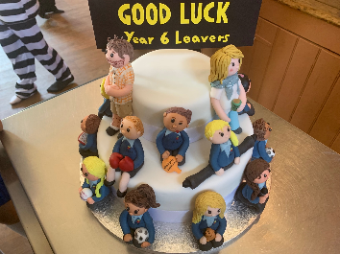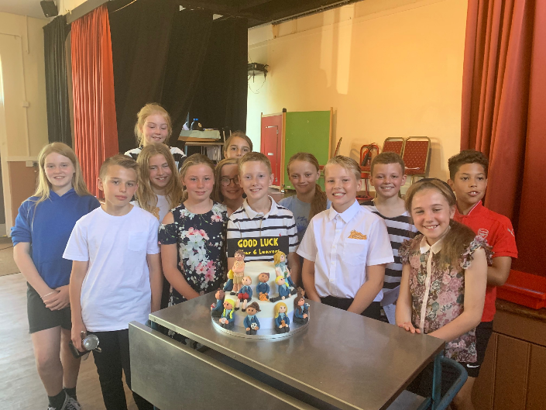

**Trophies, Congratulations to:**

**Rachel Grierson & Alfie Pearce** were both awarded the

‘Sports’ Trophy

**Ruby Robinson** was awarded the

‘Outstanding Effort’ Trophy

**Roxy Kripp** was awarded the

‘Citizenship’ Trophy

**Congratulations!**

We wish them every success at their new Secondary Schools. I am sure they will continue to reach their potential.

**Mrs Gaze**

For those who did not see the email we say a sad farewell to Mrs Gaze today. She has been an inspiration to the school and always deeply committed. She is very sad to be going, as we all are to see her go. Thank you to those parents for the wonderful gifts she received today. SHE WILL BE MISSED.

# **Labtots**

# Labtots visited EYFS class on 18th July they had an excellent morning with the 'Proff!' They explored how sound causes vibrations and as a result you can hear different sounds. They made their own straw clarinets and made a balloon talk! This really was a fantastic morning and Sophia night to life science in a fun and very engaging way.

# A reminder that Labtots will be running a lunchtime club next term for KS1 and EYFS children. If you would like to join just sign up via Labtots website! https://www.labtots.com/

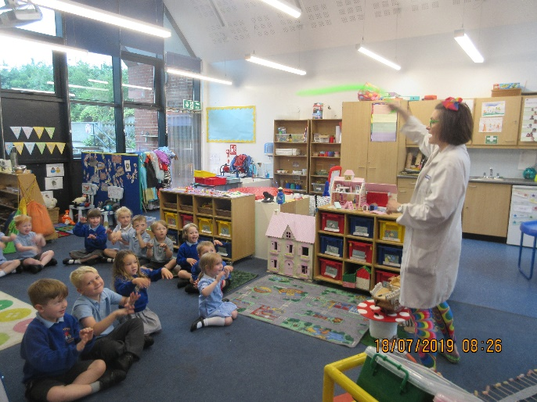

**HCC Attendance – Excellent Award 100% Attendance**

Alfie Pearce, Year 6 received the ‘Excellent Certificate’ from Hertfordshire County Council for 100% attendance

Congratulations!

**Thundridge School Attendance Awards**

The remaining year groups will receive their the Hertfordshire County Council awards next term. Also the Thundridge School attendance certificates that are awarded for attendance per term will be awarded the first week of the Autumn term due to today being the last day to check the attendance. The Year 6 children who received 100% attendance in the Summer term were awarded silver award: Billy, Issie, Rachel & Roxy.

**Rounder’s**

Thank you to Tracey Shirley for running the Rounder’s Club on a Thursday after school the children have really enjoyed it. The last game was staff against children! Yes, the children won but they did have three times the amount of children to staff, which as you can imagine made it difficult for us to field! Lots of fun was had by all. As the weather is normally still good in September Rounder’s will continue after the holidays.

**Grounds**

Thank you so much to Sandra Brooks for keeping the grounds looking so pretty and to Mrs White for the lovely window boxes.

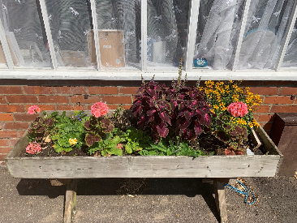

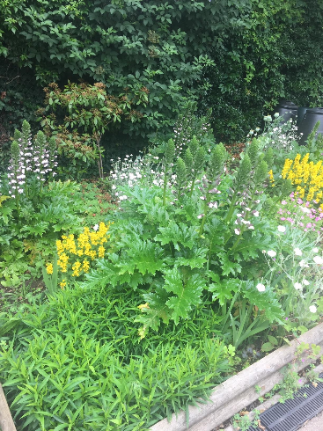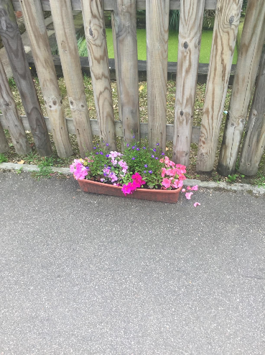

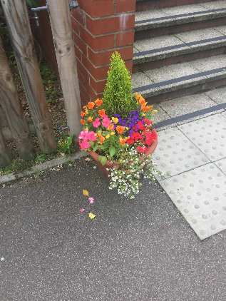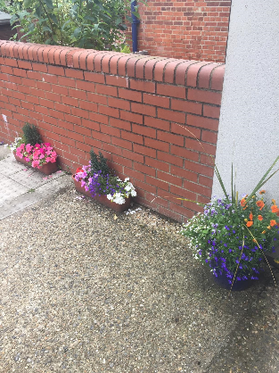

**I hope you all have an enjoyable, restful, warm and sunny summer!**

**Kind regards**

**Miss Greatrex**

**Friends of Thundridge School**

A full year at Thundridge Primary School would not be complete without attending The Friends of Thundridge School Summer Fete! The final fayre of the year, and this year was no exception! We decided to do things differently this year and hand the fundraising over to the children.

With making the most of our wonderful field and sports equipment, we asked the children to take part in a draw to decide which stalls they would be running for their house teams – all working together, across school years, with the goal of being the winning team on the day. The children were asked to design and

make their own posters and decide how much they would charge for people to have a go at their various activities.

On the day, it was all down to the pupils to run the stalls and make as much money as they could – helped out by the Friends and parents of course!!!

****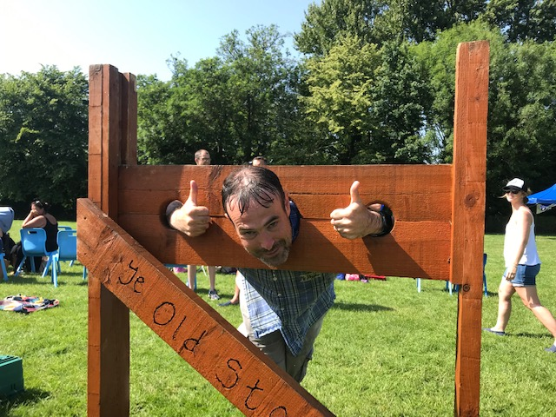****

****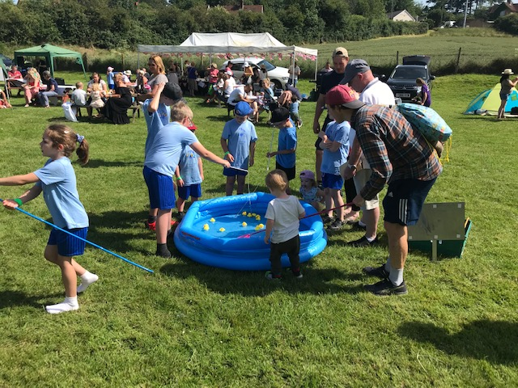

Our very own Miss Greatrex, Mrs Frost and Mr Higgins were all brilliant sports by being put in the “Clarkson” stocks and soaked with a sponge & we all witnessed some fantastic shots being made in the cross-bar challenge!

But that wasn’t all our summer Fayre was about … We had brilliant live 50’s and 60’s music from local singer Ian Goddard who helped create a wonderful atmosphere and kept everyone entertained as well as bouncy castles, a BBQ, English Tea/Cake stall and much more …

At the end of the day, once the “House” stall revenue was added up, there could only be one House team winner though and that, raising a total of £185 for the school … was Wodson. Jack Field, the Wodson captain delightedly accepted the “House Trophy” at the end of the Year 5&6 assembly! A very proud moment for everyone … (in Wodson at least!!).

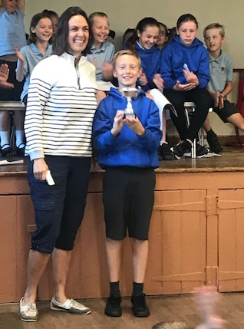

The Summer Grand Draw was also drawn that afternoon, and this time round, we offered the winners a choice of the most fabulous prizes, all of which were kindly donated by local businesses.

****Thank you so much to all the sponsors. As always, we are unable to achieve such great fundraising success with a Grand Prize Draw without the generosity of local businesses. We cannot thank everyone enough, as without their continued support we would not be able to make as much money to help support our small village school.

Finally, no end of term is complete without one last school disco, and this one was extra special as it was our Year 6’s last disco at Thundridge School before they all move on to secondary school.  Karaoke was sung, cake was eaten and finally a very large balloon drop to all of the children’s surprise!  Good luck to all of you and may the (Thundridge School) “Force” be with you!!

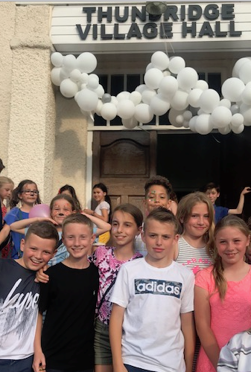

**Back to School Coffee Morning**

As always, Friends of Thundridge School will be holding a back to school coffee morning at the Feathers straight after drop off on the first day back of term.  It would be lovely to see as many faces as possible, plus any new parents joining from September, would be lovely to meet you and maybe even convince you to join the committee!!!

Have a wonderful summer and thank you, we could not do half of what we do without your support.

See you in September.

**Friends of Thundridge School**