THUNDRIDGE CHURCH OF ENGLAND

PRIMARY SCHOOL NEWSLETTER

AUTUMN WEEK 1

6TH SEPTEMBER 2019

WHAT’S GOING ON NEXT WEEK
Tuesday 10th September | Year 3&4 Curriculum Morning  Classroom 9.00-9.30  Drama Club–Years R-Year 6-  12.00-12.30
Wednesday 11th September | Year 5&6 Curriculum Morning  Classroom 9.00-9.30  French Years R-Year 6–collect-4.00
Thursday 12th September | Year 1&2 Curriculum Morning  Classroom 9.00-9.30  Rounders – Years 3-6 Collect-4.15
Friday 13th September | Library – Juniors
WHAT’S ON LATER
Monday 16th September | Foundation Stage Curriculum Morning - Classroom 9.00-9.30
Monday 23rd September | EYFS Wow Day!
Friday 27th September | Harvest Festival – St Mary’s Church 9.00am – Everyone welcome
Tuesday 22nd October | Parent Consultation Evening  3.30-6.50
Wednesday 23rd October | Parent Consultation Evening  3.30-5.20
28th – 1st November | October Half Term
Wednesday 11th December | Christmas Performance –  EYFS & Year 1&2 – Morning
Thursday 12th December | Christmas Performance –  Juniors – 2.30 & 6.30
Thursday 19th December | Christmas Pantomime  Reception to Year 6 – 1.30
Friday 20th December | Last Day of Term Finish 1.30
Monday 6th January | Inset Day – School Closed
Tuesday 7th January | First Day of Spring Term

Birthdays…
6th September – Miss Harris
9th September - Jake Satt
12th September - Mr Higgins

Awards Friday 6th September 2019

Head Teacher Award-
Preston Tyler for settling in exceptionally well in
Year 1 and trying very hard.

Class Awards:

Foundation Stage – All the children for a fantastic
week

Year 1&2 – Amy Johnson & Maisie Wright

Year 3&4 – All the children in Year 3 for an excellent
start to the Juniors and Isabelle
Sampford-Poulter

Year 5&6 – Harry March & Arthur Wilson

Lunch Staff Awards – All of Reception, Chloe Haworth
Francesc Thomas & Zoe Thomas

Well done all of you!

I hope you all had a great Summer, welcome back!

Staff would like to thank parents for the lovely gifts they received at the end of last term, they were all very much appreciated.

This is just an intial short newsletter to clarify dates etc. We are already well into establishing new routines.

Timetables and curriculum topic plans are in place and we are alredy in full swing!

Welcome to
Albert, Benjamin, Bertie, Darci, Edward, Elowen, Ferne, Florence, Fred & Henry, who have started in Early Years Foundation Stage class and Acer Wray-Howard who has started in Year 2. We hope they all enjoy their time at Thundridge School.

Curriculum mornings
Curriculum mornings are a chance to meet your child's class teacher who will give you an outline of the work your child will be covering over the year and set our classroom routines.

It is only a brief meeting of general points which will last no more than half an hour.

All to be held in the relevant classrooms, to start prompt at 9.00am please.

Individual concerns can still be addressed with the class teacher by appointment through Zoe.

Please see the list of Curriculum Morning dates:

Early Years Foundation Stage
Monday 16th September

Year 1&2
Thursday 12th September

Year 3&4
Tuesday 10th September

Year 5&6
Wednesday 11th September

Clubs….

Drama
Years Recpetion to Year 6 – Tuesdays 12.30-1.00

French
Years Reception to Year 6 - Wednesdays – collect at 4.00pm

Rounders
Year 3 to Year 6- Thursdays – collect at 4.15pm, for as long the weather permits.

Netball and football to start soon - Years 3 to 6, details to follow.

Labtots

Labtots visited EYFS class on 18th July they had an excellent morning with the 'Proff!' They explored how sound causes vibrations and as a result you can hear different sounds. They made their own straw clarinets and made a balloon talk! It was a fantastic morning.

A reminder that Labtots will be running a lunchtime club this term for KS1 and EYFS children. If you would like to join just sign up via Labtots website! https://www.labtots.com/

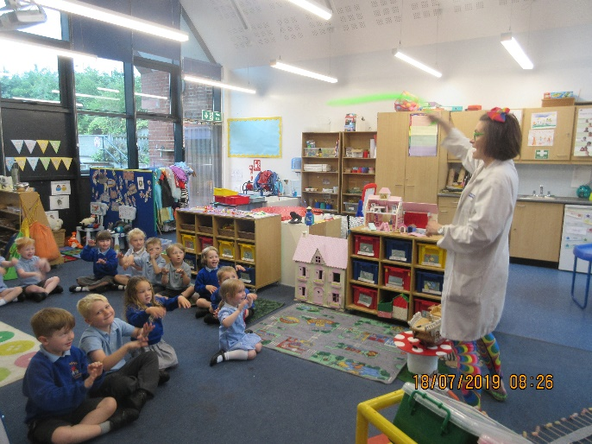

HCC Attendance – Excellent Award 100% Attendance
Arley, Brodie, Jude, Isla, Isabella LG, Lewis, Mason, Neve, Stanley, Thomas & Zoe all received an ‘Excellent Certificate’ from Hertfordshire County Council for 100% attendance for the 2018/2019 academic year.

Congratulations!

The School Gold, silver and bronze attendance certificates for last term will be given out once prepared.

Year 3&4 Class
If any children have any toys or games that clearly demonstrate forces they are invited to bring them on on Monday 9th September for their science work on forces – magnet and springs. Thank you.

Kind regards
Miss Greatrex

