THUNDRIDGE CHURCH OF ENGLAND

PRIMARY SCHOOL NEWSLETTER

AUTUMN WEEK 3-6

11th OCTOBER 2019

WHAT’S GOING ON NEXT WEEK
Tuesday 15th October | Drama Club–Years R-6 12.30-1.00  Choir – Collect 4.00
Wednesday 16th October | The Proff Science Club – Years  R-Year 2 – 12.30-1.00  French Club - Years R-Year 6  Collect-4.00  Netball & Football Clubs – Years 3-6 Collect 4.30
Thursday 17th October | Netball & Football Matches at away against Hunsdon School–Collect 4.45
Friday 18th October | New Nursery & Reception Visit Morning, 9.30  Library – Juniors  Friends Monster Ball– High Cross Village Hall – 5-7
WHAT’S ON LATER
Tuesday 22nd October | Drama Club–Years R-Year 6-  12.30-1.00  Parent Consultation Evening  3.30-6.50
Wednesday 23rd October | French Club - Years R-Year 6  Collect - 4.00  Parent Consultation Evening  3.30-5.20  Netball Club  Football Club – Collect 4.30
Thursday 24th October | Netball & Football Matches away against Bayford School–Collect 4.45
Friday 25th October | Library – Juniors
28th – 1st November | October Half Term
Friday 8th November | New Nursery & Reception Visit Morning 9.30
Sunday 24th November | Friends Christmas Fayre-Village Hall
Wednesday 11th December | Christmas Performance –  EYFS & Year 1&2 – Morning
Thursday 12th December | Christmas Performance –  Juniors – 2.30 & 6.30
Wednesday 18th December | Christmas Lunch – Whole School
Thursday 19th December | Christmas Pantomime  Reception to Year 6 – 1.30-4.00
Friday 20th December | Last Day of Term Finish 1.30
Monday 6th January | Inset Day – School Closed
Tuesday 7th January | First Day of Spring Term

Birthdays…
Harrison Campbell – 3rd October
Ferne Turner – 10th October
Thomas Smyth – 13th October
Betsy Baker – 15th October
Billy Baker – 15th October
Aden Kilighan – 17th October
Sam Field – 18th October
Fearne Watson – 18th October
Milan Cope – 20th October

Awards Friday 27th September 2019
Head Teacher Award
No award this week.

Class Awards:

Foundation Stage – Brodie Fenton & Dana Harris-West

Year 1&2 – Ralph Bradley-May

Year 3&4 – Sam Field & George Stopps

Year 5&6 – Dita Purser & Elena Smyth

Lunch Staff Awards – Lewis Greatrex, Thomas Smyth
& Zoe Thomas

Well done all of you!

Awards Friday 4th October 2019

Head Teacher Award
Izzy Basham for growing in confidence and over coming her fears
and
Martha Stopps for her consistently good attitude towards her work and going above and beyond

Class Awards:

Foundation Stage – Jude Chappell & Brodie Fenton

Year 1&2 – Ralph Bradley-May & Bradley King

Year 3&4 – Billy Baker & Mortimer Davy

Year 5&6 – Chloe Pearce & Rylie Sampford

Lunch Staff Awards – Archie Chamberlain,
Jake Sawdy & Jack Turner

Well done all of you!

Awards Friday 11th October 2019

Head Teacher Award
Isla Grierson for always doing the right thing at the right time and being a good friend and role model

Class Awards:

Foundation Stage – Leona Fox & Edward Sampford-John

Year 1&2 – Bradley King & Ioanna Koumi

Year 3&4 – Fletcher Hart & Sydney Marshall

Year 5&6 – Macy Cyl & Charlie Millhouse

Mrs Tarbuck Award – Michael Mann

Lunch Staff Awards – Oliver Chamberlain,
Phoebe Le Grys & Freddie Shirley

Well done all of you!

Harvest
We had a great turnout for our Harvest Festival on Friday 27th September.

As always, the children sang well, including the choir. They shared their work with pride and I hope the Service was enjoyed by all.

This was Reverend Amanda's first Harvest celebration with our school and she said what a delight it was.

Thank you all for you hard work in preparing for this.

HELP! - DIY
Can any of you spare some time to help with some DIY jobs needed in school tomorrow, Saturday 12th and Saturday 19th October 9.00am-4.00pm?
We have a number of activities we would like to undertake to improve facilities for our children, including:
- unpacking and installing lockers for pupils in their cloakrooms.
- moving some coat pegs and filling holes where screws have been removed.
- helping develop the Early Years outdoor area by painting some walling, creating some plant areas using tyres and creating a new pebble area.

It would be helpful if volunteers would bring tools such as drills, screwdrivers, extension cables, paint brushes. A wheelbarrow and a shovel or two would be helpful as well.
We would also appreciate some topsoil if anyone has access to some.

How much we can achieve depends on how much help we get - so please join in if you can.
Keith Hutt, Chair of Governors

Year 1&2 Trip
As they are studying Africa this term, Year 1&2 visited Ventura Wildlife Centre at Van Hages on 30th September. They held, stroked and saw animals native to this continent. Here they are pictured with the Fossa. It lives on the island of Madagascar, which is part of the continent of Africa. They had a fabulous talk presented by Rhianna and she let them hold two giant millipedes, two giant hissing cockroaches, a leopard tortoise, a giant African tortoise and they stroked a Tenrec. They had a lovely time and they all learnt lots of new facts.
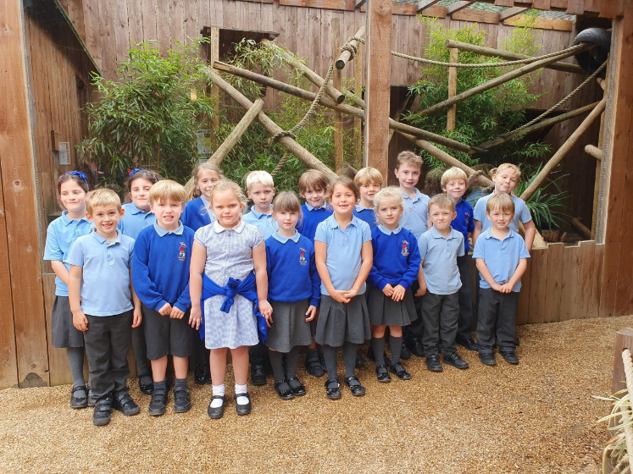

Football Reports
On 26th September the football team played its first match of the year against Larkspur School and recorded a comfortable 5-1 win.

On 3rd October the team were at home to Northaw School – a team we have not played before. This highly competitive match ended in a 2-2 draw.

On 10th October Puller Memorial School came to play us. They had a team of young players from Years 3
to 6, who had not played many matches together. It was a good opportunity for both teams, which resulted in a 6-0 win for Thundridge School.

Thank you to Mr Campbell for managing the team.

Netball Reports
We are pleased that some boys have decided to join our team this year. This boosts our numbers sufficiently to be able to field a team each week.

The first match was on 3rd October against Northaw School. This was a daunting task for some playing against some experienced players. However, the team put on a great performance losing by just one goal 2-1

On 10th October we played a very friendly match against our local rivals Puller Memorial School. All the children enjoyed the close game and came out winners 10-8.

Thank you to Mrs Shirley for managing the team.

Unfortunately, Larkspur School do not have a netball team so we were not able to play when the football team played.

Well played everyone!

Year 4 Development Day
On Wednesday 7th October the Years 3&4 class were invited to take part in a morning of activities at Wodson Park, through our Sports Partnership.

There were 4 activities to try, with 45 minutes at each to develop children’s confidence and skills.

First they tried indoor archery followed by orienteering outside in the woods. This activity really showed how some children went from no idea to confidently whizzing around the course. After orienteering the children had great fun attempting ultimate Frizbee. Here they learnt moves, such as crabs, pelican and reverse crabs. The final activity of the morning was cheerleading, this gave the children the chance to work as a team to support each other.

Another positive morning of learning new skills was enjoyed by all the children.

Thank you to the parents who transported the children back to school.

Year 3&4 Trip
On Tuesday 8th October Years 3&4 class went on trip to The Roman Baths at Welwyn and then on to Mill Green in Hatfield.

The Baths is a real example of how the rich Romans would keep themselves clean. They could easily spend 3 to 4 hours moving from room to room. The children had opportunities to dress up as Romans, pose as soldiers, play Roman games, taste their food and handle Roman artefacts.

The day finished with a true Roman love story.

The children said ‘this was an excellent trip we learnt lots and it was fun’.

Guided Reading
Year 3&4 class are looking for someone to take a guided reading group on Tuesday, Wednesday and or Friday mornings between 9.10am and 9.30am. If you are able to spare this time on a regular weekly basis please let Zoe or Mrs Frost know. Thank you.

Governor Vacancy
Could you become a school Governor?

I am writing on behalf of Thundridge Primary School in the hope that there may be someone reading this (or someone you know) who would consider joining us as a Governor. Thundridge School is a community primary school at the heart of the village, with about 90 pupils and with a great deal going for it. Children are well integrated and perform well and it is a very friendly place. However, we consistently struggle to find people to serve as Governors, and those who do sign up often find it challenging to give the necessary time to be effective. There is a small core of committed Governors, but one or two more would make a real difference. You do not need to be an educationalist or have experience of being a Governor but you would need to be willing to develop your knowledge and expertise.

It is one great way to serve the community and to get pleasure from making a real difference!

If you are interested and would like to know more, I would be very happy to meet over a coffee to talk it through in more detail. Please give me a call on
07825 399371 or give the school a ring on
01920 462642. Keith Hutt, Chair of Governors

Kind regards
Miss Greatrex

Friends of Thundridge School

Fundraising Success
The rains abstained long enough on Friday to let the Friends of Thundridge unveil last year’s total amounts raised on our wonderful “Thund-Raising Thermometer”, the production of which was kindly sponsored by Kids Connection and Direct Bathrooms. All of the children came out just before the end of the school day singing to Kool & The Gang’s “Celebration”. It was lovely seeing quite a few parents had come along as well to take part in the moment! Mollie, Chair of Friends of ThundridgeSchool, did a small presentation letting all of the children know what was bought for them with all the monies from last year, from subsidising school trips to new online and hands-on learning resources at the same time as thanking the children and families for supporting all of the activities that were completed to raise such a fantastic, target-busting amount!

Mollie was over the moon to let everyone know that a huge sum of £7,284 was raised, we still cannot believe it. Our target was £5,500!! None of this would be possible without all of the support from our wonderful parents and community. So, a very big thank you to you all and to all our sponsors & donors.

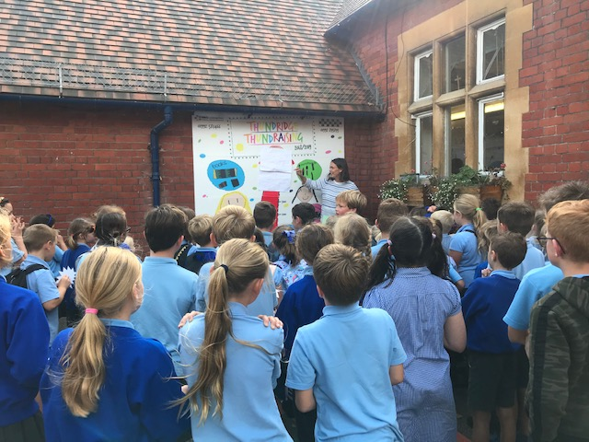

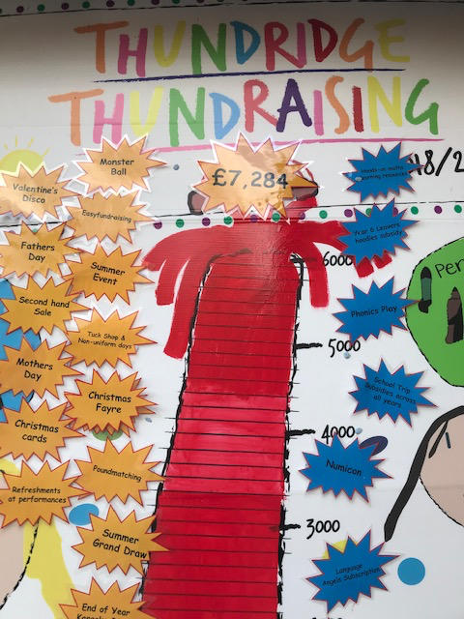
This year’s competition has already been launched in school. All the children have been encouraged to draw something that represents our fundraising efforts based on the schools wish list. This year, we are going to have to work even harder as we have set our sights on getting the children a new trim trail in the playing field. If anyone is able to help with any donations, please contact the school and they will pass any messages on to a member of the Friends of Thundridge Committee.

I think we can say Autumn is finally here. We were lucky enough to be able to arrange a sponsored walk for the whole school. Starting from the Feathers Inn, walking through the beautiful Youngsbury Farm, down past Cold Christmas Church and back to school. The children had a small activity sheet they needed to complete spotting various things on the way. We knew this was going to be a big challenge for some of the children, especially the little ones, but they all did so well and helped to raise a lot of money for their school. We would like to say an extra special thank you to Paige and staff at Tesco’s Hertford for their donations of apples and water for the children to take on their walk.

The Christmas Fayre
Thundridge Primary School’s Christmas Shopping Fayre is being held on Sunday 24th November at Thundridge Village Hall (12.30pm-3.30pm). As well as fun and games for the children to enjoy (and a visit from Santa), we have lots of external stallholders coming along to sell their wares, along with some familiar village faces in the line-up too, such as Bakes & Bouquets, Save the Children, Thundridge Cubs and Jean’s Orchard. Of course, as with any Thundridge School Christmas Fayre, we will have the school choir singing carols and the committee will be serving tea, coffee, mince pies and mulled wine along with a barbeque serving burgers and hotdogs for lunch! As always, the school looks forward to welcoming everyone from the villages to this warm and festive event.

Christmas Grand Draw
We are hoping to have our tickets printed and ready to be sold early next month (drawn early December). We have some fantastic high value prizes to give away, including, Bed and Breakfast at Hanbury Manor; Dinner, Bed & Breakfast for a family at the seafront an Old English Inn in Brighton; A luxury footstool from Sofa Club; £100 cash; £100 McMullen vouchers; £100 Amazon vouchers (from RS motors, Buntingford), and much more.

Friends of Thundridge School

