THUNDRIDGE CHURCH OF ENGLAND

PRIMARY SCHOOL NEWSLETTER

AUTUMN WEEK 9-10

TUESDAY 15TH NOVEMBER 2019

WHAT’S GOING ON THIS WEEK
Tuesday 19th November | Drama Club–Years R-6 12.30-1.00  Choir – Collect 4.00
Wednesday 20th November | French Club - Years R-Year 6  Collect-4.00  Netball & Football Clubs – Years 3-6 Collect 4.30
Friday 22nd November | Library – Juniors
Sunday 24th November | Friends Christmas Fayre-Village Hall
WHAT’S ON LATER
Tuesday 26th November | Drama Club–Years R-Year 6-  12.30-1.00
Wednesday 27th November | The Proff Science Club – Years  R-Year 2 – 12.30-1.00  French Club - Years R-Year 6  Collect - 4.00
Friday 29th November | Library – Juniors
Thursday 5th December | Christmas Performances –  Juniors-2.30 & 6.30-no tickets needed  CHANGE OF DATE
Wednesday 11th December | Christmas Performance –  EYFS & Year 1&2 – Morning
Thursday 12th December | Election - Village Hall closed for lunches, packed lunches only
Wednesday 18th December | Christmas Lunch – Whole School
Thursday 19th December | Christmas Pantomime  Reception to Year 6 – 1.30-4.00
Friday 20th December | Last Day of Term Finish 1.30
Monday 6th January | Inset Day – School Closed
Tuesday 7th January | First Day of Spring Term
Monday 2nd -5th March | Year 5&6 Bikeability
Thursday 26th March | Some Juniors - Tag Rugby

Birthdays…

George Harbour – 16th November
Edward Sampford-John- 20th November
Jude Chappell – 24th November
Archie Chamberlain – 1st December

Awards Friday 8th November 2019

Head Teacher Award - Elena Smyth for all round dedication in her learning.

Class Awards

Foundation Stage - Edward Sampford-John

Year 1&2 – Miles Collins & Maisie Wright

Year 3&4 Thomas Smyth & Fearne Watson

Year 5&6 - Libby Adams & Aden Kilighan

Lunch Staff Awards –
Charlotte Chamberlain & Bradley King

House Points Winner – Hanbury

Well done everyone!

Awards Friday 15th November 2019

Head Teacher Award – Ralph Bradley-May for consistent good behaviour and attitude to learning.

Class Awards

Foundation Stage – Harper Rose

Year 1&2 – Isabelle Basham & Phoebe Le Grys

Year 3&4 – Neve Chappell & Jack Garrett-Stone

Year 5&6 – Joseph Fox & Alex Warner

Lunch Staff Awards -
Libby Adams, Ben Alexander & Elena Smyth

House Points Winner – Barclay

Well done everyone!

EYFS Wow Space Day
All children enjoyed a fantastic WOW day linked to the theme of space. Children received their name badge and boarding pass as soon as they arrived into school and then they boarded the spaceship!
They jetted to the moon for the morning, eating tortilla moon and star snacks, making moon cakes from playdough and making their own alien ship cake!
Children were very lucky to have a moon landing photo and enjoyed listening to the story 'Man on the Moon' and singing songs to the tune of twinkle twinkle little star.
Photographs of the morning can be found in the EYFS window on our school website.
Miss Harris would like to say thank you to the parents for supporting their morning.

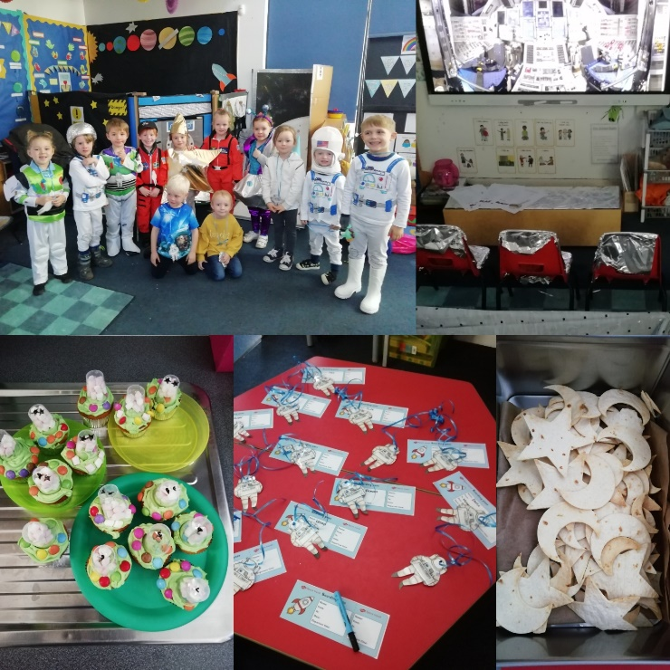

Year 5&6 Visit to Bentley Priory Museum
As part of their World War 2 topic, Year 5&6 visited Bentley Priory Museum, the war time HQ of Fighter Command. The children spent an eventful day learning more about the history of the Battle of Britain and the role that the workers at Bentley Priory played in protecting Britain between July and November 1940. The children found about 'the Few' brave Hurricane and Spitfire fighter pilots who took on the Luftwaffe and learnt about the skills used by 'the Many' ground crew who utilised radar, maps and maths to plot and intercept the movement of enemy aircraft in the skies over southern England. The children took part in a workshop to practise the skills the RAF ground crew used at Bentley Priory during the war and showed great teamwork and intelligence to plot hostile invaders.

In the afternoon, the children toured the museum learning more about individual heroes of the war, including 'the One' Sir Hugh Dowding who was the RAF Air Chief Marshall based at Bentley Prior during the Battle of Britain. The trip really helped to bring the topic to life for the children who thoroughly enjoyed the whole experience.

Children in Need 2019
In addition to raising money by buying badges and wristbands, staff took part in the duck race sweepstake and the children came in with mad hair! We had some very creative masterpieces.

£233.65 was raised, well done everyone!

Please also see below from Martha and George, well done!....

Martha’s words…..

George and I decided to make cakes and drawings to sell for children in need. We baked cupcakes, cookies, and chocolate rice crispie cakes on a stall outside our house. We sold them to a lot of people in the village. They sold very well and we only ended up with a few left over. In total villagers donated £107.47p! Much more than we ever expected, thank you!

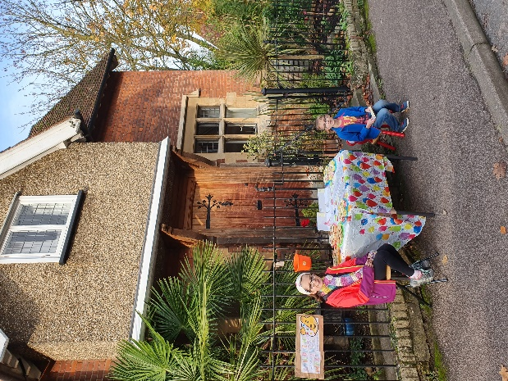

Netball & Football
Due to bad light, cold weather etc. this week will be the last netball and football clubs. They will start again in the Spring term.

Shoe Share
Thank you to everyone who donated shoes, Clarks sent a certificate for their appreciation.

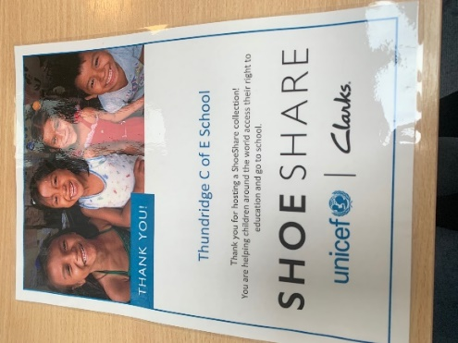

The Sun Newspaper

To collect 3500 coupons over the 57 days we need 61 participating regular Sun readers!

Do we have any regular buyers already?

Sallie Walker has kindly offered to add some (15) collection points at garages, newsagents, cafes, pubs restaurants that are local etc.

If anyone can take a collection point for their staffrooms etc. at places of work that would really help. Please let the school office know if you can and we will give you poster coupon collection bag.

Kind regards
Miss Greatrex

