THUNDRIDGE CHURCH OF ENGLAND

PRIMARY SCHOOL NEWSLETTER

AUTUMN WEEK 11-12

WEDNESDAY 11TH December 2019

WHAT’S GOING ON THIS WEEK
Friday 13th December | Library – Juniors
WHAT’S ON LATER
Monday 16th December | The Proff Club – Years R-2  EYFS Christmas Party – Morning  SATS Booster Class – Collect 4.30
Tuesday 17th December | Drama Club –12.30-1.00
Wednesday 18th December | Christmas Lunch – Whole School  Years 1 -6 Christmas Fun Festivities  French Club - Collect - 4.00
Thursday 19th December | Christmas Pantomime  Reception to Year 6 – 1.00-4.00  Collect from the theatre at 4.00
Friday 20th December | Christmas Service – St Mary’s Church, Thundridge - 9.15am  Last Day of Term - Finish 1.30
Monday 6th January | Inset Day – School Closed
Tuesday 7th January | First Day of Spring Term
Monday 2nd -5th March | Year 5&6 Bikeability
Thursday 26th March | Some Juniors - Tag Rugby
1st-5th June | Year 5&6 School Journey – Isle of Wight Experience

Birthdays…

Charlie Millhouse – 5th December
Chloe Haworth – 8th December
Jake Sawdy – 8th December
Ioanna Koumi – 15th December
Marina Koumi – 15^{h} December

Awards Friday 22nd November 2019

Head Teacher Award - No award this week

Class Awards

Foundation Stage Florence Flint

Year 1&2 – Archie Chamberlain & Miles Collins

Year 3&4 – Betsy Baker & Stanley Campbell

Year 5&6 – Rose Adams & Isabella Le Grys

Mrs Tarbuck Award – Fred Droy

Lunch Staff Awards – Leona Fox & Marina Koumi

House Points Winner – Wodson

Well done everyone!

Awards Friday 29th November 2019

Head Teacher Award – Harper Rose for an amazing I can do attitude to learning. Giving everything a go and working really hard at home to extend her learning.

Class Awards:

Foundation Stage – Ollie Brewer & Darcy Stuart

Year 1&2 – Phoebe Le Grys, Hayden Mann &
Maisie Wright

Year 3&4 – Tommy Brown & George Stopps

Year 5&6 – Mason King & Jake Sawdy

Mrs Tarbuck Award – Henry Wilson

Lunch Staff Awards –
Henry Haworth & Martha Stopps

House Points Winner – Wodson

Well done everyone!

Awards Friday 6th December 2019

Head Teacher Award – All the Juniors for wonderful and enthusiastic performances of ‘Mr Humbug Sees the LIGHT!’

Class Awards

Foundation Stage – Bertie Sampford & Elowen Sullivan

Year 1&2 – Micheal Mann & Acer Wray-Howard

Year 3&4 – Stanley Campbell & Lily Mann

Year 5&6 – Oliver Chamberlain, Harrison Campbell &
Freddie Shirley

Mrs Tarbuck Award – Isabelle Sampford-Poulter

Lunch Staff Awards – Hayden Mann & Chloe Pearce

House Points Winner: Hanbury

Well done everyone!

Year 3&4 Sportshall Festival
On 18th November, Year 3&4 children took part in a very enjoyable Sportshall Festival at Wodson Park.

The children went round a carousel of activities and therefore had opportunities to have a try at the following activities:- Speed bounce and balance bars, high steppers and speed ladders, throwing and catching targets, obstacle and reversa boards.

They then had a ‘Pudsey’ skipping challenge against all the other schools present. The top 3 girls and boys, completing the most skips in 30 seconds and were awarded Pudsey wristbands. We are pleased to say that both Milan and Sam were winners.

Christmas Performances
On 5th December, the Juniors performed their play twice, ‘Mr ‘Humbug Sees The Light’. Considering the lack of time to prepare due to the election on the original date the children were fabulous! Everybody played their parts brilliantly and it was a great success. Thank you to everyone from Mrs Le Grys and Mrs Thomas for making and preparing the props, our resident director, Mrs Frost for rehearsing with the children, face painters and of course the children themselves.

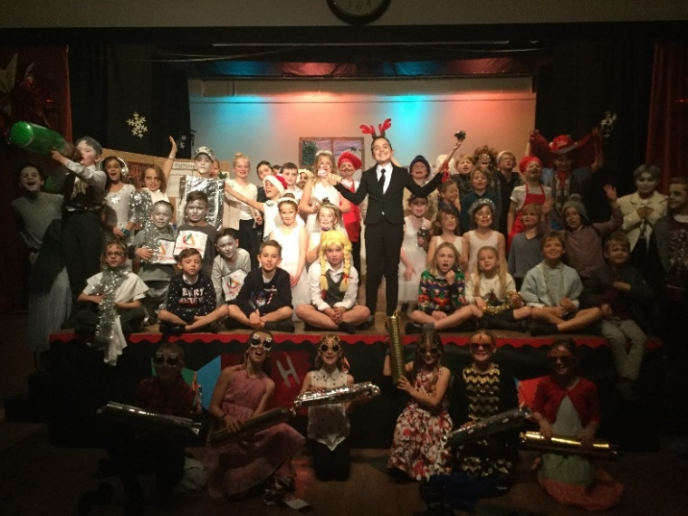

Choir
On the evening of 6th December, our Choir took part in the Hertford and Ware music carol service at Christchurch. The children sang as part of the choir consisting of 6 schools in total and then performed the song, “The Gift” beautifully. The children enjoyed themselves and were a credit to our school and themselves.

EYFS & Year 1&2 Performances
The Year 1&2 children wrote and delivered invitations to local residents to come and watch the dress rehearsal on 10th December of the EYFS and Year 1&2 performances. We hope they enjoyed it.

EYFS Performance
On 11th December, the EYFS class performed ‘Twinkle Twinkle Christmas Star’. What a treat! For this very young age, the children were confident, clear and sang beautifully. It was a stunning performance with every child fully involved. We all loved it!

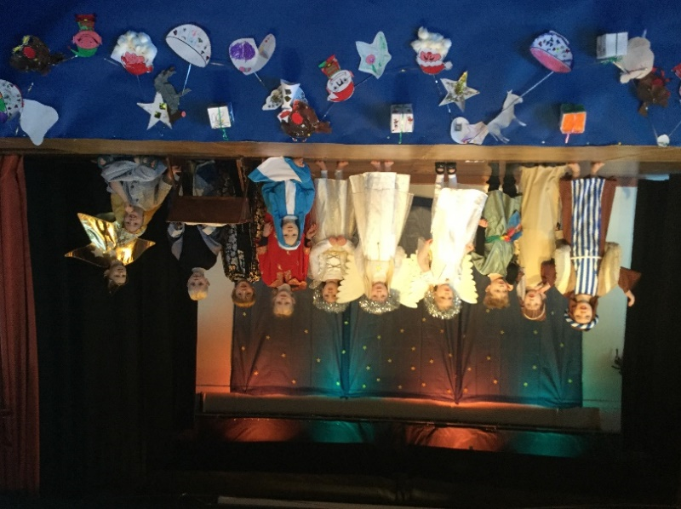

Also on the 11th after the EYFS performance, the Year 1&2 performed ‘A Christmas Recipe’. Again, this was a spectacular performance served to the audience with enthusiasm and sheer enjoyment. It was an absolute pleasure to watch and a delightful way to finish our Christmas productions for this year.

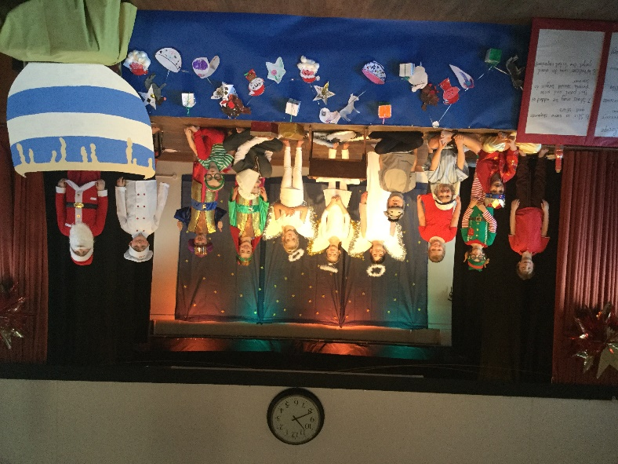

Well done and a big thank you also to the KS1 and FS staff for all their hard work too! An amazing feat with these age groups!

Finally, thank you to the Friends Committee for serving refreshments at every performance.

Christmas Carol Service
Monday 16th December - 7.30pm
The choir will be singing and reciting at the Christmas Service at St Mary’s Church, Thundridge on the evening of Monday 16th December at 7.30pm. Everyone welcome. Choir members please arrive by 7.15pm.

Christmas Lunch and Fun Afternoon
Wednesday 18th December
Everyone is welcome to wear a Christmas Jumper with uniform on the lower half including school shoes on Wednesday 18th December for our Christmas lunch and festivities in the afternoon.

Pantomime - Thursday 19th December
Years Reception to Year 6 will be leaving for pantomime at 12.45pm on Thursday, everyone to have a home packed lunch unless you have ordered one (last orders Monday). Please make the lunch as disposable as you can as nothing will be taken to the theatre. Everyone to collect their children from the theatre at 4.00pm please.

Christmas Church Service - Friday 20th December
There will be a service at St Mary’s Church, Thundridge on Friday 20th December at 9.15am. The choir will also be singing. Everyone is welcome to attend.

School will finish at 1.30pm on Friday 20th December.

Kind regards
Miss Greatrex

Friends of Thundridge School Committee

We were delighted to be able to hold our annual Christmas Fayre in the Village Hall again this year. There was an overwhelming turnout of local stallholders presenting some of their amazing homemade wares along with some fantastic bargains to be had.

The school Choir kindly came along and sang a few Christmas songs to get everyone in the spirit of Christmas, along with lots of fun and games i.e. Whack-a-Rat (kindly made by one of our pupils Grandad), Boozy Tombola and Elf on The Shelf to name but a few. It was wonderful to see lots of local faces along with quite a few new ones. We have already received some wonderful feedback from locals and stallholders (of which some have already asked to come back next year), about what a lovely community feeling there was. Therefore, a huge thank you to everyone who helped to organise such an event and to everyone who came and hopefully enjoyed themselves.
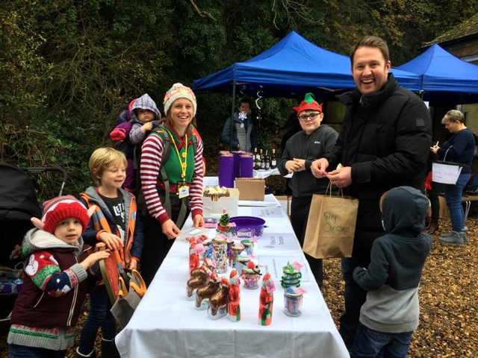
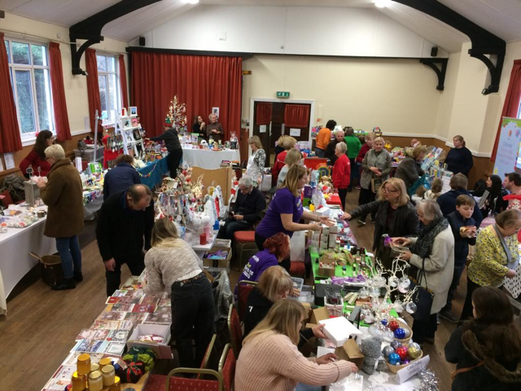
This year’s Grand Prize Draw winners will be drawn on Tuesday 17th December during Collective Worship in school, all winners will be notified.

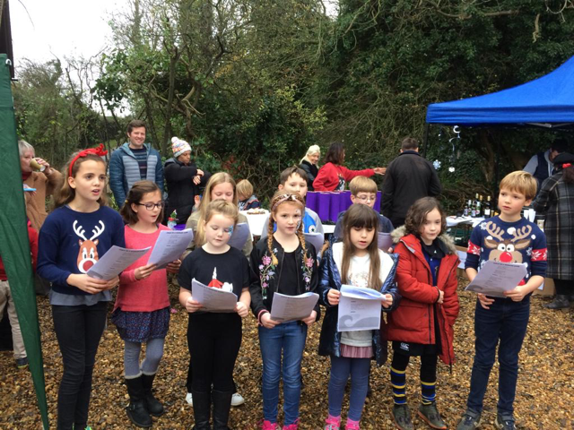
We would like to take this opportunity to thank everyone for all of your continued support and to wish you all a very Merry Christmas and a wonderful 2020.

