THUNDRIDGE CHURCH OF ENGLAND

PRIMARY SCHOOL NEWSLETTER

AUTUMN WEEK 13

FRIDAY 20TH DECEMBER 2019

WHAT’S GOING ON NEXT TERM
Monday 6th January | Inset Day – School Closed
Tuesday 7th January | First Day of Spring Term  Library – Year 1&2
Wednesday 8th January | SPAG – Year 6 - Collect 4.30
Thursday 9th January | Labtots–Lunchtime Reception-Year 2
Friday 10th January | Library – Years 3-6
WHAT’S ON LATER
Monday 13th January | SPAG – Year 6 - Collect 4.30
Tuesday 14th January | Library – Year 1&2  Drama Club - lunchtime  Choir – Collect 4.30
Wednesday 15th January | SPAG – Year 6 - Collect 4.30
Friday 17th January | Library – Years 3-6
17th-21st February | Half Term
Monday 2nd -5th March | Year 5&6 Bikeability
Tuesday 3rd March | Crucial Crew – Morning
Thursday 26th March | Some Juniors - Tag Rugby
1st-5th June | Year 5&6 School Journey – Isle of Wight Experience

Birthdays…

Joseph Fox – 24th December
Florence Flint – 30th December
Francesc Thomas – 2nd January
Freddie Shirley – 3rd January
Zoe Thomas – 10th January
Josie Brown – 12th January

Awards Friday 13th December 2019

Head Teacher Award - Bradley King for ‘an extreme act of kindness’ and being an all round superstar.

Class Awards

Foundation Stage - Everyone in EYFS for their
Christmas performance

Year 1&2 – Everyone in Year 1&2 for their Christmas
performance

Year 3&4 – Charlotte Chamberlain

Year 5&6 – Harrison Campbell & Chloe Pearce

Mrs Tarbuck Award – Ronnie Best

Lunch Staff Awards – Josie Brown & Maisie Wright

Well done everyone!

Year 6 SPAG
The Wednesday session will be for 4 weeks and then owing to football and netball clubs recommencing the SPAG session will then move to a Tuesday after school with the same finish time of 4.30pm.

Choir
On the evening of 16th December, our Choir sang at the Christmas Church Service at St Mary’s Church, Thundridge. Despite a few illnesses, the children sang beautifully. Thank you to the parents for accompanying your children. Choir will continue on a Tuesday afternoon for 3 weeks, starting 14th January then will move to Tuesday lunchtimes.

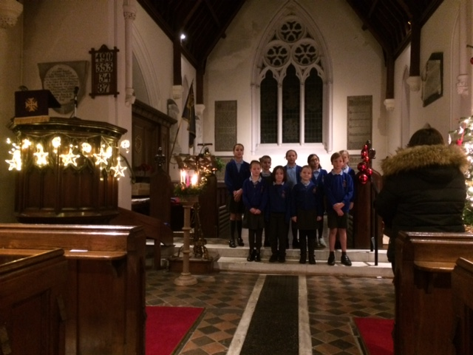

Christmas Lunch and Festivities
On 18th December all the children, staff, Governors and our school volunteers were treated to a Christmas lunch. Thank you to our cook Carol and Gemma our server for a tasty lunch.

In the afternoon, the children enjoyed a fun festive time playing games and eating more food.
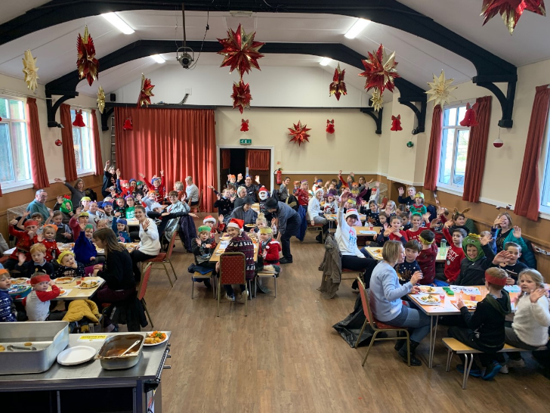

Christmas Cracker
Year 5&6 played host to their parents on 18th December in an afternoon of poetry, carols and cracking Christmas fun! The children had time for some festive fun and games before their parents arrived. The event was organised by the wonderful Mrs Thomas who provided drinks and nibbles for the parents as well orchestrating the children's performances. Well done everyone!

Snow Queen Pantomime
On 19th December, the children were entertained at Hertford Theatre to watch ‘The Snow Queen’ Pantomime. The children really enjoyed the performance and their ice cream in the interval. They thought the ‘snow’ that came down was magical! Our children were very amused to watch Mrs Frost (which was very apt!) who was asked to get up on stage and dance!
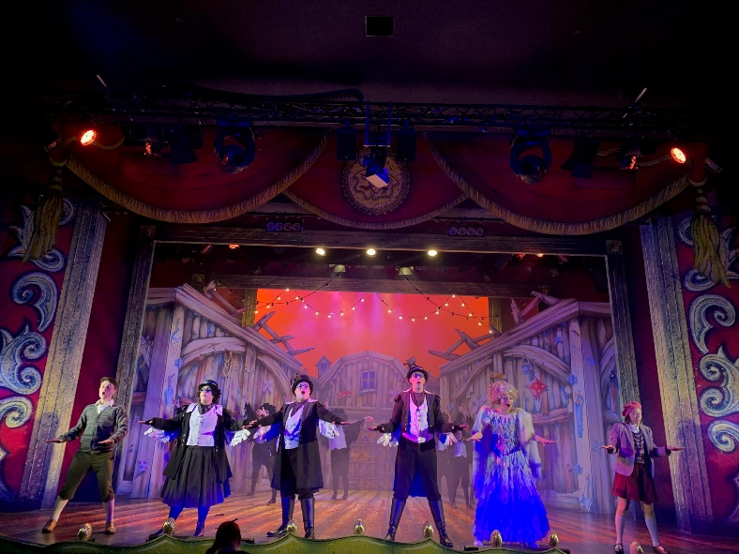

Christmas Service
Our term ended today, 20th December, with our Christmas Carol service at St Mary’s Church, Thundridge with the Year 6 children receiting their readings, the choir singing and the rest of the school and congregation singing carols. It was a beautiful service as always which everyone thoroughly enjoyed. Thank you to Sara McCrea for conducting the service.

All staff wish you all a very Merry Christmas and a wonderful New Year

