THUNDRIDGE CHURCH OF ENGLAND

PRIMARY SCHOOL NEWSLETTER

SUMMER 1

16TH JULY 2020

WHAT’S ON LATER
Friday 17th July | Last Day of Term
Monday 20th July | School Closed - Inset Day
Tuesday 21st July | School Closed - Occasional Day
Wednesday 2nd September | Inset Day – School Closed
Thursday 3rd September | First day of Autumn Term
5th-9th Friday October | Walk to School Week
Wednesday 7th October | Year 3&4 Trip - Celtic Harmony Camp – TBC
26th- 30th October | Half Term
Friday 27th November | Occasional Day
Friday 18th December | Last Day of Term – Finish 1.30
Monday 4th January | Inset Day – School Closed
Tuesday 5th January | First day of term
15th – 19th February | Half Term
24th/25th February | Dance Festival – TBC
Friday 26th March | Last Day of Term
29th March – 9th April | Easter Holidays
Monday 12th April | Inset Day – School Closed
Tuesday 13th April | First day of Summer Term
Monday 3rd May | Bank Holiday
31st May-4th June | Half Term
Wednesday 21st July | Last day of Summer Term

Birthdays

Miles Collins – 1st August

Libby Adams – 19th August

Rose Adams – 19th August

Harper Rose – 20th August

Lily-May Hewitt-Makin – 22nd August

Lewis Greatrex – 26th August

Isla Grierson – 27th August

Miss Hare – 30th August

Mrs Loader – 31st August

Sydney Marshall – 3rd September

Miss Harris – 7th September

Year 6 Leavers…….

Year 6 Leavers Treat Day

This year's Leavers Treat turned out differently than anticipated but a fun time was had by all nonetheless.

The children spent the afternoon at Hartham Park in Hertford on Friday 10th July playing in the river, scootering, enjoying pizza, plus some fun games.

It is sadly time to say goodbye to all the Year 6 children: Alex, Arthur, Charlie, Chloe H, Chloe P, Elena, Francesc, Jake S, Jake S, Leo, Lewis, Libby, Martha, Rose & Zoe.

Year 6 Leavers Performance
This term ended with our latest group of Year 6 children treating us to their own very special assembly. Considering the circumstances with this having to take place ‘socially distanced’ on the windy school field they did an incredible job!

Thank you to Mrs Frost who took on the role of ‘Head’ during much of the performance so I could be a ‘mum.’ She did a great job!

Each child was awarded a special ‘Leavers Book’ and trophies were awarded. Sadly, two of our Year six children were unable to attend, Chloe Haworth and Jake Sawdy due to shielding. Nevertheless, they have still been a part of the recordings and will receive their special books.

Trophies

Charlie Millhouse & Chloe Pearce were both awarded the ‘Sports’ Trophy

Zoë Thomas was awarded the
‘Outstanding Effort’ Trophy

Martha Stopps was awarded the
‘Citizenship’ Trophy

Congratulations!

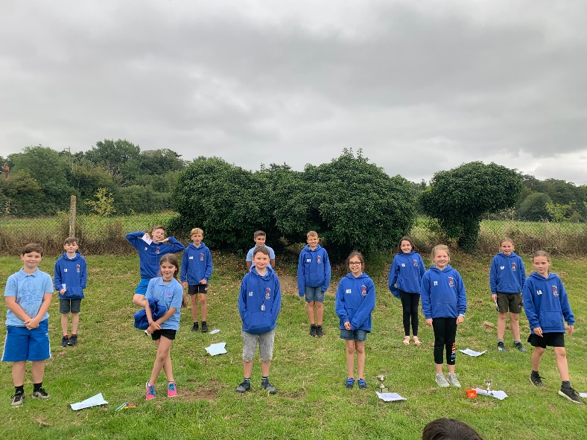

There is lots more to come from the Leavers as I write this. As a parent, I do not know the exact content but there will be special films they have made, photographs over the years and singing. These will be put onto CD and also on a private account on You Tube as they will not all fit on the CD’s! I am sure the children will treasure these memories.

We wish them all the best of luck in the future and know they will succeed at their new secondary schools building on their excellent achievements at Thundridge School.

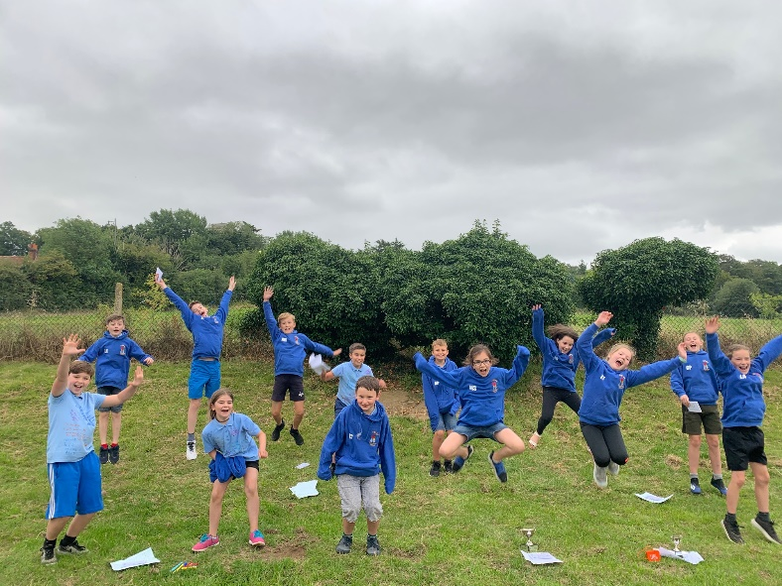

School Lunches Next Term
When we return to school in September we will be continuing as we have during ‘lockdown’ at school to serve our school lunches in the Collective Worship room at school, with the children taking their lunches back to their classrooms.

Due to Covid 19 regulations, we will not be able to use the Village Hall for our lunches.

Due to the capacity hot meals will be offered to those on free school meals and universal free school meals (Reception to Year 2) only and the rest on school packed lunches. Obviously everyone can choose to bring in their home packed lunch as usual, if they so wish.

As soon as we can offer hot meals to the rest of the school we will. Apologies for the inconvenience.

Grounds
Thank you to Mrs White for keeping the window boxes full of bloom.

Netball & Football
Thank you to Mrs Frost, Mrs Shirley and Mr Campbell for coaching the netball and football clubs this year.

Sheets to be returned……
A reminder to return the following before the start of the new term. These can be left at School Reception or emailed please:

Lunch choice sheets (attached menu and sample sheet)
Pupil passports (attached paper copy with your child)
Report reply slips

Emergency Pyramid
I will be creating a new Emergency Pyramid ready for September, if your contact numbers change please let me know immediately.

The end of a strange year
I hope you have all coped and stayed well during the past 4 months of lockdown. It has been a challenging time for everyone, staff at school who have been in school teaching as well as setting home learning for those at home and parents who have been home schooling their children.

I would like to take this opportunity to say a heartfelt thank you to ALL the wonderful staff at Thundridge School, from our cleaner and handyman to our admin, to TAs and teachers who have gone so much over and above in the last few months. I think they are all absolute stars.

The Government has said schools will be back in September, staff are looking forward to seeing the children again. Things will not be quite the same but I am sure everyone will adapt. We are getting very used to our ‘bubbles’ now!

Apologies for not sending out a regular Newsletter over the past 4 months but instead, I have been sending a weekly update to all parents.

EYFS & Year 1- Lockdown
Miss Hare would like to say a big thank you to Reception and Year 1 children who have been in school. They adapted to all the changes to their routine day and sitting at their tables fantastically - well done !

Year 2 – Lockdown
Mrs Loader & Mrs Le Grys would like to acknowledge the great attitude and behavior year 2 showed these last 3 weeks. We would also like to welcome Tom Staines in our class. He has fitted in fantastically with us and these strange times have not fazed him at all.

I hope you all have an enjoyable, restful, warm and sunny summer!

Kind regards
Miss Greatrex

