THUNDRIDGE CHURCH OF ENGLAND

PRIMARY SCHOOL NEWSLETTER

AUTUMN WEEKS 1-3

18TH SEPTEMBER 2020
WHAT’S ON THIS WEEK
Monday 21st September
Tuesday 22nd September | Year 3&4 – PE
Wednesday 23rd September
Thursday 24th September | Year 1&2 – PE  Year 3&4 – Library
Friday 25th September | EYFS – PE  Year 5&6 – PE & Library  Year 1&2 – Library
WHAT’S ON LATER
Monday 28th September
Tuesday 29th September | Year 3&4 – PE
Wednesday 30th September
Thursday 1st October | Year 1&2 – PE  Year 3&4 – Library
Friday 2nd October | EYFS – PE  Year 5&6 – PE & Library  Year 1&2 – Library
5th-9th Friday October | Walk to School Week
Wednesday 7th October | Year 3&4 Trip - Celtic Harmony Camp Trip
26th- 30th October | Half Term
Wednesday 4th November | Nasal Flu Vaccine Reception to Year 6
Friday 27th November | Occasional Day
Friday 18th December | Last Day of Term – Finish 1.30
Monday 4th January | Inset Day – School Closed
Tuesday 5th January | First day of term
15th – 19th February | Half Term
24th/25th February | Dance Festival – TBC
Friday 26th March | Last Day of Term
29th March – 9th April | Easter Holidays
Monday 12th April | Inset Day – School Closed
Tuesday 13th April | First day of Summer Term
Monday 3rd May | Bank Holiday
31st May-4th June | Half Term
Wednesday 21st July | Last day of Summer Term

Birthdays

Mr Higgins – 12th September

Eddie Staines -19th September

Neve Chappell – 20th September

Fred Droy – 20th September

Zoe Rose – 20th September

Arley Fenton - 22nd September

Felicity Staines – 22nd September

Harrison Campbell -3rd October

Ferne Turner -10th October

Awards Friday 11th September 2020

Head Teacher Award -
Izzy Le Grys for a perfect start to Year 6 with the highest standards of work and behaviour

Class Awards

Foundation Stage – Riley Penalver & Ferne Turner

Year 1&2 – Ollie Brewer, Brodie Fenton &
Michael Mann

Year 3&4 – Tom Staines
& All of Year 3&4 for an excellent start to
the Juniors

Year 5&6 – Joseph Fox & Felicity Staines

Lunch Staff Awards – Oliver Chamberlain &
Freddie Dexter-Springett

Well Done Everyone!

Awards Friday 18th September 2020

Head Teacher Award -
Freddie Shirley for showing great leadership of fairness, decency and treating peole with respect.

Class Awards

Foundation Stage – Bertie Sampford & Evie Wright

Year 1&2 – Isabelle Basham, Harper Rose &
Elowen Sullivan

Year 3&4 – Lily-May Hewitt-Makin & Henry Wilson

Year 5&6 – Finley Francis & Isla Grierson

Lunch Staff Awards – Elowen Sullivan &
Felicity Staines

Well Done Everyone!

Welcome Back!

I hope you all had an enjoyable, restful, summer

It has been lovely to have the school full of children again. The children have coped admirably with the new 'norm' and have all made a very positive start to the term.

Whilst bubbles remain a challenge especially during break and lunch times, everyone is pulling together and doing the very best they can.

The children have been very sensible with Year 6 setting a good example. Well done to all!

Last week we had our first Friday ABC Collective Worship (Awards, Celebrations & Birthdays) in months. I visited each class to present awards and really enjoyed being back with the children again for this celebratory occasion

We are thinking of doing some Collective Worship through Zoom meetings which will be an interesting experience!

We do, politely remind parents to socially distance as much as possible when dropping off and picking up.

Thank you very much for your co-operation with this.

Welcome to ……
Cooper, Edward S, Evie W, Freddie DS, Harry T,
Henry SJ, Riley P, Robyn W, Walter BM, William G who have joined our Early Years Foundation Stage Class,
Thomas S in Year 3 and Felicity S in Year 5, we hope they have an enjoyable time at Thundridge School.

Emergency Pyramid
A new Emergency Pyramid has been sent in paper form and via email, if any of your contact numbers change please let Zoe know immediately.

Letters etc.
Please return the following by Monday 21st September…

Home School Agreement
Pupil Passport
Report Reply Slip
Milk reply slip & correct cash or cheque
If you require a copy of any of the above please email admin and a copy will be sent home.

Kind regards
Miss Greatrex

Friends of Thundridge School

We would like to welcome everyone back to school along with all the new parents/guardians.

Firstly a small note to introduce ourselves to the new members of our school. We are the Friends of Thundridge School who over the course of a school year organise various events to raise money for extra equipment the school might need. This usually entails school discos, sponsored walks, end of term tuck shops, Christmas/Summer Fayres and competitions.

As I am sure you will not be surprised to hear that sadly most of our usual fundraising events have been cancelled till at least the end of this year. But we are working on a few things and providing they meet the required guidelines we hope to arrange something fun for the children soon.

We are always looking for any new members to join our sadly now small Committee to help in any way they can, from helping out at events to anyone with any new/exciting ideas to give the children something fun to do and raise money for the school. Feel free to pass your details to Zoe or message via our Facebook page. All new members warmly welcomed.

Facebook

To any new or existing parents/guardians please do join our Friends of Thundridge School Facebook page where we generally now promote any events we might be holding. This contributes towards our continued commitment to being more environmentally friendly by being paperless (emails will still be sent round from school containing any event information).

Easy Fund Raising

This is an app that can be downloaded onto any smart phone. This app is an online shopping tool which you can use instead of going to say “Amazon” for example in your search engine, you would use your Easy Fundraising app (making sure you have chosen Thundridge Primary School as your cause) choose “Amazon” for example and do your shopping as usual. This in return, for every £ you spend, we at Thundridge School get a donation back from the sellers who have signed up to join the Easyfundraising website at no extra cost to you. This is a very easy fundraising tool for the school. We would love to see some new members signing up. There are many many online shopping outlets available.

www.easyfundraising.org.uk

Trim Trail

Last year, we set about raising enough money to finally buy the children a new Trim Trail. Due to such an amazing start to our fundraising efforts and generous donations from local businesses Pat Taylor and Oakleys we were able to purchase a new trim trail and it be installed during lock down. This target undoubtedly would never have been reached without the continued support and generosity of parents, families and staff for always supporting the Friends events. So a very big thank you from us.

We have had some lovely feedback from the children who are enjoying playing on this wonderful piece of equipment. We hope they are all able to enjoy it for many years to come.

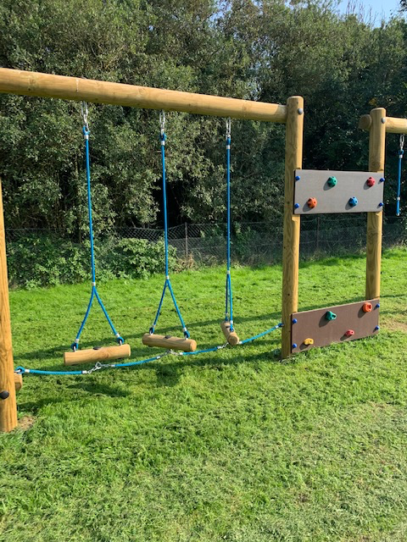

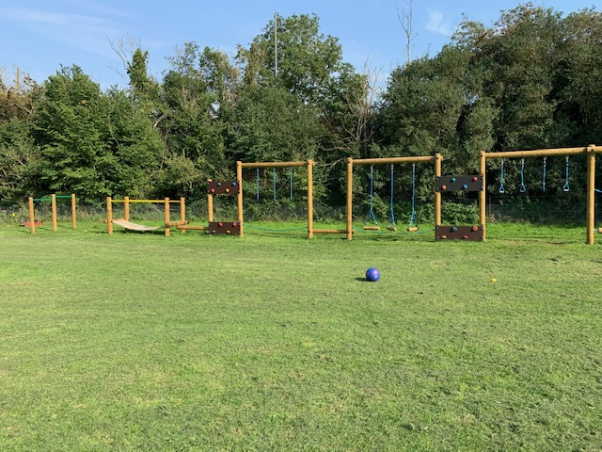
Thank you for your continued support
Friends of Thundridge School

