THUNDRIDGE CHURCH OF ENGLAND

PRIMARY SCHOOL NEWSLETTER

AUTUMN WEEKS 4-7

21ST OCTOBER 2020

WHAT’S ON THIS WEEK
Thursday 22nd October | Year 1&2 – PE  Year 3&4 – Library
Friday 23rd October | Packed Lunches only  Monster Day  Dress up day of activities  Friends Tuck Shop in the Car Park  EYFS – PE  Year 5&6 – PE & Library  Year 1&2 – Library
WHAT’S ON LATER
26th- 30th October | Half Term
Wednesday 4th November | Nasal Flu Vaccine Reception to Year 6
Thursday 12th November | Individual Photographs
Friday 27th November | Occasional Day – School Closed
Friday 18th December | Last Day of Term – Finish 1.30
Monday 4th January | Inset Day – School Closed
Tuesday 5th January | First day of term
15th – 19th February | Half Term
24th/25th February | Dance Festival – TBC
Friday 26th March | Last Day of Term
29th March – 9th April | Easter Holidays
Monday 12th April | Inset Day – School Closed
Tuesday 13th April | First day of Summer Term
Monday 3rd May | Bank Holiday
31st May-4th June | Half Term
Wednesday 21st July | Last day of Summer Term

Birthdays

Thomas Smyth - 13th October

Betsy Baker – 15th October

Billy Baker 15th October

Aden Kilighan – 17th October

Samuel Field – 18th October

Robyn Whittle – 19th October

Awards Friday 25th September 2020

Head Teacher Award -
Archie Chamberlain for using some fabulous ‘wow’ words in his writing. Archie is always wanting to improve his writing and make it exciting for the reader.

Class Awards

Foundation Stage – Henry Moseley &
Henry Sampford-John

Year 1&2 – Ben Alexander & Maisie Wright

Year 3&4 – William Haworth & Jack Turner

Year 5&6 – Macy Cyl & Sam Field

Lunch Staff Awards – Ben Alexander, Isla Grierson &
Amy Johnson

Well Done Everyone!

Awards Friday 2nd October 2020

Head Teacher Award - No award this week.

Class Awards

Foundation Stage – Albert Mosely & Henry Moseley

Year 1&2 – Dana Harris –West & Elowen Sullivan

Year 3&4 – Ava Field & Phoebe Le Grys

Year 5&6 – Harrison Campbell & Henry Haworth

Lunch Staff Awards – Mason King, Acer Wray-Howard
& Maisie Wright

Well Done Everyone!

Awards Friday 9th October 2020

Head Teacher Award -
Harry March for excellent progress in writing. Keep it up!

Class Awards

Foundation Stage – William Galer & Harry Thomas

Year 1&2 – Ralph Bradley-May & Ollie Brewer

Year 3&4 – Arley Fenton, Sydney Marshall &
Thomas Smyth

Year 5&6 – Charlotte Chamberlain & Olly Judge

Lunch Staff Awards – Hayden Mann, Lily Mann &
Henry Moseley

Well Done Everyone!

Awards Friday 15th October 2020

Head Teacher Award -
Brodie Fenton for an amzing attitude towards learning. Brodie always does his best and never gives up.

Class Awards

Foundation Stage – Florence Flint & Edward Staines

Year 1&2 – Jude Chappell & Michael Mann

Year 3&4 – George Harbour & Amy Johnson

Year 5&6 – Oliver Chamberlain & Jack Stone

Lunch Staff Awards – Ava Field, Michael Mann &
Freddie Shirley

Well Done Everyone!

Welcome To….
Miss Bentley who has joined our team of Midday Supervisory Assistants.

Finley and Alex who have started in our Nursery.

We hope they all enjoy their time at Thundridge School.

Covid-19
We are continuing to manage within school with our ‘bubbles’ etc. We appreciate your patience while we deal with everything in a different way for example, Parent consultations and Curriculum mornings.
This may well be the new ‘norm’ for quite some time.
We as a school are doing everything we can to maintain the strong links we have with our parents as this is so important for our home/school partnerships.

Thank you all for your co-operation, especially at drop off and pick up.

Year 3&4 Trip to Celtic Harmony Camp
On 7th October, the Year 3&4 class went on a trip to Celtic Harmony Camp at Brickendon, Hertford.

All children and staff entered into the spirit of the day by dressing as Stone Age characters.

They were met from the coach by our guide Waylin. Throughout the day, he explained how life would have been for them in Stone Age times.

They learnt where they lived, how they made fires and their tools and how they were Hunter Gatherers to make sure they had food to eat.

The children had hands on experience at making dock leaf and herb soup and hunting a mammoth!

In the afternoon, they built their own dens from wood and bracken and took part in a trading activity.

The children stated they had an excellent time and learnt a lot about the Stone Age.

Thank you to all parents for the wonderful costumes and the Friends of Thundridge School for subsidising the cost of the trip.

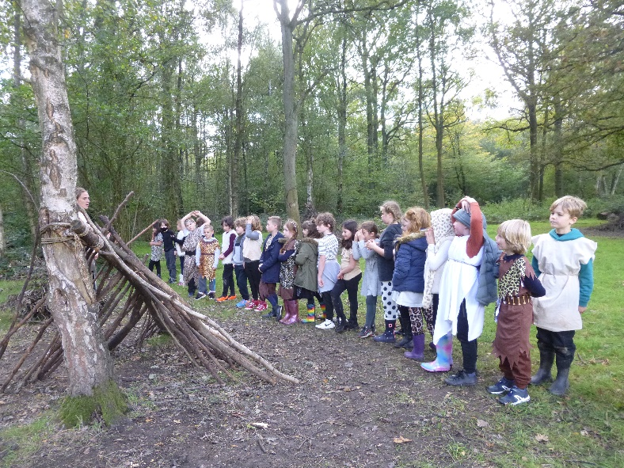

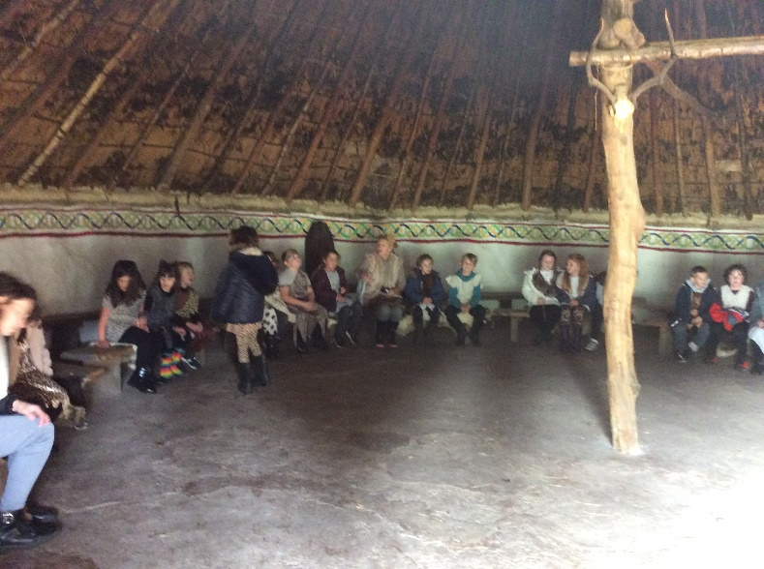

Year 1&2 Space
Year 1&2 have been learning about Space and have been exploring the moon and our solar systems. They made some planetary head bands and they made paper plate moons with landing rockets and astronauts. They have been looking at the Osiris Rex satellite today as it was successful in it’s mission to recover samples from the asteroid Bennu.

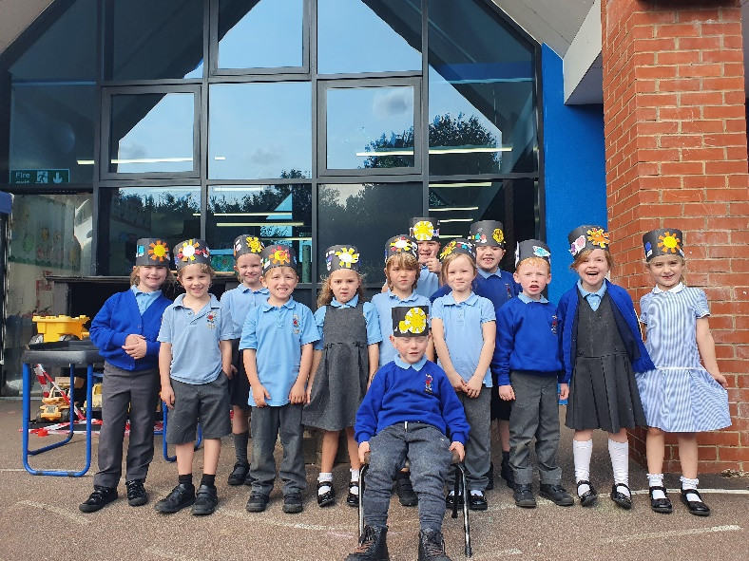

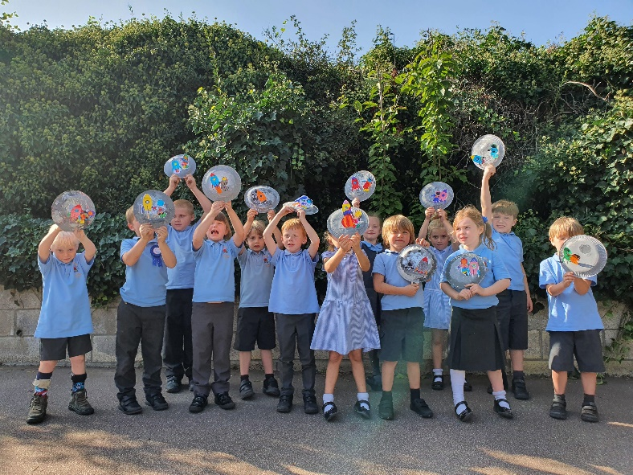

Parking
As well as the regular emails we send out to parents can I again please ask you (anyone who drops/collects your children to park with consideration to all residents of Ermine Street, ensure emergencies vehicles can gain access if necessary etc. Please do not park on grass verges, block driveways, stop on the zig zag outside school. Remember you can also park in the Village Hall car park during the hours of
8.30am-4.30pm too. If your child is at breakfast or after school club or if you need to collect your child during the day for medical reasons etc. then you can park in the staff car park.

Report Reply Slip
It is mandatory to return your child’s report reply slip, please return before half term. If you require a copy please email admin and a copy can be sent home.

Kind regards
Miss Greatrex

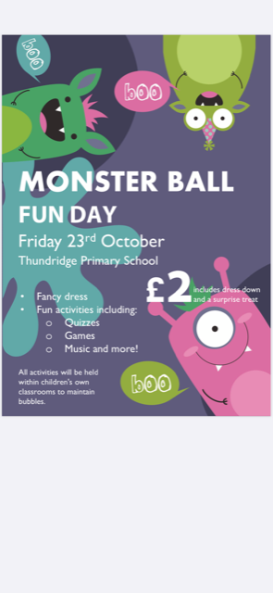
Friends of Thundridge School

There will also be a tuck shop outside within school hours in year group ‘bubbles’. We will be selling ‘Monster pocket money gifts’, individually wrapped cakes and sweet cones. Each item will be 50p each. Please send in the exact money you allow your child to spend in a named purse/wallet/envelope any day before Friday afternoon and give to their class teacher to look after.

Thank you for your continued support
Friends of Thundridge School

