THUNDRIDGE CHURCH OF ENGLAND

PRIMARY SCHOOL NEWSLETTER

AUTUMN WEEKS 8-10

19TH NOVEMBER 2020

WHAT’S ON THIS WEEK
Thursday 19th November | Year 1&2 – PE
Friday 20th November | EYFS – PE  Year 5&6 – PE & Library  Year 1&2 – Library
WHAT’S ON LATER
Thursday 26th November | Year 1&2 – PE
Friday 27th November | Occasional Day – School Closed
Wednesday 2nd December | ‘Elf Day’ – Isabel Hospice
Monday 7th December | Individual Photographs
Tuesday 8th December | Year 6 – Height & Weight Measurements by School Nurses
Friday 11th December | Circus Skills Day – Whole School
Wednesday 16th December | Christmas Lunch  Wear a Christmas Jumper- Save the Children Fund
Friday 18th December | Last Day of Term – Finish 1.30
Monday 4th January | Inset Day – School Closed
Tuesday 5th January | First day of term
15th – 19th February | Half Term
Friday 26th March | Last Day of Term
29th March – 9th April | Easter Holidays
Monday 12th April | Inset Day – School Closed
Tuesday 13th April | First day of Summer Term
Monday 3rd May | Bank Holiday
31st May-4th June | Half Term
Wednesday 21st July | Last day of Summer Term

Birthdays

Acer Wray- Howard – 5th November

Miss Greatrex - 7th November

Lily Mann – 13th November

George Harbour – 16th November

Edward Sampford-John – 20th November

Jude Chappell – 24th November

Archie Chamberlain – 1st December

Thomas Staines – 8th December

Awards Friday 23rd October 2020

Head Teacher Award -
Tom Staines for absorbing all teaching and responding with excellent contributions in all subjects.

Class Awards

Foundation Stage – Florence Flint & Henry Mosely

Year 1&2 – Fred Droy & Ollie Brewer

Year 3&4 – Besty Baker & Hayden Mann

Year 5&6 – Aden Kilighan & George Stopps

Lunch Staff Awards – Archie Chamberlain,
Florence Flint & Bradley King

Well Done Everyone!

Awards Friday 6th November 2020

Head Teacher Award -
Ferne Turner for outstanding progress in all areas.

Class Awards

Foundation Stage – Cooper Martin

Year 1&2 – Ralph Bradley-May & Harper Rose

Year 3&4 – Neve Chappell & Bradley King

Year 5&6 – Mason King & Lily Mann

Lunch Staff Awards – Ronnie Best, Albert Mosely
Lily-May Hewit-Makin

Well Done Everyone!

Awards Friday 13th November 2020

Head Teacher Award -
Maisie Wright for always giving her best efforts not only academically.

Class Awards

Foundation Stage – Walter Bradley-May &
Harry Thomas

Year 1&2 – Ollie Brewer, Archie Chamberlain &
Harper Rose

Year 3&4 – Billy Baker & Acer Wray-Howard

Year 5&6 – Stanley Campbell & Olly Judge

Lunch Staff Awards – Stanley Campbell,
Mortimer Davy & Harry Thomas

Well Done Everyone!

School is continuing to work as well as it can. Due to Covid-19 we will not be able to have our annual Christmas performances or go to Pantomime etc. this year but we do have some fun activities lined up for the children in December as well as supporting others in need.

Monster Day
Normally the Friends Committee would hold a Monster Disco in October. Due to the circumstances we were not able to hold one this year. Instead Mrs Le Grys, our Year 1&2 Teaching Assistant organised an in-house Monster Day at school. All the children came to school dressed as a monster.

The classes spent the day playing monster games and activities and ended the day with a Monster Quiz.

Each child was given a goody gift bag with their own special pencil wand to take home.

After school the Friends Committee held a ‘socially distanced class’ tuck shop selling gifts and confectionery.

Thank you so much for the great ideas Mrs Le Grys.

Everyone had a great day!

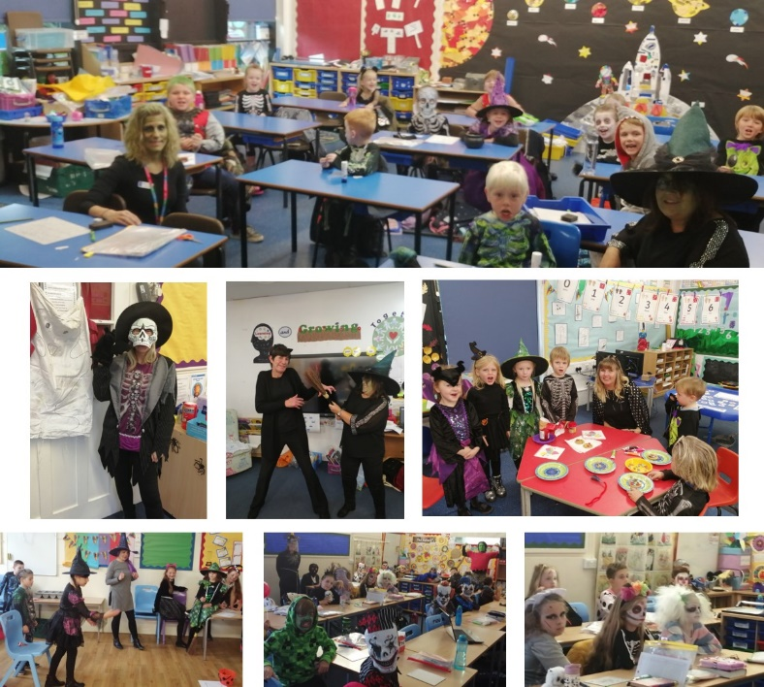

Remembrance Day
This year the school came together to make a poppy tree for Remembrance Day. Years 5&6 explored key words and made their poppies based on this exploration. Years 3&4 chose to make their poppies with paint, collage, and pencils. Years 1&2 used air dough to form their poppies and painted them after and EYFS made poppies by hand printing. Our tree will be on display in Reception for the rest of November.

The children in this photograph are our new Nursery & Reception children this year. Unfortunately, due to absences and attending different days we could not take a photograph of all the new children.
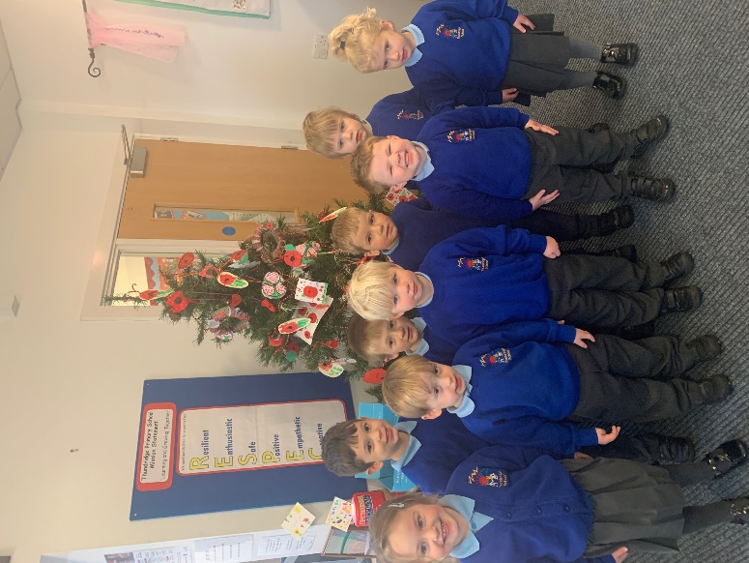

Children in Need
On 13th November the children were invited to come to school dressed in spots or yellow to represent Pudsey Bear for Children In Need. The children donated money and purchased Pudsey merchandise. £120.00 was raised after the cost of purchasing the merchandise.

EYFS really enjoyed the Children in Need day, they took part in counting, colouring and collaging activities. We spent some time learning about how Pudsey helps children.

Year 1&2 watched the duck race online on the whiteboard. They were very excited that Miss Hare’s duck came 2nd in the staff sweepstake.

Year 3&4 solved a Children in Need Maths challenge and in the afternoon took part in an online art class learning to draw Pudsey Bear properly.

Year 5&6 completed a skipping challenge during their PE lesson.

EYFS & Year 1&2
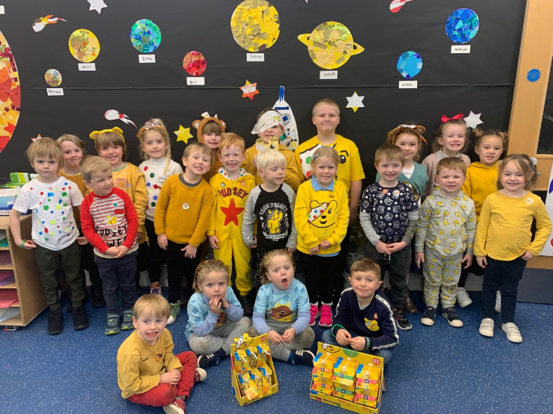

Year 3&4
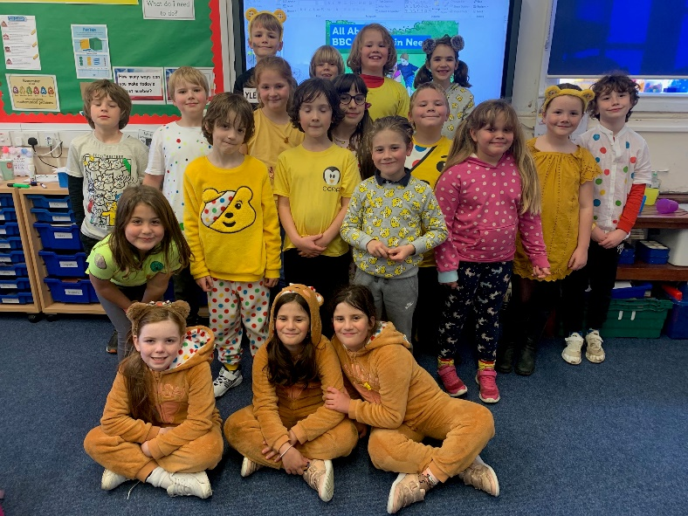

Year 5&6–During their PE Lesson Skipping Challenge
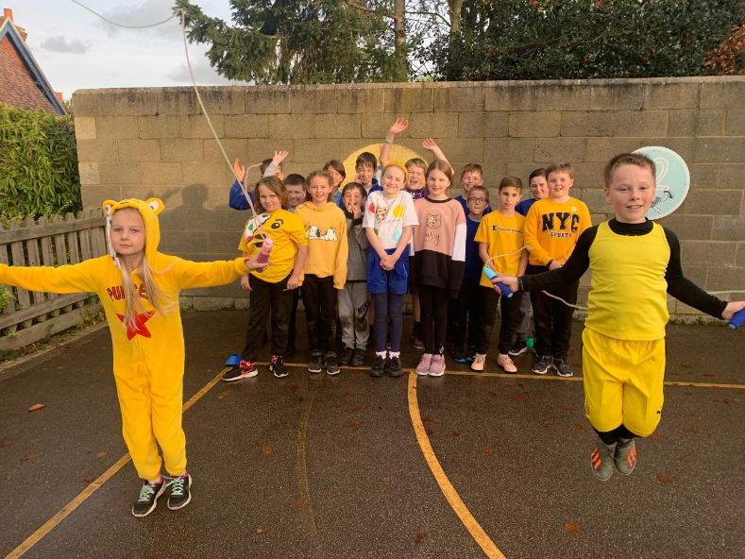

A message from Hertfordshire Libraries…

Libraries are open for Ready Reads
We all know how it important it is for children to have access to books. Despite the current lockdown situation, Hertfordshire libraries are offering a new way to borrow books, Ready Reads- We select you collect. Families can order books for their children and themselves using the online form and then collect from a selected library. If families are unable to access online services, please encourage them to contact us on 0300 123 4049 and a member of our team will be able to help fill out the form. We understand some families have not felt able to visit the library for a while, this is an easy way to borrow. In addition, our requests service is fully operational so for specific books these can be ordered through our catalogue and picked up in the same way. Never have books been more important, not only supporting children with their reading but also with their health and wellbeing, enabling them to leave behind the daily stresses and escape into imaginary worlds. You can find the latest information about Hertfordshire libraries re-opening plans and our online services on our website.

Kind regards
Miss Greatrex

Friends of Thundridge School

During October it has become custom for us to hold our annual Monster Ball Disco. But, due to things being very different this year, we were unable to do so. So working alongside the school and the Friends, we were able to have a Monster Ball Fun Day on the last day of term along with a tuck shop after school. It was brilliant seeing everyone dressed up in their costumes and the effort made by everyone. The teachers did a brilliant job making the day fun for all the children, with extra credit going to Mrs Le Grys who came up with the idea in the first place along with many of the fun activities. We were able to make £144.00, so a huge thank you to everyone who donated.

You will be receiving your child’s personalised Christmas cards, gift tags, mugs, and bags as they arrive this week, we are sure you will be very pleased with them.

Thank you for your continued support
Friends of Thundridge School

