THUNDRIDGE CHURCH OF ENGLAND

PRIMARY SCHOOL NEWSLETTER

18TH DECEMBER 2020

WHAT’S ON LATER
Monday 4th January | Inset Day – School Closed
Tuesday 5th January | First day of term  Year 3&4 – PE
Thursday 7th January | Year 1&2 – PE
Friday 8th January | EYFS – PE  Year 5&6 – PE & Library  Year 1&2 – Library
Thursday 21st January | Dog Safety Online Workshop
15th – 19th February | Half Term
Friday 26th March | Last Day of Term
29th March – 9th April | Easter Holidays
Monday 12th April | Inset Day – School Closed
Tuesday 13th April | First day of Summer Term
Monday 3rd May | Bank Holiday
31st May-4th June | Half Term
Wednesday 21st July | Last day of Summer Term

Birthdays

Ioanna Koumi – 15th December

Marina Koumi – 15th December

Joseph Fox – 24th December

Florence Flint - 30th December

Freddie Shirley - 3rd January

Josie Brown – 12th January

Olly Judge - 17th January

Tommy Brown - 20th January

Awards Friday 20th November 2020

Head Teacher Award - Macy Cyl for outstanding effort in her maths, showing increased confidence and faith in her abilities.

Class Awards

Foundation Stage – Alex Miu & Bertie Sampford

Year 1&2 – Izzy Basham, Isabella Dexter-Springett &
Jude Chappell

Year 3&4 – Ioanna Koumi & Marina Koumi

Year 5&6 – Tommy Brown & Rylie Sampford

Lunch Staff Awards – Isabella Dexter-Springett,
George Stopps & Robyn Whittle

Well Done Everyone!

Awards Friday 27th November 2020

No Awards – Inset Day

Awards Friday 4th December 2020

Class Awards

Foundation Stage – Freddie Dexter-Springett &
Robyn Whittle

Year 1&2 – Isabella Dexter-Springett &
Dana Harris-West

Year 3&4 – Mortimer Davy, George Harbour &
Henry Wilson

Year 5&6 – Finley Francis & Isla Grierson

Year 5&6 Pupil Awards – Harrison Campbell,
Charlotte Chamberlain & Mason King

Lunch Staff Awards – Isabella Le Grys, Hayden Mann
& Henry Sampford-John

Well Done Everyone!

Awards Friday 11th December 2020

Head Teacher Award - Mortimer Davy for stepping up and being a very sensible and responsible member of his class.

Class Awards

Foundation Stage – No Awards

Year 1&2 – Ben Alexander & Maisie Wright

Year 3&4 – Billy Baker, Miles Collins & Jack Turner

Year 5&6 – Stanley Campbell & Izzy Le Grys

Year 5&6 Pupil Awards – Oliver Chamberlain

Lunch Staff Awards – Billy Baker, Ralph Bradley-May,
Fletcher Hart & Edward Sampford-John

Well Done Everyone!

Awards Friday 18th December 2020

Class Awards

Foundation Stage – Florence Flint & Bertie Sampford

Year 1&2 – Whole Class

Year 3&4 – Josie Brown & Isabelle Sampford-Poulter

Year 5&6 – Henry Haworth & Freddie Shirley

Lunch Staff Awards – Jude Chappell, Bertie
Sampford, Isabelle Sampford-Poulter & Sam Field

Well Done Everyone!

Elf Day
On 2nd December the children were invited to dress up as an Elf and raise money for Isabel Hospice. £85.00 was raised, thank you everyone.

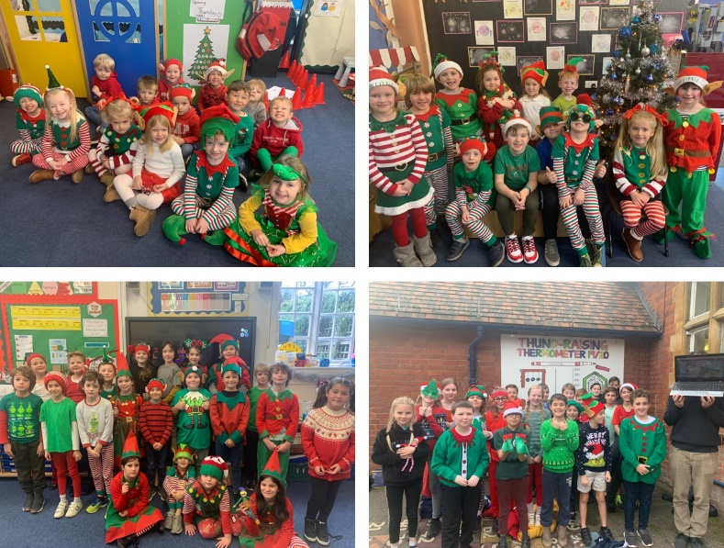

Circus skills Day
On 11th December, we held a circus skills day instead of our annual trip to Hertford Theatre to watch a Panto. Each class had an hour session at the Village Hall. The children enjoyed the magic and the tricks Steve had to show them. The children all had a chance to balance on ‘elephant feet’, twirl toothbrushes, roll flour sticks down and up their arms and spin plates on sticks. Everyone agreed it had been a great experience.

EYFS
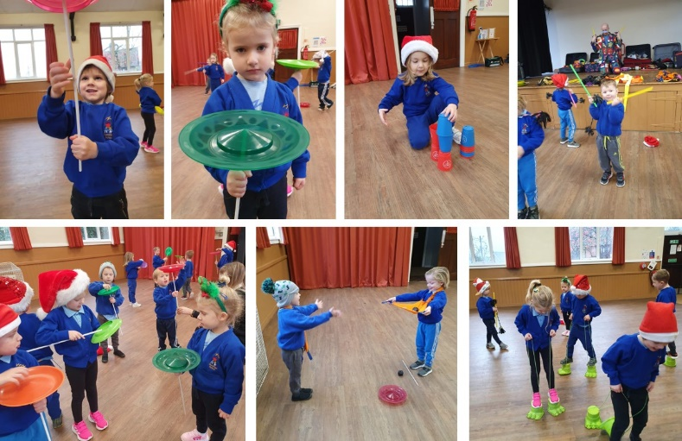

Year 1&2
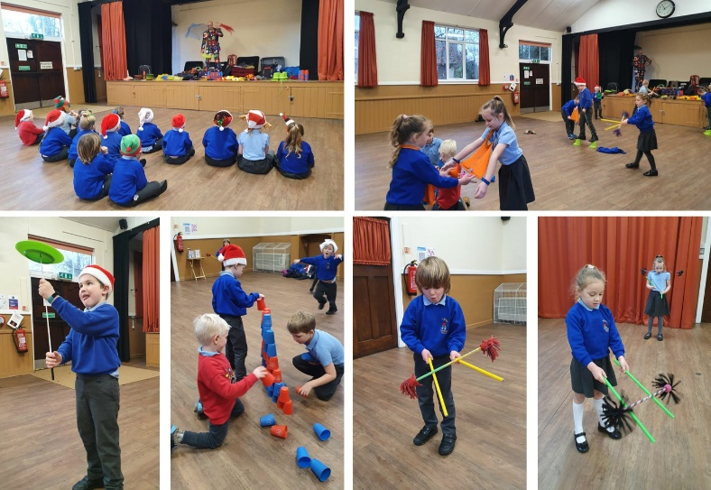

Year 3&4
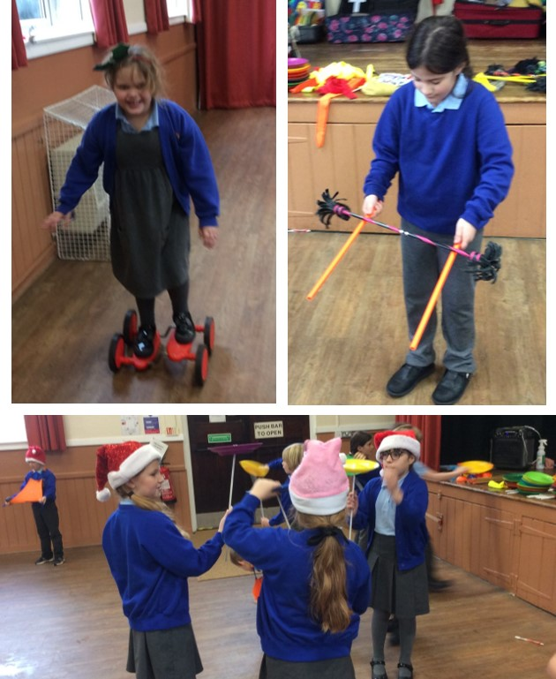

Year 5&6
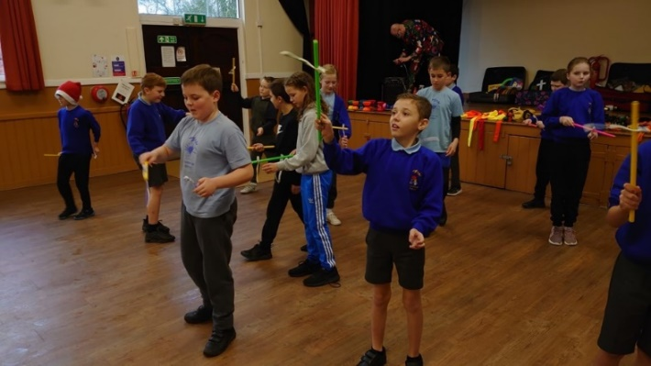

Santa Dash
Also during the day each class took part in the County Youth Games Santa Dash. The children wore a Santa Christmas hat while running laps of the playground or field. Even though it was not a race they all enjoyed this fun, fitness activity.

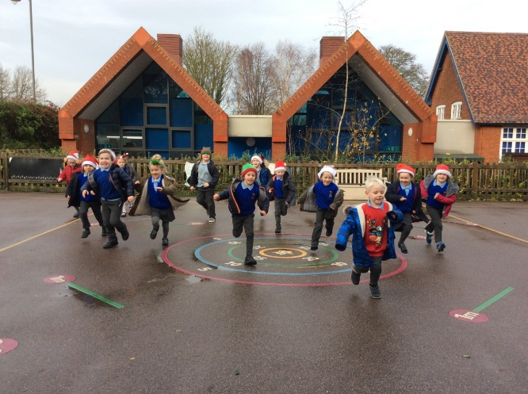

Christmas Lunch
Everyone enjoyed a lovely Christmas lunch on 16th December. Thank you to our cook Carol and server Gemma for a delicious meal. All Thundridge School staff served the children’s meals. Thank you to the Friends Committee for the Christmas Crackers, squash and chocolate lollies. Everyone wore their Christmas jumpers for Save the Children, £51.45 was raised. Thank you for your donations.

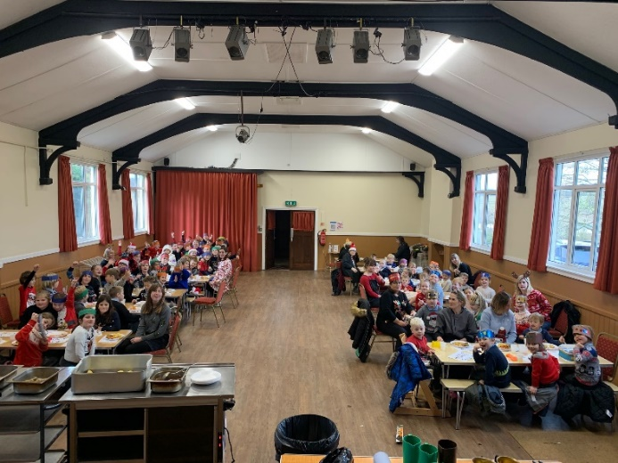
Festive Afternoon
The children enjoyed a fun festive, Christmas afternoon in non-uniform in their own classrooms on 17th December.

Church Service
Again due to Government Guidelines we cannot hold our annual Christmas Carol Service in the Church, instead the children gathered together (in their ‘bubbles’) on the last day of term and shared some Christmas sentiments on the playground.

All staff would like to wish you all a very Merry Christmas and Happy New Year!
Kind regards
Miss Greatrex

